A. Cover Sheet Information:

• Case Study Title No Shelter Pet Left Behind
• Case Study Category (Select one: Economic Vitality, Organizational Design, Community Building or Partnerships)
• Jurisdiction Name Manatee County Government
• City/County Manager Name Ed Hunzeker
• Would you like the application to be considered for an Innovation Award? (eligible to Alliance member jurisdictions only) Yes
• Would you like the application to be considered for our Rapid Fire Session? No
• Project Leader (Primary Contact for case study notification)
o Name Kristopher J. Weiskopf
o Title Chief
o Department Animal Services
o Phone Number 941-742-5933 ext. 8346
o eMail kris.weiskopf@mymanatee.org
o US Mail Address, including zip code 305 – 25th Street West, Palmetto, FL 34221
• Each Presentation Team Member:
o Name Joel Richmond
o Title Animal Services Supervisor
o Department Animal Services
o Phone Number 941-742-5933 ext. 8303
o eMail joel.richmond@mymanatee.org

B. Synopsis

Provide an in-depth 1 to 3 page description of the case study, including:
• Intent of the project/program/service

It is the mission of No Kill Manatee County, Animal Services, to save as many animals as possible by achieving a 90% save rate. This means that we will do everything we can to make sure pets are given that second chance, primarily through adoption programs. Saving pets will also be accomplished in cooperation with other animal welfare organizations, animal shelters, the media and the public through methods such as enhanced family pet retention, returns to the pet’s family, increased fostering and adoption, free and low cost spay and neutering and a feline TNR (trap/neuter/return) program.

Unfortunately, many communities are stuck in the “adopt a few and euthanize the majority,” pitting the animal control agency against animal advocacy groups. This results in many negative interactions and creates massive stress for the animal services staff who are painted as anti-animal when nothing could be further from the truth. We felt it was critical to adopt a model that ensured a complete collaboration and engagement of all community stakeholders for a more positive outcome for both the animal and human members.

We are following the model of Nathan Winograd, a nationally renowned advocate, ensuring that we are protecting the vulnerable pets in our communities by not allowing rampant reproduction and euthanasia. We have embraced the sections of Nathan Winograd’s no-kill philosophy that we have the ability to effect directly. These components include being the primary intake for dogs and cats; providing shelter and care until the dogs and cats are released; providing aggressive adoption programs and public education. Our community partners are working with us, rather than against us as we have seen in many communities.

A 90% save rate is our yardstick for success. To progress toward no-kill, performance measurements are necessary. A monthly 2% increase in the save rate, began in October 2011 and has been our barometer, with a 91% save rate goal projected for December 2012.

The impacts of this are multifaceted. We are saving animals from unnecessary deaths. We are encouraging employee self empowerment by their own belief in the concept and the trust we place upon them to carry it out. We are changing the image of Animal Services from a place where animals die to a place where animals find homes. We are creating a total community, along with the public, animal welfare organizations, animal shelters and the media, all dedicated to saving the lives of animals. And, to become a model in the State with the highest save rate and becoming self-sustaining through recurring revenue, licenses and services.

• Costs, if any

No additional funding has been requested or required. The Board of County Commissioners adopted a resolution defining the desire to become a “No-Kill’ community by providing other alternatives to euthanizing pets without requiring additional programmatic funding.

We are confident this plan will work within our allocated budget.

• Identify innovative characteristics and explain how they improved the organization

We motivated our staff to become active participants in our plan. Staff then promoted the plan to others within the community and educated those who may be resistant to the benefits of an effective plan.

Staff welcomed this plan with excitement and enthusiasm. Staff is working together as a team, making an effective internal partnership.

Adoption programs are very important. A team was put together to come up with innovative adoption programs. We asked for creativity; something that will catch the attention of the public. A different adoption program is presented each month which is comprised of ideas from staff. The team creates the monthly special, flyers and press release to promote it.

A foster program was initiated in order to give our pets a “home away from home” while they were treated for illnesses or injuries. Once they were back to health, they became available for adoption.

The opening of an off-site adoption center turned a lot of heads and became the talk of the downtown area. To further the excitement for our center, volunteers visit on their breaks and lunch time to walk dogs around town. The dog walking became so popular that our health benefits and those at the school board recognize this program as a health incentive. Volunteers also spend time with the cats, providing much needed socialization.

All Animal Services Officers have been issued a microchip scanner for use in the field. The purpose was to get loose dogs and cats home. If a dog or cat did not have a license tag, the officer will scan it, looking for a microchip. If a microchip is located, the pet may be returned home. This provides for excellent customer service in the field and affords the officer an opportunity to interact directly with the pet owner, educating them about our no kill efforts and how to make sure their pet is safe.

Professional photos of each pet are taken by volunteers to highlight their individual personalities. Historically, photos of impounded dogs and cats have been taken when the pet is processed is our system. The photos were always very basic and gloomy. The dogs and cats were not at their best and their photos were not appealing. A marketing volunteer came up with an idea to help us help the dogs and cats. This volunteer had contacts with professional photographers and pitched an idea to have our impounded dogs and cats photographed with props to show their personality. We have a schedule of professional photographers and handlers who take time out of their day to photograph our dogs and cats in adoption and impound. The photos are uploaded and placed on our website. The difference cannot be explained, one would have to see for themselves. This has enhanced our pet adoptions.

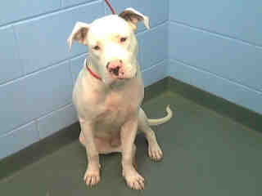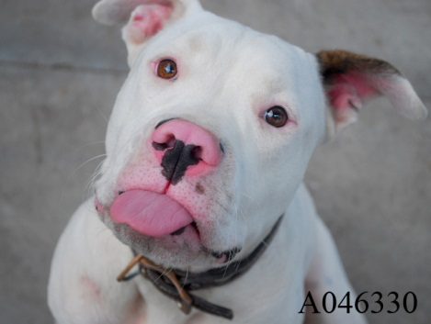
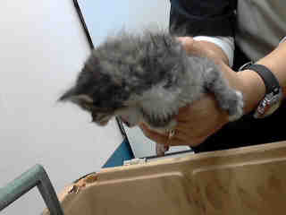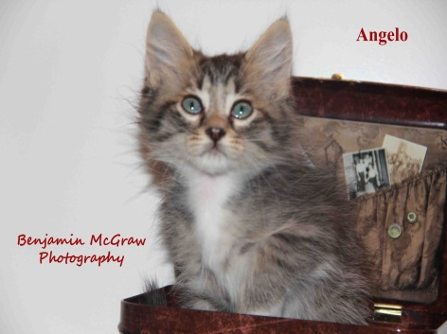
• Obstacles, if any

We have no control over intake of animals as we are an open admission shelter. This means we accept any and all animals and our save rate is predicated on events outside of our control. With the assistance of our community partners, we continue to find creative ways to manage that intake population.

• Outcomes – cost savings, for citizens, any performance measures information, etc.

Our plan was to increase our save rate each month by 2%, beginning in October 2011. The goal for that month was a 63% save rate. We achieved a 68% save rate this first month. We are proud to say that as of the end of May 2012, our goal was a 77% save rate and we achieved 79%. Our goal is a 91% save rate by the end of December 2012. This has been achieved without any budgetary increases.

• Applicable Results and Real World Practicality

No kill efforts are popping up nationwide. While we are the first government agency in the State of Florida to adopt a plan and resolution, two other counties have joined our efforts. We have had many inquiries about our efforts and we are seeing great impacts in the cohesive approach of the many animal advocates and animal welfare organizations around the community. In the end, we would like to see a no kill nation.

• Was a private consultant used?

No
▪ If yes, describe their involvement; and
▪ Identify the consultant and/or firm, including contact information

• Other – additional information

C. Presentation Style

Briefly describing what your case study presentation might include. We want to know how you will make your session creative and unique.

We will focus upon the success of the endeavor by presenting successes, strategies and statistics. The successes will highlight the soft side of the story and show some amazing pets that have become “family” to their adopters. The strategies will describe how our plan was formed and how we engaged our team, including staff, volunteers and animal welfare organizations. And, the statistics will detail where we were in previous years and the months leading up to our official declaration to become a no kill community, including our current vision.

We will use PowerPoint for our presentation with embedded videos and vignettes, and we would expect, of course, audience participation. We want this to be an experience for everyone and to motivate others to do the only right thing to do….. give dogs and cats a second chance.
For example:
• Presentation Tools Plan to Use: for example Prezi, PowerPoint, Video
• How do you plan to be both entertaining and educational?
• Group Activity Description
• Live demonstration(s)
• Other – BE CREATIVE, this is TLG!

