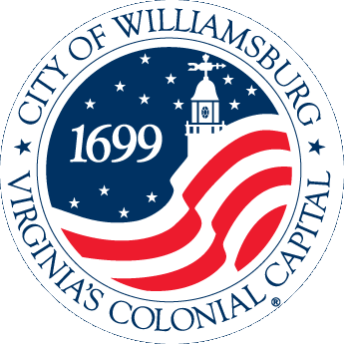
2013 Transforming Local Government Conference
Case Study Presentation Application
April 10-12, 2013

“Williamsburg Gets Her Cool Back”

Case Study Category: Economic Vitality

Jurisdiction Name: City of Williamsburg

City Manager Name: Jackson C. Tuttle, II

Would you like the application to be considered for an Innovation Award? Yes

Would you like the application to be considered for our Rapid Fire Session? Yes

Project Leader
Name: Michele Mixner DeWitt
Title: Economic Development Director
Department: Economic Development Office
Phone Number: 757-220-6120
Email: mdewitt@williamsburgva.gov
US Mail Address, including zip code: 401 Lafayette St, Williamsburg, VA 23185

Presentation Team Member:
Name: Jack Tuttle
Title: City Manager
Department: City Manager’s Office
Phone Number: 757-220-6100
Email: jctuttle@williamsburgva.gov

Presentation Team Member:
Name: Michele DeWitt
Title: Economic Development Director
Department: Economic Development Office
Phone Number: 757-220-6120
Email: mdewitt@williamsburgva.gov

Presentation Team Member Invited:
Name: Kyra Cook
Title: Citizen and Working Artist
Department: NA
Phone Number: 757-645-8440
Email: kcook@wchf.org

Presentation Team Member Invited:
Name: Former Williamsburg Mayor Jeanne Zeidler
Title: Former Mayor
Phone Number: 757-345-0912
Email: jzeidler@wchf.org

Williamsburg Gets Her Cool Back

Cool Factor - 1. Definition (expr.) being cool. 2. The measure of how good a party [City] is going to be, depending on who will be there. The right mix of people to make a party [City] successful.

"Cool always sells because the basis of cool is aspirational," says Del Breckenfeld, author of The Cool Factor: Building Your Brand's Image Through Partnership Marketing (Wiley).

The Mayor remembered a time thirty years ago when part of Williamsburg’s “cool factor” was the many working artists who lived in the City’s neighborhoods. Blacksmiths, potters, glass blowers, and others plied their trade in home studios throughout the City. They earned income working part time or full time with their art. Many worked in the historic trades division at Colonial Williamsburg. Rising property values, increased demand for housing, and more restrictive zoning ordinances have priced most of these artists out the City. Many relocated to less expensive housing in adjacent counties. Others moved farther away to southwest Virginia or locations out of state that welcomed artists. Part of Williamsburg’s cool factor disappeared.

During the 2005 Comprehensive Plan (the City’s land use vision) review, Kyra Cook, one of the few remaining working artists with a studio at her home, presented a concept to the Planning Commission, “Let’s change a residential zoning district to allow artists to live and work at their home.” The seeds were planted for the City’s Creative Economy Initiative.

In 2006, the City and the Economic Development Authority (EDA) identified the creative economy as a target industry for economic diversification in the City’s Economic Development Plan. The Creative Economy, which creates wealth and jobs with the intellectual capital of creative professionals and artists, is an economic growth sector in an increasingly globalized world. Additionally, the Creative Economy complements and enhances the City’s existing economic drivers of hospitality and education.

Also in 2006, City Council implemented the Comprehensive Plan’s vision to allow artists to live and work in one of the City’s residential zoning classifications. This zoning district (RS-3) exists in four different neighborhoods in the City. The innovative zoning changed codified combined live/work spaces for artists, which helps artists overcome some typical hurdles to operating an artist studio and commercial space in his home. Namely, artists’ difficulty obtaining finance and insurance products for places where the use and the zoning are not aligned. Many artists were using space that had become nonconforming to zoning ordinances, so banks and insurance companies often were unwilling to sell their services. Additionally, the zoning change showed vision and innovation because almost all other localities have modified zoning restrictions to prevent what is seen as industrial uses (artists’ kilns, glass shops, metal shops) from residential areas. With the change the zoning hurdle was crossed. Williamsburg now offered artists the opportunity to live and work in homes in residential areas of the City – much as the Mayor remembered. However, housing prices in the City remain another obstacle to artists returning.

In 2009, several more endeavors continued the City’s move towards its former creative cool factor. To reinforce its decision that the Creative Economy is a growth sector for the City, the EDA commissioned the College of William & Mary (W&M) to quantify and assess the creative economy potential in Williamsburg. The resulting white paper reinforced the economic benefits to be gained by a creative economy and arts initiative. That same year, the Virginia General Assembly passed legislation that allows localities to create Arts and Cultural Districts. This allows the City to provide tax rebates, grants, technical assistance, or other incentives to attract and grow the creative economy and the arts. Later that year, the Mayor appointed an Arts and Creative Economy Task Force to work with a consultant, Artspace, Inc, a nationally renowned nonprofit specializing in affordable live and work space for artists, to analyze the feasibility of further initiatives, including affordable live and work space for artists and potential locations for an Arts District in the City.

After several public meetings, one of which attracted 120 artists to meet on a rare snowy evening, and analysis with Artspace’s expertise, the Task Force recommended the creation of an Arts District in an older mixed-use area with 22 percent commercial vacancy and 78 percent renter-occupied housing stock. It also recommended commissioning Artspace to conduct its standard Artist Demand Survey to determine options for affordable live/work and stand-alone workspace in the proposed Arts District.

Public interest and some skepticism followed the project. The City’s Communications Director set up systems to contact everyone interested in the project with enotify emails and online comment blogs. An information web site was created – WilliamsburgArtsDistrict.com. Postcards were mailed to every property owner in the proposed District. Press coverage was substantial. After several highly attended public discussions and meetings, City Council approved the Arts District in February 2011. The District offers tax incentives and permit fee waivers to encourage creative economy businesses to locate or expand in the Arts District. The long term vision for the District is a vibrant, walkable area of the City where creative businesses, like art galleries, jazz clubs, bakeries, cafes, artist studios, and antique stores, would co-exist with creative professionals, like software engineers, architects, and graphic designers, and artists living and working in the District. With the result of vibrancy and coolness, where all generations (college students, young professionals, retirees and visitors) will live, work, shop, eat, and have fun.

Since the designation of the District, seven creative businesses have opened there, creating 32 jobs. (Two of these businesses closed in July 2012, reducing the job creation to 28. Another creative business currently is renovating this now vacant commercial space and should qualify for the District incentives.) The businesses include bakeries, antique shops, jewelry and art gallery, an art education center, and a dancers’ boutique. The cool factor increases.

As business prospects showed more interest in the District, regulatory obstacles in the Zoning Ordinance became apparent to the Planning and Economic Development staff. The Planning Commission and the EDA worked together, which is innovative in its own right, to propose changes to the parking requirements and restaurant size thresholds for the District. After continued public notifications and thorough public discussions, City Council adopted the changes to the Zoning Ordinance in June 2012. Another hurdle was crossed.

Artspace was invited back to the City to undertake its Artist Demand Survey. In an innovative public/private partnership, six partners joined the City to pay for the survey – Busch Gardens, the Chamber & Tourism Alliance, Chesapeake Bank, the College of W&M, the Colonial Williamsburg Foundation, and the EDA. The results showed demand for the construction of 22 affordable live/work spaces and 24 standalone workspaces for artists. Unfortunately, this is not enough demand for Artspace to build and operate its own affordable artist building, but the City is optimistic and ready to identify opportunities to move forward, to continue to increase the cool factor.

Future steps include looking for workspace for artists, convening the District businesses to form an association to market the District, investigating a creative business incubator, assisting redevelopment opportunities, and seeking opportunities to facilitate affordable artist live/work space. City Council will fold these next steps into its biennial Goals, Initiatives & Objectives document to be adopted this fall, and the EDA is incorporating them into its Economic Development Plan update. The future looks cooler….

Costs
$12,500 – Initial Artspace Feasibility Study (paid for by the City and the EDA)
$42,500 – Artspace Artist Demand Survey (paid for with a National Endowment for the Arts grant and funds from Busch Gardens, the Chamber & Tourism Alliance, Chesapeake Bank, the City, the College of W&M, the Colonial Williamsburg Foundation, and the EDA)

Innovative Characteristics
- The zoning changes countered the national trend of pushing artist studios out of cities by allowing kilns and other industrial-type artists’ tools in densely populated areas.
- Public outreach via email notification, information web site, online comment blog, stakeholder meetings, and press coverage
- Public/Private partnership with large employers and significant institutions was developed by identifying the benefits of a local Creative Economy initiative to each of the partners needs, which varied and included housing for workforce, economic opportunities for trailing spouses of employees, enhancement to the visitors’ experience, investment in a specific area of the City, attracting young professionals, and economic diversification.
- The Planning Commission and the EDA worked together to develop regulatory changes to grow the creative economy. This short-term effort has launched a longer-term relationship with joint review of the Comprehensive Plan (planning document) with the Economic Development Plan (EDA document) and public support and defense of each other’s efforts.
- The City created it first economic incentive district in a fiscally responsible way. The tax incentives only apply to portions of future, currently uncollected tax revenue. No current tax revenue is lost.

Obstacles
Public skepticism existed in response to the Creative Economy Initiatives, including fear of the City using eminent domain in the Arts District and the Arts District attracting undesirable businesses. Transparency, extra public notifications, and extra public meetings were used to discuss these fears.

Outcomes
5 businesses
28 jobs
Notable press coverage and positive “buzz” has been constant throughout the efforts.

Private Consultant
ArtSpace (www.artspace.org) a nonprofit real estate developer for the arts, specializes in affordable space for artists and the creative economy, conducted the original feasibility study and subsequent artist demand survey. They have advised cities such as Denver and Boston as well as suburban and rural areas across the nation.
Wendy Holmes, Senior Vice President
Consulting and Strategic Partnerships
612-465-0240, wendy.holmes@artspace.org

Presentation Style

- Power point with many images
- Skilled public presenters will include anecdotes and lessons learned while explaining the case.
- A product from a business in the Arts District will be shared with every attendee (most likely a cupcake from a culinary arts business called Extraordinary Cupcakes. Eating one of their cupcakes is a memorable, positive experience.)
- An interactive art related activity for group members to complete and create a memento will be used.

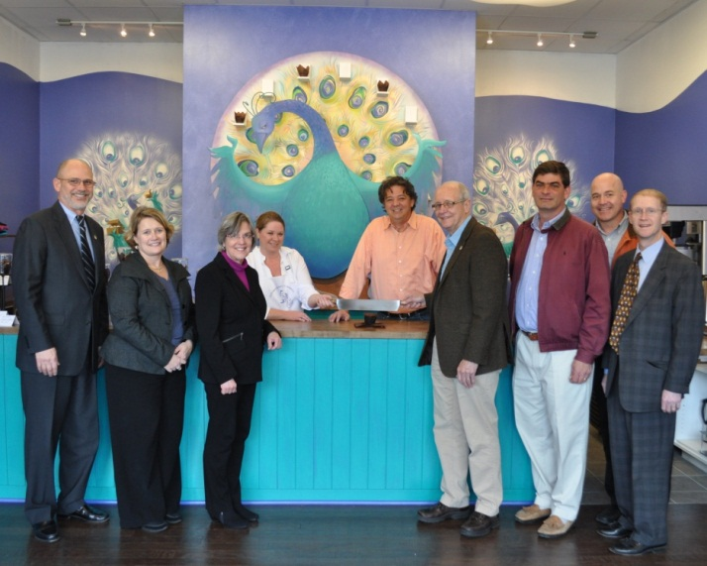

The fifth creative business in the City's Arts District opened to standing room only crowds for the ceremonial “cupcake cutting” on Wednesday, January 25, 2012. (L-R: City Manager Jack Tuttle; Economic Development Director, Michele Mixner DeWitt; Arts Task Force Chair Jeanne Zeidler; Owners Dyana and Adam Steely; Mayor Clyde Haulman; Planning Commission member and landlord Demetrios Florakis; City Council member Doug Pons; and Vice Mayor Paul Freiling

Nguyen, Lan. 'Cool' Factor Still Sells During a Recession, March 6, 2009, http://www.thestreet.com/story/10468180/1/cool-factor-still-sells-during-a-recession.html

