A. Cover Sheet Information:  
  
· Case Study Title **Community Gardens and the Food Pantry--An "organic" match**  
· Case Study Category: Community Building/Partnerships  
· Jurisdiction Name Township Of Denville, New Jersey  
· City/County Manager Name Steve Ward  
· Would you like the application to be considered for an   
Innovation Award? Yes

· Would you like the application to be considered for our Rapid   
Fire Session? Yes  
· Project Leader (Primary Contact for case study notification)  
o Name Bob Grant  
o Title **Community Gardens Administrator**  
o Department Volunteer  
o Phone Number 201-859-6216  
o eMail [Bg1044@aol.com](mailto:Bg1044@aol.com)  
o US Mail Address 114 Ridgewood Parkway East

                       Denville, NJ 07834  
· Each Presentation Team Member:  
o Name Bob Grant  
o Title  Same as Above  
o Department  
o Phone Number  
o eMail  
  
B. Synopsis  
Denville, NJ is a town of 16,000 residents with a part time food pantry which is open Monday, Wednesday and Friday between the hours of 9 am and noon.  Denville has been hit with the economic problems common to the rest of the country and in addition, suffered a severe flood at the end of August, 2011 which displaced a number of people.  The need for food assistance, as for many necessities, has gone up sharply. Few people in town realize there is a food pantry and that there are a number of residents who need it.  The Pantry has some handicaps--part time--located in the Municipal Building on the second floor and most important from the point-of-view for this presentation, it cannot receive food from the New Jersey Food Bank because it is not a 501 (c) 3 not-for-profit.

Denville also has a 4-5 acre community garden with about 120-130 individual plots for use by residents at an annual registration fee of $6. For the fee,  they receive water.  Gardeners must provide all tools, seeds, plants and labor.  Bob Grant has been tilling his 18' by 26' plot of land for more than 20 years, but just took over this year as the Administrator and serves with a co-chair to organize things.

Two things came out of a first meeting between Grant and the new Township Social Services Director, Diedre Rock: 1) The local Girl Scout Chapter was given a plot and; 2) Grant made a commitment to try to help supply the Food Pantry with excess produce from the gardens.  The Girl Scouts immediately signed on to the idea.

The growing season in Northern New Jersey hits it's peak toward the end of July but already the idea has been enthusiastically endorsed by the gardeners and the staff and director of the department of Social Services.  A large amount of leafy greens--kale, lettuce, spinach, Swiss chard--has been donated as have green beans and peas.  Squash and cucumbers are coming into their own.  Other crops such as corn, tomatoes, peppers and eggplant are just beginning to get ripe and from the looks of the gardens, there will be an abundance to share.

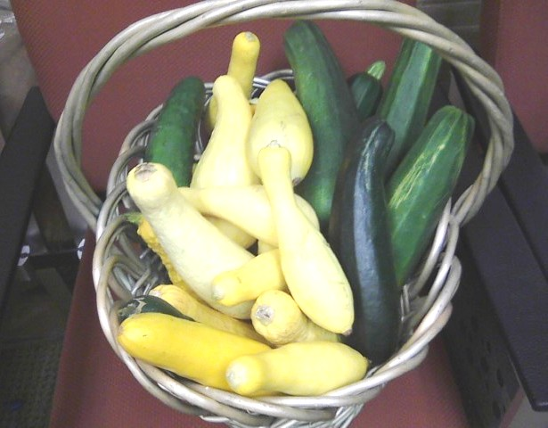

Although only in it's initial year, the program is really an "organic natural" and is serving to bring the gardeners and the larger community together. Equally important, in these days of political divisiveness, the program has bi-partisan support.

As with anything new which requires cooperation and real work the program is still small, but seems to already be producing enough fresh produce to meet the needs of those who use the food pantry.  We anticipate that as the word spreads, more people will start showing up for the garden goodies and more gardeners will donate.

We have an annual Gardeners picnic which was organized by Grant and a few others four years ago and this year not only will it give the new and returning gardeners a chance to know each other, but it will give us a chance to promote the relationship with the food pantry.

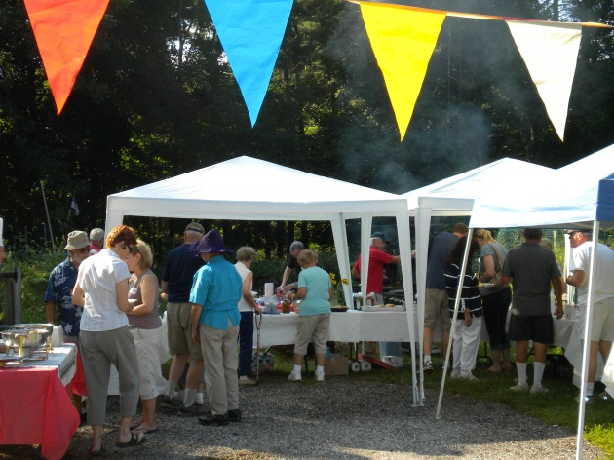

· Intent of the project/program/service Help feed those in need.  
· Costs, if any None  
· Savings, if any The Savings are to the folks who use the food pantry and the pantry itself as there is no cost to getting fresh produce.  
· Identify innovative characteristics and explain how they   
improved the organization **Everyone involved has a stronger sense of Community and a sense that they have helped.  Those who use the food pantry, often older more isolated residents, feel someone cares.**   
· Obstacles, if any Letting people know about the program and getting gardeners into the habit of contributing.  Also, letting the users of the food pantry know that fresh vegetables are available.  Because of the very limited hours of operation for the pantry, a supply system had to be organized to ensure that fresh material didn't wilt between picking and delivery.     
· Outcomes – cost savings, for citizens, any performance   
measures information, The cost savings to both the pantry and its patrons are real and amount to about $2 for every pound of produce delivered.    
· Was a private consultant used? No  
  
C. Presentation Style  
  
Briefly describing what your case study presentation might include. We   
want to know how you will make your session creative and unique. For   
example:  
· Presentation Tools Plan to Use: for example Prezi,   
PowerPoint, Video:  Video and Power point  
· How do you plan to be both entertaining and educational?  Picture our oldest gardener, 93 year-old Wally, chasing a woodchuck away from the bag of squash that he was planning to give to the food pantry while shouting "colorful" things at the animal.  Pictures of the garden, gardeners and the Scouts as well as the creatures which share it with us should be captivating.

