CITY OF WINDSOR HEIGHTS: Community and Events Center Plan and Implementation

The City of Windsor Heights, Iowa is a landlocked community located in the heart of the Des Moines, Iowa metropolitan area. Windsor Heights is also a primarily residential community, with a large number of senior residents (20.4% in Windsor Heights as opposed to 12.4% nationally) and a housing stock that is an average of 30+ years old. Conversely, the other suburban communities in the area have a great deal of growth, with newer houses and offer more of the amenities that young families desire, such as excellent parks and recreation programming.

Windsor Heights is 1.7 square miles and has only 2 parks. One park is very small and the other park, Colby Park, is the main park for the city and is highly visible from the interstate that traverses the Des Moines metropolitan area. Colby Park had never been laid out in any comprehensive or planned manner. It was a hodge podge of (well-intentioned, if not well-placed) amenities with very little usable green space.

The City realized that action had to be taken to upgrade the recreational amenities. Therefore, the City council gathered a number of community organizations and began a planning project. The Council formed an ad hoc committee that included representatives from the city government, the Citizens Capital Planning Committee, the Windsor Heights Foundation, the Lions Club, the Keep Windsor Heights Beautiful Committee and the Chamber of Commerce. Each of these organizations not only committed to the planning process, but also made a funding pledge to improve the shelter house. The initial focus of the group was to find a way to get restrooms in the park that would be open to the public. The purpose of the ad hoc committee quickly expanded from a focus on the shelter house to the layout, function and condition of the overall park.

The ad hoc committee met for a period of nearly two years and created a comprehensive concept for the park, which the Council adopted in July, 2006. First, the playground was redesigned with new, more modern and safe equipment. The City had been working to enhance relationships with the local schools. There are two elementary schools in Windsor Heights, one of which is a Montessori school. City staff worked with the teacher of the 6th and 7th grade students to create a curriculum for the students which would actually have them developing the architectural program for the playground. Staff talked with the students about the various issues they needed to address when developing a plan.

The 2nd phase of the Colby Park redesign involved the reconfiguration of the ballfield. The city worked with the local (Walnut Creek) Little League to design a field that would meet their needs to kids could enjoy the best possible field. The next phase involved the creation of a performance pavilion. Every Tuesday during the summer there is a “Music in the Park” series sponsored by the Windsor Heights Foundation. In addition, every Friday there is “Movie in the Park”, sponsored by the Windsor Heights Special Events Committee. Finally, came the development and construction of the Windsor Heights Community and Events Center, which began in 2009 with the dedication of the center in July, 2010 and the full opening of the center in September of 2010.

The park redesign plan from 2006 had a concept for the new shelter house, which left a significant amount of the building in a flood plain. As flooding has become a much more frequent occurrence in recent years, allowing a building to be expanded upon in a flood plain was quickly removed, which proved invaluable towards the end construction of our new Community and Events Center.

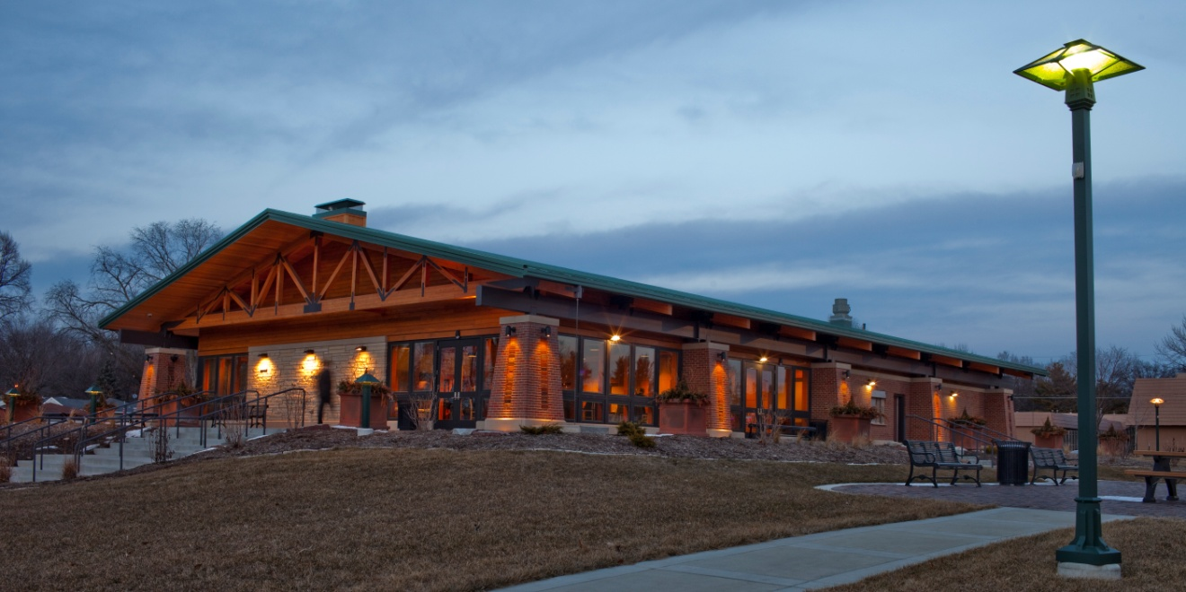

One of the biggest contributors to our new center was Polk County. Working with the engineering and public works department, Polk County provided in kind services valued at nearly $300,000. Polk County removed the old shelter house, all the preliminary dirt work for the new building, including building the 6-foot bed of dirt up out of the flood plain for the over 6,000 square foot building. Polk County also provided construction oversight for several phases of the entire project. The new Community and Events Center opened in late 2010, but barely. As can be seen in the below picture, 9 days after the opening of the new building, the park flooded. Amazingly, the building acted as designed and stayed completely dry! Three more steps up and the building would have flooded! The old shelter house would have had 4 feet of water in it.
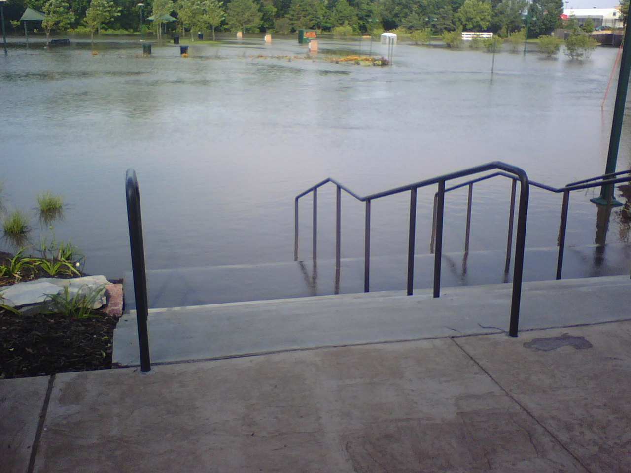

In order to finance the building of Colby Park was added to be included in a Tax Increment Finance (TIF) district. This allowed the city to issue debt based on future revenue from the TIF district. Although taxes had to be adjusted the first two years after the issue of the bonds, since that time other debt has been paid off and enough revenue is being brought in that the average citizen paid very little in taxes for the $2.4 million dollar building and the $4+ million park project. As you can imagine, the city strived to get as much outside funding as possible.

Iowa has a Community Attraction and Tourism (CAT) grant that cities, counties and non-profits can apply for. Staff applied for the very detailed grant and presented to the board on two occasions. Each time the board always asked for more information or additional outside contributors. As the city worked hard on the application, the state legislature passed a program called I-Jobs. The purpose of this legislation was to stimulate economic activity across the state during the economic downturn. The legislature wanted to see the money spent as-soon-as-possible. Windsor Heights quickly acted and applied for I-Jobs fund. Because the city had been working so hard on our CAT Grant application, the city was well positioned to receive an I-Jobs Grant. After consideration, taking into account jobs created and how shovel ready projects were, our center scored the 2nd highest in the entire state!

The Community and Events Center has served to transform the way we act and the programming we offer for our city. Prior to the building opening, there were very few places, other than the council chambers, to offer educational or recreational programming. In addition, for a city that is completely built out and surrounded by other communities, adding programming and staff is almost impossible, but since opening the building a full time staff person was added to handle the rentals in the building and keep the center full and used as frequently as possible.

When the new full time staff member was hired, the Parks and Special Events Coordinator, was given a general but lofty goal. “Keep the parking lot as full as possible” so that everyone would know the building was being used. As can be imagined, the new center did meet with strong resistance from some citizens who did not want to see the city go into debt to build the new building and from some more tenured residents who thought the layout of the old park was “good enough”. But through the programming we have offered, we believe those few who were skeptical of the project have been converted.

Following the park flooding and cleanup, the building did not initially getting used until October of 2010. Since opening the building, the below items have been offered:

Recreation Type Classes:
Bridge Lessons  Yoga  Zumba  Tai Chi | Dance  Right-Brain Journaling  Art Classes

Educational Classes:
Emerald Ash Borer  Energy Efficient Lighting | Watershed Analysis  Your Own New Biz Camp

Others:
Health Screenings  Natural Hormone Replacement  Green Arts in the Park | Hypnosis  ABC’s of Moving for Seniors

Special Events:
July 4th (7-8,000 people)  Movies in the Park  Music in the Park | Oktoberfest  Windsor Wonderland  Shakespeare in the Park

Revenue from the Community & Events Center in the fiscal year was $80,752 (well beyond the $46,000 budgeted) with usage at 14,178 people. City elected officials and staff find these numbers exciting because it shows that the hard work, the planning and the years of effort created a Community and Events Center that was truly envisioned by the Community and is well-used by the Community and serves the Community well.

