Managed Competition
“It is not government’s obligation to provide services, but to see they’re provided.”
―Former New York Governor Mario Cuomo

Managed competition is a process used by local governments to identify the most cost-effective method for quality service delivery. It calls for carefully comparing the costs and benefits of contracting with private business or another government entity against the costs and benefits of providing the service in-house. It is important to note that managed competition is not the same as privatization. Privatization assumes that private business can always do a better job of providing services; managed competition considers the current provider (government employees) as a viable, long term provider of services in a fiscally constrained environment. According to one estimate, managed competition has the potential to produce annual savings of 10 – 30 percent.
During managed competition, the in-house business unit competes against private contractors to secure delivery of services. This strategy evolved in large part to ensure that employees were not marginalized or unfairly considered during the switch to a competitive environment. This method was pioneered by the City of Phoenix, Arizona in the late 1970s. Its application by the City of Indianapolis, Indiana, in the 1990s found managed-competition programs empowered employees to contribute to the process and become partners in the efforts to deliver cost-effective and quality services. Here, employees are given an opportunity to structure bids, conduct cost comparisons, and change the service delivery paradigm.
Governments have utilized a few variations on managed competition. The following provides a brief overview of these approaches:
- Ad Hoc Approach: In-house costs are compared with market price being paid for the same or similar service. If the costs are not favorable, then the jurisdiction should consider:
  - Giving staff a fixed time to improve operations and reduce costs;
  - Informal bidding between department and private firms; or,
  - Formal bidding between department and private firms.
- Informal Bidding: Fixed prices are obtained from private firms for specific services and then compared to in-house cost estimates. Some may incorporate invitation for bids or request for qualifications into the process. The downside of this approach is that bids from private firms are fixed, and the jurisdiction only has an estimate of in-house cost.
- Formal Bidding: Fair, equal, and competitive comparison between bids submitted by private firms and in-house departments.
Many different benefits of managed competition have been discussed in the field of public administration. The following are some examples of the most often discussed:
- Best-value services. Enables cities to find solutions where they can get the most “bang for the buck” or where the expectation of services may be reset so that the jurisdiction can reduce the overall cost of service by meeting a slightly lowered delivery schedule.
- Empower front-line employees: Provides current staff an opportunity to come up with solutions and changes, softening the transition process. It also helps to mitigate harsh community reaction to privatization by objectively looking at the cost of services.
- Encourage innovation: Challenges current system, fosters creativity, and engages employees. It also allows employees to begin thinking out of the box in terms of service delivery, demand, and employee availability.
- Encourage partnerships: Managed competition provides an opportunity for labor and management to work together. It focuses on partnerships and looks to provide the best solution given fiscal constraints.
- Reward competitive thinking: Some governments have developed gain-sharing programs to reward employees with part of any savings generated out of managed competition. Incentives such as these can further reinforce increases in performance and lead to future gains.
While there are many benefits to a managed-competition process, there are also some disadvantages. Below we discuss some of the more common ones:
- Accurately identifying a fully loaded cost of service: Some public agencies do not have the cost accounting systems in place to tie specific internal costs (labor, commodities, equipment) with performance and service levels.
- Getting people to change their idea of service delivery: People can be resistant to change and it can be difficult to get buy-in for these types of programs.
- Staff reductions: If internal costs are high, the internal work group bidding on the services may have to consider layoffs or wage cuts in order to be competitive with the market.
- Employee morale: There may be a negative impact on labor relations and employee morale if employees lose a bid. However, some jurisdictions utilizing managed competition have seen the work group or bargaining unit come back in future years with a more competitive proposal to win back the work and retain it in the long term.
Process
As discussed earlier, the managed competition process can take many forms. In general, the formal-bidding, managed-competition process is the most robust, requiring the greatest amount of time and effort to implement. Despite the costs and time involved, decision makers are often able to obtain the best possible information through the formal bidding process. Additionally, this process is perceived to be more fair and equitable when compared to informal or ad hoc managed competition.
While the specific steps for a formal-bidding, managed-competition process may vary, we are able to describe a high-level process that should elicit the most competitive results. The following is a brief overview of that process:
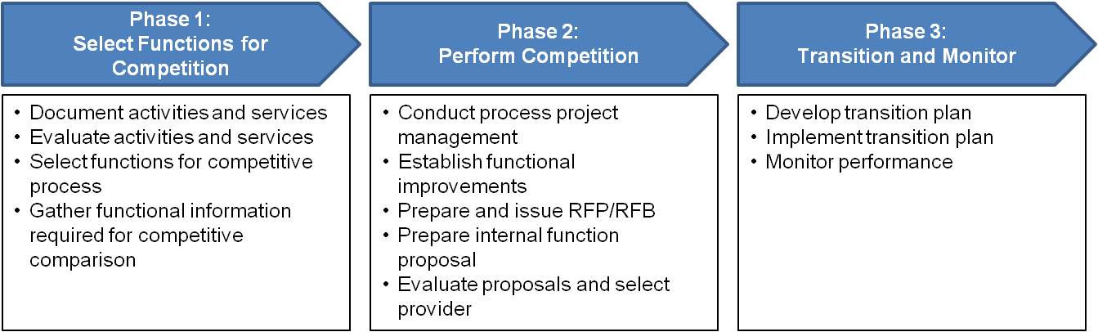
Phase 1 of the managed competition process focuses on identifying in-house business units that are the best candidates for competition. Typically, this will occur by “functional” area, e.g.,, transportation, waste management, street maintenance, snow removal, dispatch, etc. Keep in mind that, if a function is too broadly defined or complex, the private market may be unable to provide comparable services. Once business units and their services are appropriately scoped, they are evaluated as to their cost and performance expectations. Evaluators must consider multiple factors including but not limited to:
- Legal factors: Union restrictions, federal or state law requirements
- Job type: Inability to contract out policy setting, contract management, and other duties
- Strength of private market: Strong competitive markets will result in most cost-effective services
- Financial impact: Costs of providing a particular service
- Risks: Costs of service disruption, negative public opinion, safety concerns, and financial liabilities
- Implementation feasibility: Availability of clear performance standards, ability to change regulations or staff levels, variability of funding
- Capital investment recovery: Costs and revenues from managing capital investments including selling or renting buildings, equipment, and vehicles
Phase 2 of the managed competition process begins with establishing the process, participants, and timelines of the competitive analysis. Project management activities should establish clear expectations with stakeholders to instill a sense of objectivity and fairness. The structure of comparing services and developing cost estimates must be clearly established at this point. Managed competition often fails when the process of comparison is not clear, timelines are delayed, and expectations are changed or not met. Strong project management and the communication of expectations are essential for a successful managed competition process.
Identifying functional improvements is one of the most critical components of this phase. Here, government business units identify innovative opportunities to improve services, increase efficiency, and reduce costs. Business units use information gathered in Phase 1 to establish current service levels and costs, and compare these to industry benchmarks or peer organizations. Opportunities to adjust the organizational structure and personnel, improve processes, or implement new technologies are identified. In addition, functions must estimate the costs of their services if the identified improvements are made. In some circumstances, government functions may actually begin implementing identified improvements and evaluate actual service costs and levels once the improvements are made.
The final component of Phase 2 focuses on comparing the internal business unit and private contractors. A request for proposals (RFP) is created with a clear statement of work. The RFP is communicated to private contractors, and the government business unit is required to develop a proposal. The government proposal is based on the estimated “improved” operations and service costs established earlier in the managed competition process. After receiving private contractor proposals, an evaluation team will typically select the strongest private candidate to compare to the government proposal through a sealed competitive bidding process. If the government business unit is selected, it is required to implement the identified improvements and is held to the performance standards identified in their proposal.
Phase 3 of the managed competition process transitions the organization from current operations to the new service provider. A transition plan is typically developed to guide the process. If the function remains with the government, the transition plan identifies how and when the operational improvements will be made. The transition plan should address budget changes, purchasing and investments, employee transitions, and communications. After the implementation takes place, performance of the new services is monitored and evaluated. If the government or private contractor are not meeting agreed-upon requirements, the function may become eligible for competition once again.
Conclusion
Managed competition can be a powerful tool for governments to improve service delivery and reduce costs in a resource-constrained environment. However, if not managed properly, managed completion can also create a hostile environment and waste valuable time and resources. Careful consideration must be given when developing a managed-competition program. For example:
- Time and resources: The process can take several months to several years. Factors include but are not limited to the complexity of the service provided, availability of information, time allowed, and the structure of the review and approval process.
- Fully Loaded Cost Calculations: Agreeing on the method for calculating government service costs is a common sticking point for managed competition. Information to make these calculations is also required.
- Estimating Risk: Costs such as rehiring laid-off staff or repurchasing equipment should be taken into consideration if the business unit is outsourced.
- Comparison to best-in-class services: Often, it is more realistic for governments to compare service levels and costs to comparable entities. Striving for best-in-class services may outweigh the benefits.
- Stakeholder cooperation: Successful managed competition requires cooperation and buy-in from political officials, managers, staff, and unions.
When executed properly, managed competition can result in significant cost savings, high citizen satisfaction, and a sense of pride for government staff who are able to “beat out” their competition. For more information about our approach, please contact Christine Smith, Principal at 800.362.7301, ext. 2391 or by e-mail christine.smith@bakertilly.com.

Sclar, Elliott. The Privatization of Public Services: Lessons from Case Studies. Economic Policy Institute. 2004.

