
Brandi Allen
Conferences & Education Director
Alliance for Innovation
ballen@transformgov.org
602- 496-1097
COVER PAGE

Innovation Study Title _RISK MANAGEMENT FINANCIAL REPORTING SYSTEM

Category _Technology and Tools_________________________________

Jurisdiction Name _City of Virginia Beach, Virginia_________________________

City/County Manager __James Spore_________________________________________

Population __447,800_____________________________________________

Submit Innovation Study for an Alliance Innovation Award Yes [ X ] No [ ]
Alliance member jurisdictions only. Learn more about the award program at transformgov.org/en/about/innovation_awards

Project Leader/Primary Contact

Name __Patti Phillips_____________________________________________

Title __Director of Finance________________________________________

Phone Number ____(757) 385-4681___________________________________________

Email ____PPhillips@Vbgov.Com____________________________________

Mailing Address _Department of Finance
2401 Courthouse Drive, Bldg. #1
Virginia Beach, Virginia 23456

Presentation Team Member #1

Name John F. Grook

Title _Risk Management Administrator_________________________

Phone Number _757-385-8380

Email _jgrook@vbgov.com

Mailing Address _Department of Finance-Risk Management Division
2400 Courthouse Drive, Bldg. #22
Virginia Beach, Virginia 23456-9081

Presentation Team Member #2

Name _Bernard Abey

Title __Risk Management Analyst

Phone Number __757-385-8892

Email _babey@vbgov.com

Mailing Address _same as above

Presentation Team Member #3

Name ____________________________________________________________

Title ____________________________________________________________

Phone Number ____________________________________________________________

Email ____________________________________________________________

Mailing Address ____________________________________________________________

Presentation Team Member #4

Name ___________________________________________________________

Title ___________________________________________________________

Phone Number ___________________________________________________________

Email ___________________________________________________________

Mailing Address ___________________________________________________________

Page 2 of 2

Risk Management Financial Reporting

Intent of the Idea and Length of Time It Has Been Enacted

The City of Virginia Beach’s Risk Management Financial Reporting system supports the successful analysis of significant indicators that affect overall risk, claims and payments and helps to initiate significant changes within the organization. It provides a snapshot of the claims and payment activity at the end of each quarter of the fiscal year, as well as highlights the financial condition of the Risk Management function as of June 30th of each year. The system outlines the role of Risk Management, and details the claims activity and costs for each quarter and the current fiscal year. The report outlines claims history by the main types: automobile liability, general liability, and workers’ compensation. This information is critical to developing a comprehensive risk management program at the department level, including identifying causes and prevention approaches. This year marks the third year the system has been in place.

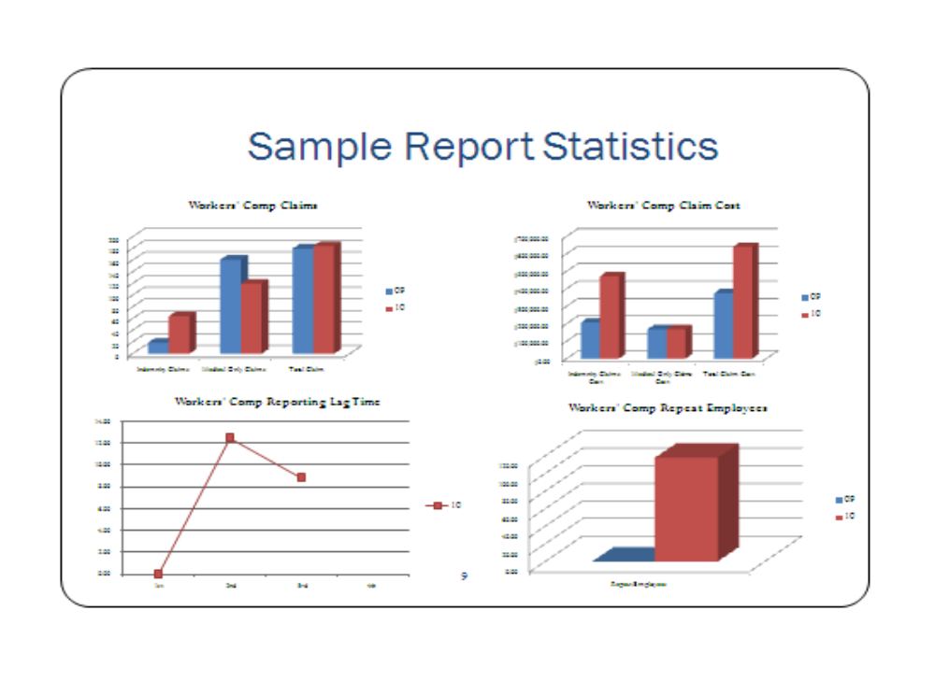
Historically, the Risk Management Division of the Finance Department has collected automobile, general liability and workers’ compensation claims information, however this information was rarely shared with individual departments. Because of the rapidly rising cost of insurance, particularly workers’ compensation, the City tasked departments with better controlling the cost of risk associated with their regular operations. Without timely and accurate information concerning their claims history, departments would be unable to evaluate status or progress in the areas of claims frequency and severity. In order to determine the necessary actions required to control risk, departments needed to have more information on the types of risks and the frequency and severity at which they were occurring. The financial reporting system was designed to help fulfill the need for current and accurate information that departments could utilize in analyzing their current position and to establish a baseline from which to measure improvement.

The Risk Management Division formed a citywide focus group consisting of several members from across City departments. The members provided guidance on the development of content and format for the system. In addition, because all reports are prepared by Risk Management with the assistance of a third-party administrator, the third-party administrator (“TPA”) was invited to participate with this focus group to provide guidance on workers’ compensation issues. The input of the departments that would be utilizing the report, as well as the input of the TPA, was extremely important to the success of the reporting project.

The majority of risk management professionals believe that it is necessary to provide some kind of reporting to management to detail the current risk management program and to propose necessary changes to improve the risk experience. The concept of reporting is important to risk management in the public sector because it provides a model of how information can be shared with those who have the most opportunity to exercise control over the risk events occurring in their areas of responsibility.

The system is unique because it attempts to estimate future liability and show hidden costs. The reports present information in a manner that everyone can understand and follow from Risk Professionals to City Officials and citizens. The reports structure information to provide an overall picture or Executive Summary, as well as a detailed organizational breakdown of all major operating departments. They provide information on future directions, significant activities and include benchmarking of critical indicators for similar organizational entities.

This product could easily be adopted for use by other organizations wanting to improve their internal and external communications concerning risk management issues. Each organization would need to begin by determining what specific information relating to the organization should be included in the system. Next, the organization would need to identify an information source for storage and retrieval of the information needed. To be successful, the risk management reporting system must be tailored to the organization, to senior management’s knowledge and attitudes to the subject area and to the operating department’s specific needs.

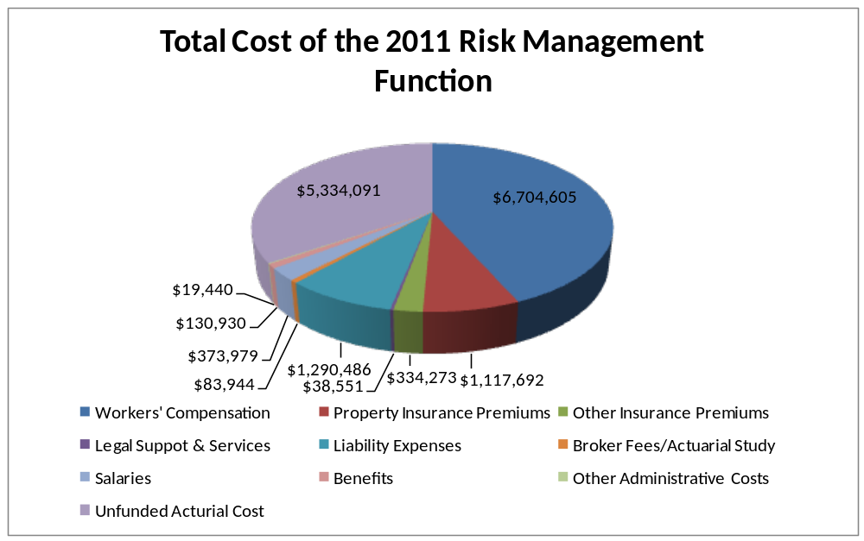
Anticipated and Actual Outcomes

The City’s Risk Management Division anticipated that by sharing information with departments, they would be able to develop a better understanding of the City’s insurance program, both insured and self-insured, including the costs associated with injuries and damages to private and public property. With access to this type of data and with department specific analysis, departments would be able to invest in programs to reduce their injuries and subsequent claims.

The City’s Risk Management Division also anticipated that the system would provide an important communications link for both internal and external stakeholders. The system should be used to document “best practices” for lowering risk based upon the information provided. The information can be shared between departments to address issues concerning any new policies, Administrative Directives or standard operating procedures that resulted from the work currently being done.

The system has been instrumental in stimulating coordination between departments in a team approach to the management of disability and return-to-work programs. In addition, routine reporting of information has resulted in a number initiative by departments to better control their risk exposure. After the second year of reporting, the average lag time for reporting events has been reduced from over 8 days in FY10 to just over 4 days in FY11. Some department director’s performance evaluations have been changed to include consideration of their efforts to improve the actual costs of risks incurred by their respective departments.

Cost and/or Savings

The costs of this effort have been minimal. The focus group met once for approximately two hours. Within the Risk Management Division, approximately 40 hours were dedicated to deciding and establishing the reporting format. The on-going costs consist of the salaries for the time consumed in the production of routine reports. The Risk Management Department already had an information system to capture automobile and general liability claim information. Workers’ compensation claim information was captured and reported through an information system maintained by the third party administrator as part of their annual contract. The return on investment is potentially significant if the information provided assists the operating departments in reducing their risk exposure, if even by a small amount.

The actual preparation and reporting requires approximately 120 hours of time annually. The individuals involved in its preparation are the Risk Management Administrator and the Financial Analyst assigned to the Risk Management Division. The 120 hours are divided equally between these two individuals. The third party administrator provides a series of pre-defined reports used in the preparation as well. No additional costs are incurred from the third party administrator, as the reports provided are part of the routine administrative fees paid.

Innovative Characteristics

The system is unique and is an original piece of work not modeled after the GFOA CAFR. It was developed by a focus group of City employees and devised from best practices obtained from other risk management reporting systems.

This effort is unique because very few public entities actually produce routine risk management financial reports, and for those that do, the information is not geared towards assisting departments in reducing their risk exposure. We began this effort to ensure that department management personnel would become allies in the effort to control the City’s cost of risk.

Summary – 3rd Quarter 2011 compared to 3rd Quarter 2010 | No Activity This Quarter | Decrease | Increase | No Change
Indemnity Claims |  | X
Indemnity Claim Cost |  | X
Medical Only Claims |  |  | X
Medical Only Claims Cost |  | X
Total Claims |  |  | X
Total Claims Cost |  | X
Repeat Employees |  | X
Automobile Liability Claims |  |  | X
Automobile Liability Claims Cost |  |  | X
General Liability Claims |  | X
General Liability Claims Cost |  | X
Reporting Lag Time |  | X

Obstacles and Results Achieved

Because of this effort, several departments have begun an extended effort to understand and control risk expenditures in their areas of responsibility. The Department of Public Works compiled a Risk Analysis report to assess risk exposure. The department has been trending down in claims and cost over the last year, but believes that more could be done to reduce claims and costs. The Department of Public Works used the information provided by the Financial Reporting system to strategize for future risk reduction. The department established specific goals for reduction of claims costs and the number of claims by the end of FY2011. These reductions will be achieved by practicing better safety techniques, by providing recognition to employees for lowering risk claims through a new recognition program, and by becoming more efficient. The Director of Public Works has committed to be held accountable for the reduction strategy in his annual performance evaluation and will like-wise hold his managers to the same standard in their reviews.

The Department of Parks and Recreation requested and receives their open claims on a monthly basis, and reviews and works closely with Risk Management to return injured employees to their original positions. The Police Department has committed to taking a uniformed position and assigning duties of a Safety Officer to further lower claims and the severity. Senior Management reviews Quarterly Reports and challenges departments to their lower Lag Time (single most important factor), lag time to report claims. Studies validate the following: the sooner claims are reported and the quicker medical treatment can begin, the faster employees return to work. The end result is that the medical costs are better controlled. Another indicator of success is that although Virginia Beach is the largest city, it has the lowest percentage of litigation cases in Hampton Roads. The Financial Reporting and presentations to the seven largest departments (comprises 80 +% of Workers’ Compensation claims) has increased the awareness that lowering their Cost of Risk has a direct impact on departmental budgets, and increasing productivity by returning injured employees to full duty. Highlighted to departments is the fact that Workers’ Compensation claims have a very long payment tail. In other words, payments continue long after the employee is off the City’s payroll.

The trending information provided to departments details such risk factors- age, years of service, day of week, time of day, gender, repeat offerors, matches claim to vehicle (to determine maintenance issues), etc.

For FY 13, the results obtained from past reporting will be used to more accurately allocate risk costs to all budget units. The Total Cost of Risk per FTE has been trending down since the implementation of the reporting system.

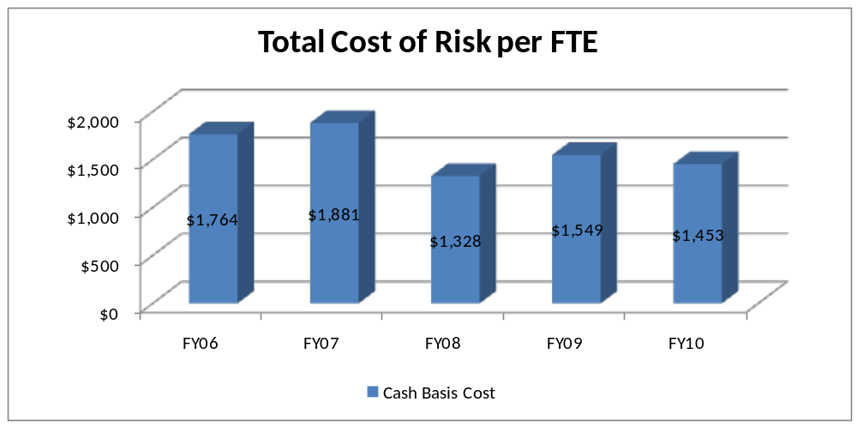

Innovation Study Presentation

We will be using a PowerPoint presentation documenting the reporting system and presenting a video interviewing several department leaders and having them describe how the reporting system changed their understanding and thinking about risk management and lowering their costs of risk. Handout materials will be provided including PowerPoint notes and samples of Quarterly Reports and the Annual Financial Report.

