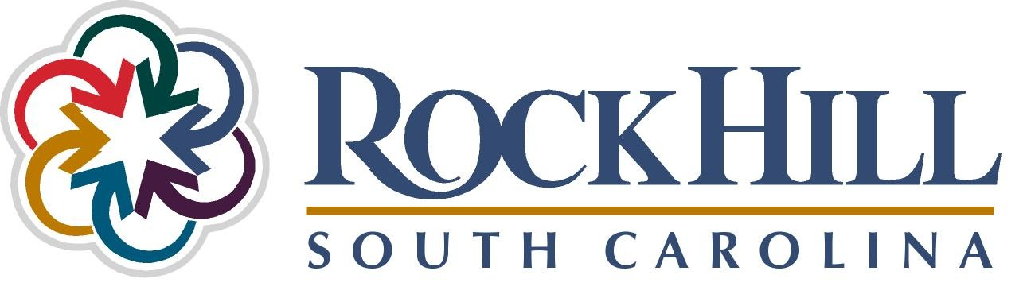

Jurisdiction Name: City of Rock Hill, SC
Population: 66,154
Project Name: Riverwalk Project: A New Era of Development
Case Study Category: Sustainability
Alliance Innovation Award Consideration: Yes
Project Contact: Holly Eskridge, Assistant to the City Manager
PO Box 11706, Rock Hill, SC 29731
803.326.3837
heskridge@cityofrockhill.com

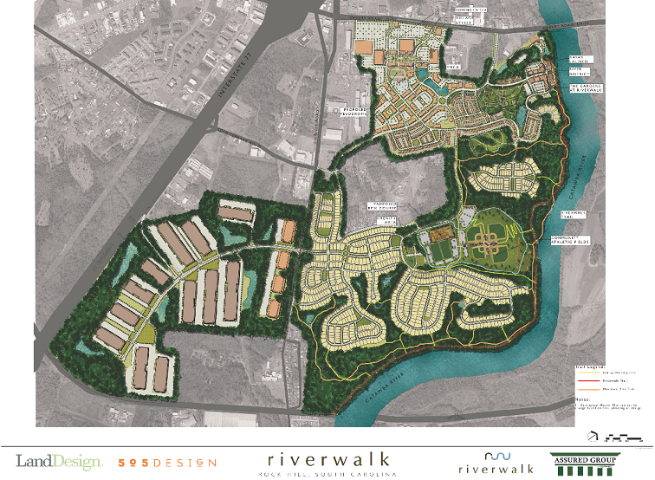
Riverwalk Project: A New Era of Development

Project Overview
Along the banks of the scenic Catawba River, a new era of commerce is in the works. A joint effort between the City of Rock Hill, South Carolina, and a development partner, Greens of Rock Hill, has resulted in the engagement of a unique brownfields redevelopment opportunity. This partnership grew from a vision of a group of entrepreneurs who saw vast potential beyond the estimated $45 million in environmental obstacles associated with this more than 1,000 acre brownfield site that once housed the largest cellulose acetate manufacturing operation in the United States. This public/private partnership created the design of the Riverwalk mixed-use development with a truly innovative funding model that largely alleviated risks to the City of Rock Hill and its taxpayers.

Upon completion, the project is expected to produce $600 million in private investment, over $49 million in public investment, increase property taxes by $4 million annually and generate 4,000 new jobs for Rock Hill. Riverwalk is a development unlike any other in the Charlotte, NC metropolitan region.

Goals and Objectives
The overall goal motivating this project was the sustainable reuse of the largest and most contaminated brownfield site in the City of Rock Hill in a manner that would benefit the community as whole. This would be accomplished through the following:
- Strong public/private partnership between the City and developer.
- The remediation and cleanup of environmental issues on the property.
- Attract high-quality development on a very important site for the Rock Hill area.
- Maximize the advantage of the site’s unique opportunities such as the three miles of Catawba River frontage, large areas of undisturbed woodlands and close proximity to the Interstate-77 corridor.

To achieve this, several steps had to be completed, all with a great deal of time, investment and risk taken by both parties. Listed below are the innovative practices and processes areas undertaken by the partnership between the City of Rock Hill and the developer. Each of these are described in great detail in the “Innovation Study Components: Innovation/Creativity” section of this proposal.
- Brownfield Remediation
- Redevelopment Planning
- Land Development Agreement
  - Financing Agreement
  - Financing Agreement Bond Structure
- Public Amenities Plan

Rock Hill Tax Payer Protection
At the foundation of the City of Rock Hill’s involvement in the Riverwalk project is ensuring all efforts are in the best interest of both the City organization and its taxpayers. While there is still an inherent risk for the City organization engaging in this effort, staff took on all necessary steps to ensure the risk is as minimal as possible. Through the use of creative financing and the land development agreement, a plan was created that without a shadow of a doubt accomplished this.

Taking these steps provided the public financing the developer needed to make this project a success while requiring the developer to provide the City securities that would protect any public investment. Additionally, the establishment of the Riverwalk Municipal Improvement District (MID) is an efficient use of resources since only those who live and work in the district repay any bonds associated with the public investment (See Innovation Study Components: Innovation/Creativity for additional MID explanation). By providing a unique, high-quality development like Riverwalk and its public amenities, it is a resource that all Rock Hill taxpayers are able to enjoy.

Challenges and Obstacles
Several legal, financial and implementation challenges have occurred with the Riverwalk project. Examples include:
- Challenges in the economy significantly limiting the developer’s options for any needed repayment of bond debt service.
- Utilizing the land development agreement process – a new experience for both the City and the developer.
- Working with regulatory agencies such as EPA and SC Department of Health and Environmental Control that have no flexibility to work with laws they work under.
- Ensuring all financing options for public improvements proposed in the land development agreement comply with South Carolina state laws.

Any of these are expected with a project of this magnitude. In fact, in anticipating challenges would occur, the partnership planned time in the project schedule to make adjustments.

Because commitment to the Riverwalk project was established so early on in the visioning of the site, the City and its development partner have successfully tackled challenges that have arisen and never once doubted confidence in each other’s ability to work together on a solution. Having this trusting relationship is vital to tackling barriers to project success.

Applicability to Other Communities
In these difficult times, both the City of Rock Hill and the developer realize that certain risks and creative problem-solving are necessary to accomplish a challenging project like the Riverwalk development. While restrictions for the funding mechanisms and agreements used in this project may vary by state, overall, the model of this brownfields development and the roles of the public/private partnership are transferable to any community in the country.

This success did not take place over night. Any public/private partnership takes time and a significant amount of work and dedication. Establishing trust among partners is paramount. Building a project with this at its core will result in immeasurable, long-term benefits to the community, achieving what we all strive for as public service organizations.

Innovation Study Components: Riverwalk Project

1. Innovation/Creativity
Several creative and unique practices and processes were taken by the partnership of the City of Rock Hill and the developer. The information below highlights four main areas where innovative thinking and risk-taking were essential.

Brownfield Remediation
There were significant problems with the project site because of the cellulose acetate manufacturing operations at the plant once located there. As a result, clean up the site fell under regulations of the U.S. Environmental Protection Agency’s Resource Conservation and Recovery Act (RCRA). The RCRA covers sites that are one step from receiving a Superfund designation. The industrial firm that originally owned the site estimated that its cleanup would cost approximately $45 million, a figure that remained accurate for the developer as well.

In spite of these obstacles, the City’s development partner purchased the property and provided indemnification to the manufacturing firm for all known and unknown environmental liabilities, on and off the site. The development partner also self-insured the site. Through a partnership with the South Carolina Department of Health and Environmental Control, Rock Hill’s development partner was able to complete the investigation and cleanup process efficiently.

Redevelopment Planning
Once the environmental clean up was completed, the developer began intensive negotiations with City officials regarding future development on the site. Since the site was located outside of the City of Rock Hill limits, the process first resulted in identifying the need to annex the property and rezone the land to suit the needs of the developer. The developer was motivated to do this since this would open up the opportunity for a tax increment financing (TIF) arrangement with the City for inclusion in a TIF district located adjacent to the project area.

The developer hosted an intensive, two-day multidisciplinary workshop to begin creating a plan for development of the site, facilitating an open discussion among project stakeholders. A team of design experts met with the City of Rock Hill, York County, representatives of the business community, other developers and members of the education community, gathering information on issues related to the development. The workshop team then offered solutions that resulted in a clear, detailed realistic vision for the future of the site.

The results centered on the need for a mixed-use development that would include residential, commercial and light manufacturing elements. Additionally, the river village concept, distinguished by more than three miles of waterfront, intended to produce a development plan like none other in the region. The ultimate development proposal, called Riverwalk, would create a mixed-use, pedestrian-friendly community that emphasized employment, connectivity, recreation/sports tourism and open space uses.

Land Development Agreement
The City entered into a memorandum of understanding in March 2007 with its development partner to provide a framework under which both parties agreed to a set of goals before a final agreement. It also stated that both the developer and the City of Rock Hill intended to proceed with the development under a public-private partnership to ensure the public financing required for any public infrastructure – including roadway improvements, trails, utilities, storm water and recreational facilities.

Most importantly, the memorandum of understanding also committed the City and developer to enter into a land development agreement under the laws of the State of South Carolina and City of Rock Hill. The City had never previously used this new development tool and the Riverwalk development provided an excellent opportunity to test the viability of this latest addition to the City’s zoning code.

The unique nature of the land development agreement is that it combines zoning and financial commitments into a single agreement between the developer and the City of Rock Hill. In general, the land development agreement parallels a rezoning application for the Riverwalk project and gives the City and developer the maximum latitude for creative and flexible design. The agreement also allowed the partnership to condition development on the provision of specific improvements on the site or other phasing requirements. Lastly, this tool also ensures that the developer only receives certain development concessions or incentives if the quality of the development reaches the City’s expectations. In addition to approving the rezoning of the property, City Council must also approve a financing agreement prior to consideration of the land development agreement.

Financing Agreement
Before terms of a financial agreement were agreed upon, the City utilized a gap financing model to identify to what extent, if any, the developer actually required public financing to make the Riverwalk project a reality. The value of the City’s gap financing model is that it uses a third party to evaluate the developer’s financial ability to complete a project solely with private capital. This includes a review by the third party of the developer’s personal and professional financial statements over the past three years. If the developer is able to profitably develop and finance the entire project with private capital, public participation is not appropriate. The gap analysis determined the Riverwalk project would not be feasible without the City’s involvement.

Once the gap analysis was complete, the City and developer began to negotiate the terms of the financing agreement. Through this process, the City of Rock Hill realizes significant protections, since the City Council has to approve the financing agreement and incorporate it into the land development agreement before the later could be approved.

The financing agreement included strong security and payment guarantees by the developer and its parent company. The main protection the city sought – and the developer agreed to – was a security interest in the Riverwalk site through creating the Riverwalk Municipal Improvement District (MID). The Riverwalk MID describes the improvement area boundaries and the anticipated time schedule, costs and funding resources for public improvements to be constructed in the district. Creating the MID resulted in the security that in the event the developer should fail to fulfill its financial obligations to the City, the City would have the right to foreclose on the Riverwalk site – which has an appraised market value of approximately $40 million – and sell it to repay bond debt.

Financing Agreement Bond Structure
To enhance the marketability of both the land in the development and the bonds used to fund improvements in the development, the City and developer worked with a consulting firm to create three types of bonds for public improvements on the property. The main advantage to this approach is allowing the developer to focus the debt in specific areas of the development and specify which segments of the development would be responsible for repayment. The three types of bonds in the financing agreement are listed below:
- Tax Increment Financing (TIF) and Municipal Improvement (MID) bonds are used to finance public improvements such as roadways, water, sewer, and infrastructure the City would own.
- MID permanent bonds are used to finance public amenities that benefit the entire development, such as neighborhood parks and publically owned recreation and wellness facilities.
- MID paydown bonds are used for actual development of the essential infrastructure and are paid for as lots are sold to future developers and builders.

With each of the three types of bonds, the only property that pays these assessments is the property specified within the Riverwalk MID. All debt within the improvement is paid by those who live and work within the district. No other property owner in the City has any obligation to pay for these improvements. Additionally, if tax revenues are not sufficient to pay debt service on the TIF/MID bonds, the developer also agreed to pay added special assessment to fulfill the debt service obligation.

The land development agreement and all of its associated components were approved by the City Council before the 2009 year end.

Public Amenities Plan
In addition to the land development agreement, the City of Rock Hill and the developer established a public amenities plan. This is an important part of the overall plan, since the vision of Riverwalk is to provide a dynamic riverfront community with a distinctive and active outdoor lifestyle. The plan provides a summary of the proposed public amenities, a plan for how the City will finance certain amenities, and a description of related commitments by the developer.

Furthermore, the public amenities plan dedicates 250 acres, (valued at $8.1 million) for the creation of a major riverfront amenity system, significant sports and nature-based tourism, and new athletic fields and other sport opportunities. Also included are the East Coast’s only Olympic-qualified oval bicycling racing track (known as a velodrome) and a BMX (bicycle motocross) course. The City also agreed to use financing options such as TIF bonds, hospitality tax certificate of participation (supported and backed by hospitality tax revenues), Municipal Improvement District (MID) bonds, Recovery Zone Bonds and New Market Tax Credits. Listed below are the three phases public amenities will be constructed.
- Phase I: Includes the construction of the Riverwalk trail (See pictures in attachment A), pedestrian friendly bike trails, canoe and kayak access areas, and protection for environmental and National Historic Register sites located on the property. (Phase I completed)
- Phase II: Includes the constriction of an Olympic–quality velodrome that is built to standards for international competition (See construction pictures in attachment A) and a BMX supercross course designed to similar standards. (Phase II underway with expected completion by January 2012)
- Future Phases: Construction of community recreation facilities, a closed bicycle road course, playgrounds, public parks and gardens, mountain biking trails and city and regional trail connections. (Phase implementation schedule TBD)

Consulting Services
The consulting firm, MUNICAP, Inc., was utilized by the City of Rock Hill throughout the establishment of the financial agreement for the Riverwalk Project. Their contact information is,

MUNICAP, INC.
525 North Tryon Street,
Suite 1700
Charlotte, NC 28202
Phone: (704) 837-4330
Fax: (443) 539-4120

2. Outcomes Achieved
As stated in the project synopsis, the Riverwalk project was built on the foundation of providing a valuable resource to the Rock Hill community while protecting tax payers from risks associated with public investment in the development. Through the creative financing and securities provided by the developer, this undoubtedly occurred. The City of Rock Hill is known for its athletic and recreation facilities and huge amounts economic impact from sports tourism.

With that said, the Rock Hill community has an expectation that its city government will continue to be a leader in this area. With the cycling venues planned for the site and walking trails, some of which have been completed, the City is well on its way to meeting this expectation. With over 6,000 visitors to the Riverwalk Trail in the past year, remediation of a brownfield site and historic and nature preservation of one of the community’s biggest land and archaeological assets, the health, safety and overall quality of life for Rock Hill citizens has definitely improved.

3. Applicable Results and Real World Practicality
What the City of Rock Hill and its development partner accomplished through the successful implementation of the Riverwalk Project is what all communities should view as the new norm. With resources in the public and private sectors become more limited and increasing scrutinized when expended, creative, fiscally responsible financing mechanisms such as those used in Riverwalk will become a necessity for jurisdictional growth and prosperity. While rules and regulations for utilizing items like land development agreements, municipal improvement districts (MID) and bond financing may differ from state to state, everything demonstrated in the project synopsis and the “Innovation/Creativity” section above have real world practicality to local governments across the country. The City of Rock Hill is better when all cities prosper. In addition to the information presented at the conference, any assistance that can be provided by City staff in making deals like this work in other communities is available and easily accessible.

4. Innovation Study Presentation
The presentation will be lead by two City staff intimately involved in the project and its financing model. The presentation will consist of a combination of PowerPoint, still images and video to capture the true essence of the project’s innovative nature. Handouts along with contact information will be provided to all participants that summarize the various components of the project. It the City of Rock Hill’s goal to provide a presentation and handouts that are user friendly and allow for easy application to similar projects in other jurisdictions.

Attachment A:
Public Amenity Pictures
Riverwalk Trail

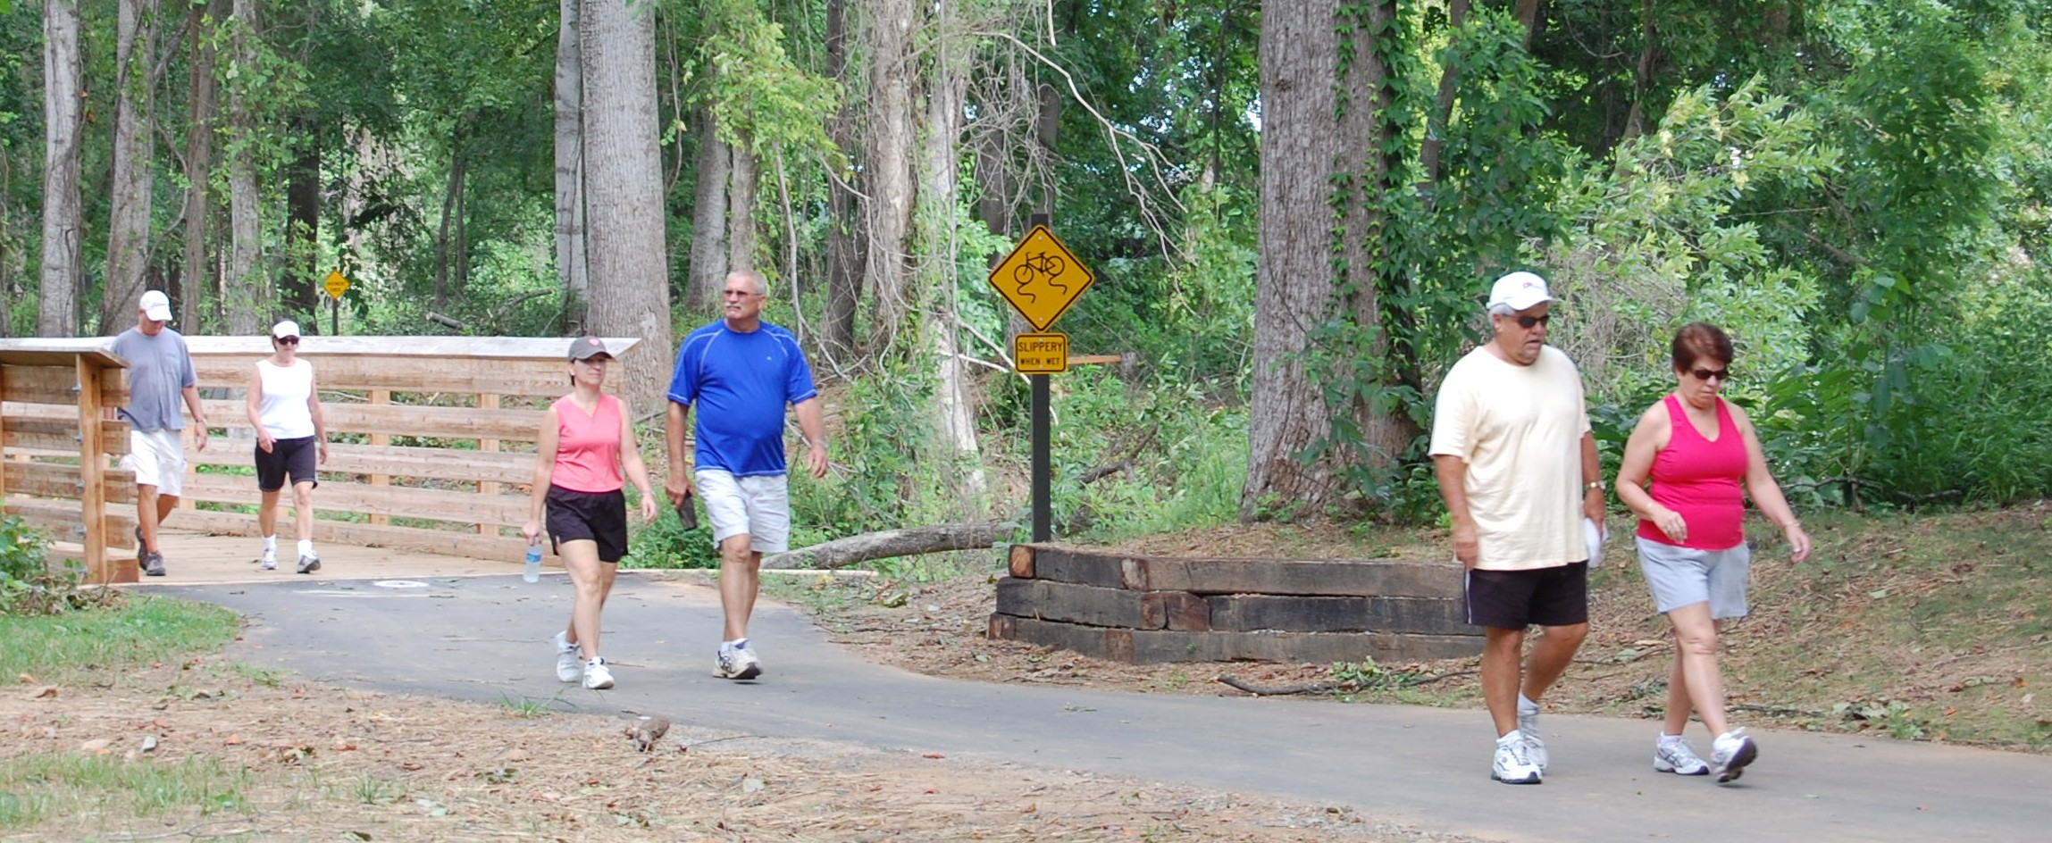

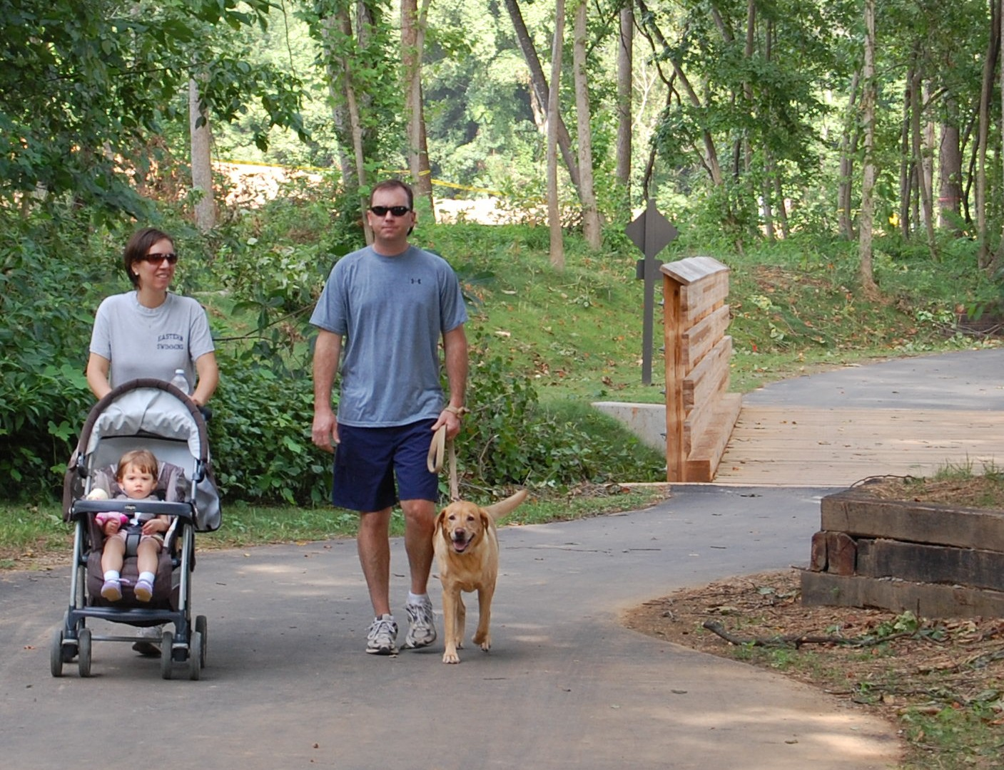

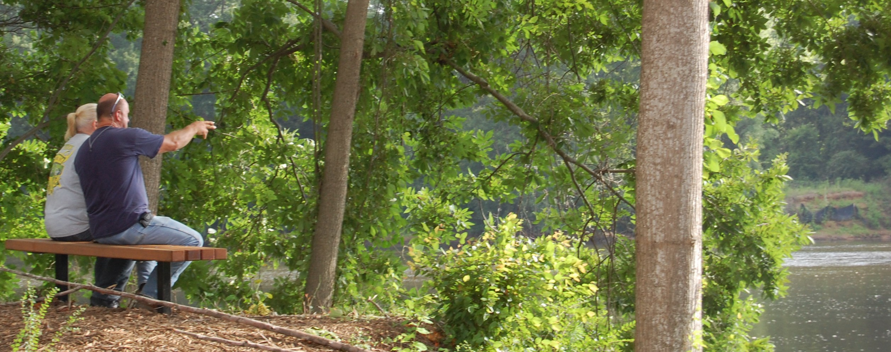

Velodrome Construction (winter 2012 completion date)



