2011 Annual Awards Program

Program Excellence Awards Nomination Form

Deadline for Nominations: March 11, 2011

Complete this form (sections 1 and 2) and submit with your descriptive narrative.

SECTION 1: Information About the Nominated Program
Program Excellence Award Category (select only one):
Community Health and Safety
Community Partnership
Community Sustainability
Strategic Leadership and Governance
Name of program being nominated: | HomeSafe Program
Jurisdiction(s) where program originated: | City of Surrey, British Columbia
Jurisdiction population(s): | 475,000
Please indicate the month and year in which the program you are nominating was fully implemented. (Note: All Program Excellence Award nominations must have been fully implemented by or before January 31, 2010, to be eligible. The start date should not include the initial planning phase.)
Month: | October | Year: | 2008
Name(s) and title(s) of individual(s) who should receive recognition for this award at the ICMA Annual Conference in Milwaukee, Wisconsin, September 2011. (Each individual listed MUST be an ICMA member to be recognized.):
Name: | Murray Dinwoodie
Title: | City Manager | Jurisdiction: | City of Surrey, British Columbia
Name: | Dan Bottrill
Title: | Deputy City Manager | Jurisdiction: | City of Surrey, British Columbia
Name:
Title: |  | Jurisdiction:

SECTION 2: Information About the Nominator/Primary Contact
Name of contact: | Dan Bottrill
Title: | Deputy City Manager | Jurisdiction: | City of Surrey, British Columbia
Street address: | 14245-56 Avenue
City: | Surrey | State/Province: | British Columbia
Zip/Postal Code: | V3X 3A2 | Country: | Canada
Telephone: | 604-591-4122 | Fax: | 604-591-4357
E-mail: | DBottrill@surrey.ca

Submitting a Nomination
Forward the nomination form and descriptive narrative to be received at ICMA by close of business on March 11, 2011. Please email all submissions to: awards@icma.org.

Questions should be addressed to ICMA’s Awards Program at awards@icma.org or 202/962-3656.

Please see narrative below.

Community Health and Safety nomination: HomeSafe Program
City of Surrey, British Columbia

HomeSafe program OVERVIEW
HomeSafe is a proactive evidence-based home visitation program in the City of Surrey, British Columbia that targets residential fires in neighbourhoods with the highest incidence of fire.
Surrey launched the program in October 2008 after commissioning the University of the Fraser Valley (UFV) to examine 20 years of local fire data and to research international best practices related to public education for enhancing fire safety. Through HomeSafe, Surrey firefighters go door-to-door in neighbourhoods revealed by this UFV study to have the highest incidence of fire. They distribute fire prevention information, check for working smoke detectors, install free smoke detectors as required, and offer to return for a free home safety inspection.
In the program’s first 25 months, the areas visited by HomeSafe saw an estimated 49.6% reduction in the number of residential structure fires – 1.86 times greater than the rest of the community, which experienced a 26.6% reduction in the number of fires during that time frame.
When fires did occur in the target areas following the visits, they tended to be smaller and caused less damage than fires prior to HomeSafe. The average fire losses after HomeSafe dropped by almost 50% in the HomeSafe areas, while there were significant gains in smoke alarm activations (a 169% increase) and confinement of fires to the object of origin (a 251% increase) following this intervention.
the Problem that prompted the program’s development
As part of its commitment to evidence-based approaches, Surrey Fire Service commissioned the University of the Fraser Valley in 2008 to analyze fire data to expose trends that had emerged over a 20-year period, from 1988 to 2007. Through analysis of nearly 5,000 structure fires, it was determined that the rate of fire had steadily increased longitudinally during that time period, and that residential properties were involved in more than 75% of these structure fire incidents.
Follow-up analysis identified a range of individual characteristics associated with residential structure fires (e.g. smoking, age, mental health, substance dependence, and disability), and also revealed that residential structure fires tended to be clustered – geographically, as a consequence of dwelling use, and by sources of ignition. There were also geographic variations with respect to the presence of functioning smoke alarms.
The findings prompted Surrey Fire Service to make an ongoing commitment to preventing future residential structure fires.
PROGRAM Implementation and Costs
Implementation of HomeSafe relied heavily on analysis of local fire data, augmented by international fire research that demonstrated the positive impact of fire safety education, smoke alarm giveaways and home safety visit initiatives. Surrey created a custom fire education program that targeted neighbourhoods historically associated with a higher residential fire risk. The aim was to not only reduce the number of fires, but the severity of fires that did occur.
Local fire statistics pointed to hotspot areas across the city that demonstrated higher incidents of fire between 2003 and 2007. Surrey Fire Service then identified addresses that fell within these hotspot areas and distributed the HomeSafe information packages to these dwellings. To date, a total of seven waves of distribution of HomeSafe infomration have taken place, with each of Surrey’s 17 fire halls receiving an equal number of information packages to distribute on each occassion; an average of 2,620 information packages were distributed in each wave.
Going door-to-door, uniformed firefighters spoke to residents about fire safety, provided an information package and offered to install a free smoke detector on the spot (a signed waiver was required). Residents were also invited to contact Surrey Fire Service for a free follow-up home safety inspection. If residents were not at home, the package of information was left for them. The package includes a letter from the Fire Chief and covers a range of topics, including smoke alarms, home fire escape plans, children and fire, senior fire safety and kitchen fire safety.
Costs
Hard costs have been limited to the information package and the smoke alarms left with the occupants. After the initial cost of $4,900 for information materials, the total annual cost has ranged from $2.54-$2.96 per home visited: $8,881 in 2008 (3,000 visits), and $24,295 in 2009 and in 2010 (9,000 visits per year). 12,000 visits are planned for 2011. Sponsorship has funded the cost of the smoke alarms to date, while staff time is absorbed by the organization. Media coverage and free public announcements were utilized to advertize the program.
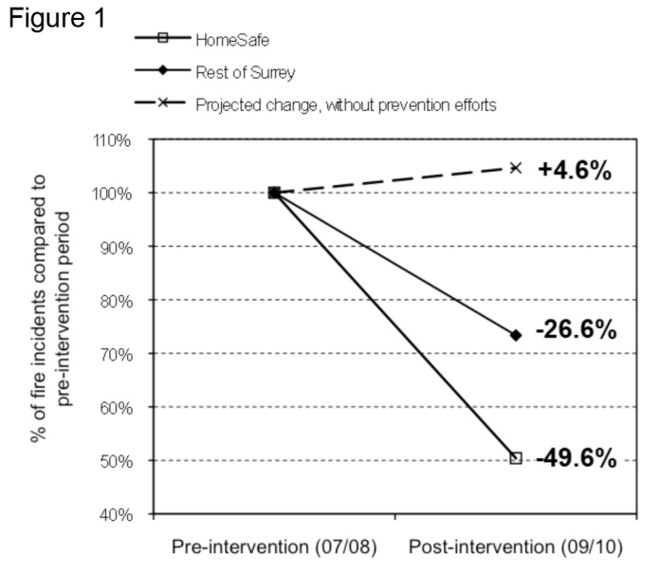
tangible Results or measurable outcomes
Fire data was extracted in November 2010 to analyze the HomeSafe program after its first 25 months. At this point HomeSafe had visited 18,473 addresses, representing about 14% of all homes in Surrey (excluding apartments).
Simply comparing the number of fires pre- and post-program would not have provided accurate results, given that HomeSafe was rolled out over seven separate time intervals. Instead, Surrey used historical fire data to estimate that if HomeSafe had never been initiated, 25.8 fires would have occurred in the dwellings that were visited. In actuality, only 13 fires occurred in those areas – an estimated 49.6% reduction (see Figure 1). While the rest of Surrey experienced 26.6% fewer house fires between 2007 and 2010, the previously high-risk areas targeted by HomeSafe experienced a decrease 1.86 times greater.
Surrey’s data was then compared with provincial fire data for eight other B.C. municipalities, showing a 6.5% decrease in Surrey residential fires from 2007 to 2009, compared to a 14.7% increase in the other municipalities in the same period.
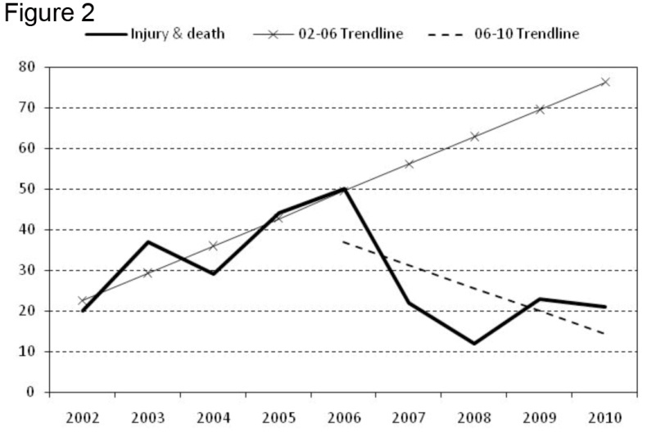
These results align with the decline in injuries and deaths from residential fires in Surrey since 2000. As Figure 2 displays, if the trends up to 2006 had continued, there would have been a continued increase in injuries/deaths (as per the 2002-06 trend line). However, as displayed by the actual data (and 2006-10 trend line), since the inception of prevention programs including HomeSafe, there has been a marked decrease in these events, despite the 24% growth in the city's population since 2000. This translates to a 58% decline in absolute numbers of injuries/deaths since 2006.
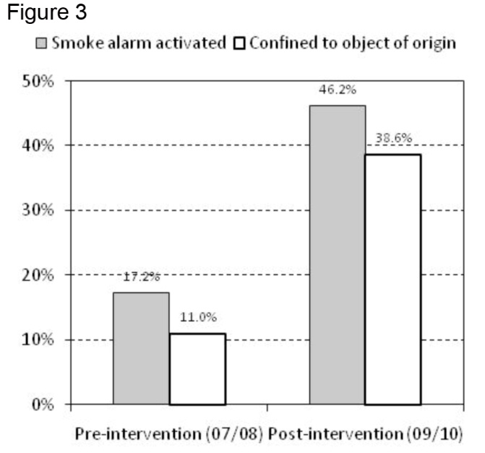
Other positive results found when examining the 13 fires in the HomeSafe-visited areas:
- Smoke alarms were activated in 46.2% of cases, compared to 17.2% pre-intervention – a 169% increase (Fig. 3).
- 38.6% of fires were confined to the object of origin, compared to 11% pre-intervention – a 251% increase (Fig. 3).
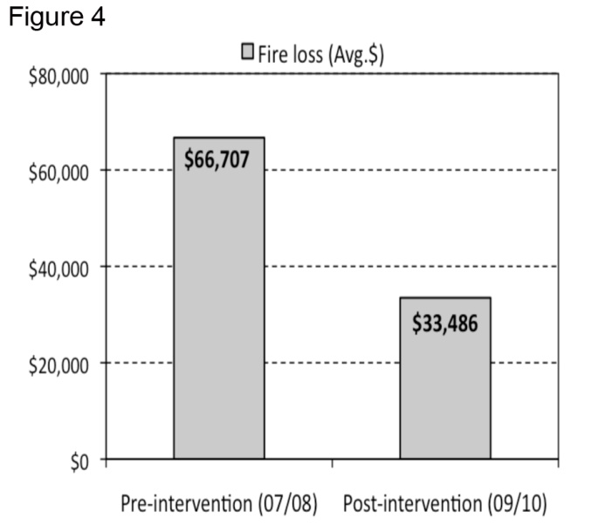
- Average loss of $33,486, compared to $66,707 pre-intervention – a 49.8% decrease, although average property values in the areas grew from $380,000 to $405,000 (Fig. 4).
National Fire Protection Association research has found that fires that spread beyond the room of origin account for more than 75% of deaths. By containing fires to object of origin more frequently, HomeSafe can also be expected to reduce fire-related injury and deaths.
Further, by extrapolating the findings regarding reduced fires and the reduced financial impact of the fires that did occur, Surrey estimates HomeSafe saved almost $1.3 million in its first 25 months ($33,000 × 13 for fires that did occur, and 12.8 × $67,000 for fires that did not occur).
Lessons learned during planning, implementation and analysis
The answers are in the data. Cities must collect and analyze data to ensure they direct their limited resources to the real – versus perceived – priorities in their communities. Analysis of 20 years of fire data helped the City of Surrey pinpoint and address a significant issue: 75% of its fires were in homes, and certain neighbourhoods were more prone to fires than others.
Look afield for solutions. Best practices from around the world can inspire better practices at home. Surrey built its effective HomeSafe program around interventions with proven success abroad – in particular, home visits and smoke alarm giveways.
When resources are limited, focus on the biggest problem. By targeting neighbourhoods with the highest incidence of fire, HomeSafe is significantly improving the overall safety of the city.
Prevention is cost-effective. HomeSafe is estimated to have reduced the financial impact of residential fires by almost $1.3 million in its first 25 months for an outlay of less than $63,000.

