ICMA Consulting Services conducts dozens of such studies annually using operations research approaches. We consistently find that the aggregate data produced by the typical Computer Assisted Dispatching systems (CAD) or the usual Records Management System (RMS) do not provide a clear picture of actual workload (as opposed to calls for service data).
It is critical to fully understand true workload (that is, the total time required to handle the work) as opposed to calls for service (the number of calls) requires a deep dive into the data. Few police or fire departments have the internal capability to do this.
Fire / EMS
In the fire service in particular it is often necessary to analyze calls manually since the aggregate data does not give a clear picture of what is really happening. For example, most systems report “structure fires.” However, in fire classifications a structure fire is a fire “in or near a structure”. Thus a dumpster fire near a building would often be classified as a structure fire even if the building was in no danger. The same might be true for a frying pan stove fire which was extinguished using a lid by the cook. Thus decisions made on the basis of the total number of “structure fires” may not be based upon accurate information.
When making staffing decisions, particularly in the fire service it is critical that deployment not be based upon the “worst case” scenario. It is impossible to staff for the worst case since no matter how bad a scenario can be developed someone else can always think up a “worser” case. Rather staffing should be based upon commonly occurring events workload above that level should be handled by mutual aid, call backs, etc.
This kind of detailed analysis can often determine that existing apparatus does not meet the operational needs of the department. For example we recently studied a large West Coast fire department that routinely staffed two aerial trucks. The department was convinced that it needed this redundancy regularly since they were often dispatched simultaneously to calls. However our analysis found that while regularly dispatched together there was only one instance in 16 years that required the use of both trucks. Thus the city had paid for manning the apparatus 24/7 with five firefighters unnecessarily for years.
Finally remember that most staffing recommendations for fire departments are based upon fire suppression needs while the vast majority of calls are typically medical / EMS. Oftentimes staffing needs for these two disparate types of calls are in conflict.
Police
Police agencies routinely speak about “recommended officers per 1,000 population” or a “National Standard” for staffing, or comparisons to other municipalities.
There are no such standards. Nor are there “recommended numbers of “officer per thousand”. Nor is it useful to make comparisons with other communities.
The International Association of Chiefs of Police (IACP) states; “Ready-made, universally applicable patrol staffing standards do not exist. Ratios, such as officers-per-thousand population, are totally inappropriate as a basis for staffing decisions.”
Joseph Brann, the first Director of the COPS Office and retired chief of police in Haywood, California wrote in “Officer’s per Thousand and other Urban Myths” appearing in ICMA’s PM Magazine,
“A key resource is discretionary patrol time, or the time available for officers to make self-initiated stops, advise a victim in how to prevent the next crime, or call property owners, neighbors, or local agencies to report problems or request assistance. Understanding discretionary time, and how it is used, is vital. Yet most departments do not compile such data effectively. To be sure, this is not easy to do and, in some departments’ may require improvements in management information systems.”
Staffing decisions, particularly in patrol, must be made based upon actual workload and very few police agencies have the capability of conducting that analysis. Once an analysis of the actual workload is made, then a determination can be made as to the amount of discretionary patrol time should exist, consistent with the community’s ability to fund.
ICMA’s team of doctoral level experts in Operations Research in Public Safety have created in The ICMA Patrol Workload & Deployment Analysis System ©the ability to produce detailed information on workload even in those agencies without sophisticated management information systems. Using the raw data extracted from the police department’s CAD system our team converts calls for service into police services workload and then effectively graphs workload reflecting seasonally, weekday / weekend and time of day variables. Using this information the police department can contrast actual workload with deployment and identify the amount of discretionary patrol time available (as well as time commitments to other police activities.
Police service workload is different from calls for service in that calls for service is a number reflecting recorded incidents. Workload is a time measurement recording the actual amount of police time required to handle calls for service from inception to completion. Various types of police service calls require differing amounts of time (and thus affect staffing requirements). As such, call volume (number of calls) as a percentage of total number of calls could be significantly different than workload in a specific area as a percentage of total workload. The graph following sample graph demonstrates this difference in units.
Calls for Service vs. Workload
ICMA has found that the most effective way to manage operations, including public safety, is to decisions based upon the interpretation and analysis of data and information.
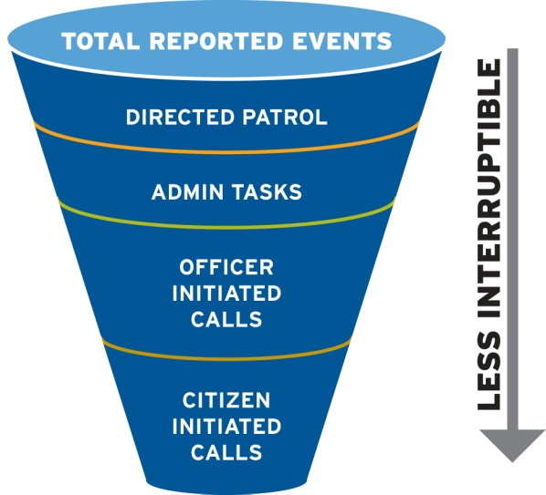
To achieve this, a data analysis of police department workload, staffing and deployment will be conducted. By objectively looking at the availability of deployed hours and comparing those to the hours necessary to conduct operations, staffing expansion and/or reductions can be determined and projected. Additionally the time necessary to conduct proactive police activities (such as directed patrol, community policing and selected traffic enforcement) will be reviewed to provide the city with a meaningful methodology to determine appropriate costing allocation models.
Understanding the difference between the various types of police department events and the staffing implications is critical to determining actual deployment needs.
Data Analysis
This portion of a study should look at the total deployed hours of the police department with a comparison to the time being spent to currently provide services. The analysis should review response times both cumulative as well as average for all services
Workload vs. deployment analysis sample
This is one of the ways that can show the amount of available, non-committed patrol time compared to workload. As you can see we break out the various activities, convert them to time and then compare to available manpower. The deployment is based upon actual hours worked.
So in this example, at noon there are approximately 17 hours of work (including citizen initiated & officer initiated calls for services, including traffic) and administrative activities (meals, vehicle, reports, etc.). There are approximately 30 man hours of available resources meaning that at that hour, on average, of the 30 officers on duty 16 are busy on activities.
The area shown in green and brown is uncommitted time. This is the area where staffing decisions impact – it becomes a policy issue as to how much uncommitted time a city wants, and is willing to pay for.

