T - (403) 362-3333

F - (403) 501-0090

E - wmortensen@brooks.ca

City of Brooks

201-2st Ave West

Brooks, Alberta

T1R 0Z6

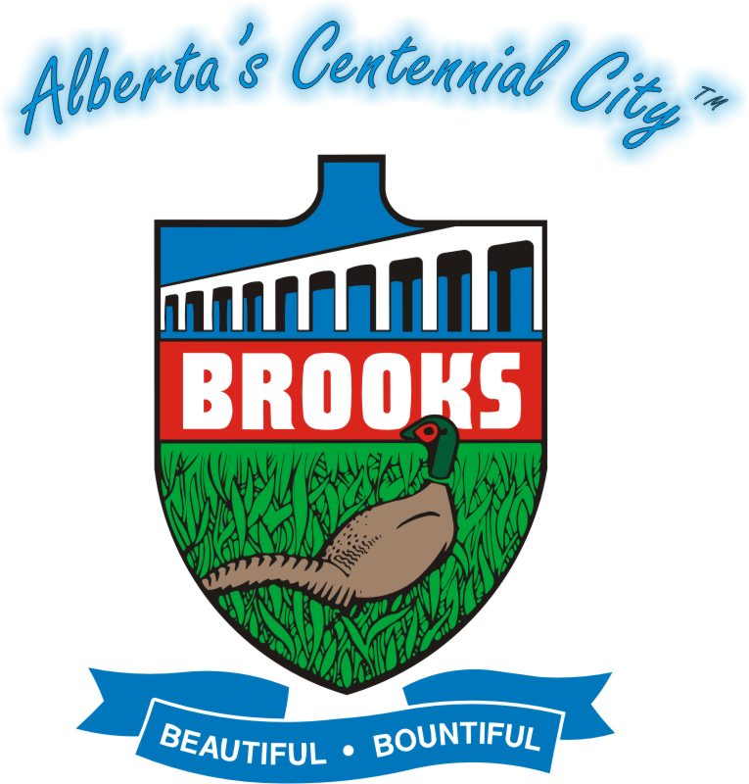

**Joint Municipal Services:**

**Working Together for the Residents of our Region**

Presented by: Wanda Mortensen

Chief Administrative Officer

City of Brooks

Alberta, Canada

**Joint Municipal Services: Working Together for the Residents of our Region**

*Overview*

The City of Brooks and the County of Newell created a Joint Services Committee five years ago which has been tasked with exploring different shared services and regional projects. Today, this revolutionary committee is still going strong, implementing cost sharing agreements, multi-million dollar projects, and sharing employees. Without open communication and a forum for discussion, many of these innovations would never have been implemented and cooperation between the two municipalities would not be as cohesive.

*Our Region*

The City of Brooks is home to 13,581 residents and there are an additional 7,101 in the surrounding County of Newell. Located in South-Eastern Alberta, we are the largest urban centre within 100 kilometres. Our region is economically centred around the oil and gas industry, as well as agriculture. The County of Newell is very rich in natural resources and there are well over 30,000 oil and gas wells within the municipal boundaries; the strong activity in the oil & gas sectors provides a large tax base to the County that makes taxes more affordable for ranch, farm and acreage owners in the County. Within the City boundaries, taxes are levied primarily on residential properties, with some commercial and industrial to supplement. To service our population, the City spends a considerable amount of money on capital projects for recreation, leisure, parks, integrated pathways, utility infrastructure and road maintenance. Operational costs also increase with more funding towards policing, fire protection, recreation programming and social services. The City and County share a familiar relationship found between rural and urban municipalities in North America; the situation that has developed is that the County possesses the wealthy tax base, while the City acts as a service centre with valuable infrastructure. The historical relationship may often create a stage for a battle to develop between the “rich rurals” and the “expensive urbans”. While this may have occurred in the past, the level of cooperation has grown significantly in recent years.

*Our Cooperation*

The City/County Joint Services Committee has been able to move strongly forward and implement a number of partnerships such as:

* Disaster Services - Disasters rarely take municipal boundaries into consideration, so to plan for the worst, the Joint Services Committee pools resources and ideas.
* Fire and Rescue Services - The City of Brooks Fire Department provides Fire and Rescue services to the city and the rural area immediately surrounding the city. The two municipalities have an agreement in place for the operation and capital costs of the service.
* Coordination of Infrastructure - A recent initiative to undertake a feasibility study for a truck route bypass and future transportation network. In 2009, with funding assistance from the County of Newell, several City boundary roads and truck routes were upgrade and paved.
* Integrated Statutory Planning - Ensures that each municipality’s statutory planning framework and development takes into consideration adjacent land uses in each municipality. For the first time ever, an inter-municipal development plan was created in 2003 and has since been updated in 2009.
* Shared Services - Several shared service initiatives have started in the following areas:
  + Grant Administration (one shared employee, a Grant Administrator);
  + Corporate Safety (two shared employees, Corporate Safety Officers);
  + Municipal Enforcement (two shared employees, Community Peace Officers); and
  + Fire/Emergency Services) one shared employee, a Regional Fire Services Coordinator).

The City of Brooks and County of Newell have entered into agreements for the provision of the above services which have allowed for the ability to “share” employees. Depending upon the type of service provided, one or more employees are contracted to the neighbouring municipality. Sharing employees has allowed each municipality to gain services that they normally wouldn’t necessarily be able to afford, provide office space for, or recruit for.

* Grant Applications - Whenever possible, if the financing program allows for it and the project fits within either municipality’s operational plans, the City of Brooks and County of Newell apply jointly for funding programs which can often allow for higher yields and better consideration for the application.
* Recreation Services - Recognizing that their residents utilize recreation, leisure and social services within the City of Brooks, the County of Newell has contributed significant funds to support new developments, as well as the operating expenses for these developments. The County of Newell, on behalf of two divisions, provides $65,000 in operational funding towards recreation services. A one-million dollar donation went towards the construction of a community pool and regional arena, and the County has also provided funding for integrated pathways, athletic programming, and cultural events.
* Brooks Regional Airport - One of our newest partnerships is the change of the City of Brooks Airport to a jointly owned Regional Airport. After years of joint use of the City Airport, the County of Newell is now officially a joint owner and contributing partner; the facility was just recently renamed the *Brooks Regional Airport*.

*Other Regional Initiatives:*

In addition to the work of the Joint Services Committee, the City of Brooks has entered into a number of similar partnerships with other neighbouring municipalities - the Villages of Tilley, Duchess, Rosemary and the Town of Bassano. These are smaller urbans located within the County of Newell.

* Planning Services - The City of Brooks supplies planning services to the Villages of Tilley and Rosemary and have for a number of years. These small urbans are able to access planning and development assistance and expertise whereby otherwise they would have to contract consultants from outside the region to complete these types of services for their residents.
* Municipal Enforcement - The City also has entered into an agreement for the provision of municipal enforcement services to the Villages of Tilley, Duchess, Rosemary and the Town of Bassano as well as the Eastern Irrigation District in 2008. This partnership once again allows all involved to have professional Community Peace Officers (CPO’s) enforce the bylaws of each respective jurisdiction. Such service would not otherwise be available.
* Regional Water - One of the largest projects undertaken was the formation of Newell Regional Services Corporation. This is a partnership between the City of Brooks, County of Newell, the Town of Bassano and the Villages of Duchess, Rosemary and Tilley. This is a $45 million project that provides potable water to the residents of these areas; the project included an upgrade to the City of Brooks Water Treatment Plant and the construction of miles of water pipelines to various parts of the County of Newell to deliver clean, potable water to residents in small urban areas throughout the region.
* Grasslands Regional Family and Community Support Services - Grasslands Regional FCSS was established in October 2004 and exists under an inter-municipal agreement between the County of Newell, City of Brooks, Village of Rosemary, Village of Duchess and Village of Tilley. Each municipality submits funding and programming is delivered throughout the region; without shared funds, many of the small urban areas would not be able to access these programs.
* Annual Joint Council Meetings - Annually there are a number of Joint Municipal Council Meetings held between all of the municipal jurisdictions within the County of Newell. Meetings are held throughout the region and provide an opportunity for all elected officials to discuss areas of common interest.
* Inter-municipal Chief Administrative Officers Meeting - In 2009, the Chief Administrative Officers of each municipality began to meet and discuss common issues, whether it be assessment, taxation, financial or other types of services. This shall be branching off so that members of each public works department shall be starting to meet to discuss similar aspects with their municipal colleagues.

*Importance*

These projects are important to our region because we see working together as a necessity for moving forward. Internally, our employees have been given more freedom to explore innovative ideas, and the capacity to implement them. From the community’s standpoint, the municipal services offered are stronger, more efficient, and more creative.

*Benefits*

Throughout that past 5 years, the residents of our region have benefitted immensely. At the same time, both municipalities are able to achieve great things because of the political and economic support from the Joint Services Committee. Neighbouring municipalities, non-governmental groups, service clubs and charitable organizations have also benefitted because of cost-sharing and support for their programs.

*Initiation and Implementation*

In 2005, the Joint Services Committee was formed between Council members of the City of Brooks and the County of Newell. Up until this point, inter-municipal partnerships were undertaken on a voluntary basis and at the time, each Council thought it would be advantageous to come together regularly and discuss opportunities for cooperation. Today, the Joint Services Committee continues to meet regularly and various innovative shared services, funding agreements and projects have been implemented.

*Risks*

When initiated, there were many sceptics who thought that regionalizing services would mean a loss of autonomy and political power; it was also thought that one partner would consistently gain more than the other. There was also a concern from the standpoint of residents that “their” tax dollars would go towards another municipality’s projects. However, after five years, many of these concerns have subsided and the clear benefits of cooperation have been brought to the forefront.

*Environment*

At the time of creation, the political and economic environment in Alberta was very strong and experiencing rapid growth. Provincial and Federal governments always valued inter-municipal partnerships, but there was rarely pressure applied on municipalities. Within the past two to three years, the environment has changed significantly, and at other levels of government, there is strong direction towards increased municipal cooperation, partnerships and regionalization. For the City of Brooks and County of Newell, we have become leaders and a successful model in the Province of Alberta as to what can be achieved through cooperation and shared visions.

*Costs and Saving*

The costs/savings of regionalizing services depend on the project being implemented. In some situations, financial support has been as high as one million dollars, and in other situations, it’s as simple as providing office space for a shared employee. Material and equipment have also been shared, cutting down on replacement and storage costs. There have also been financial gains in the form of additional funding that have been available due to regional applications. For the Regional Water project, the project partners received a grant for $37 million, and just last week, the City of Brooks was fortunate to receive a grant for $200,000 to replace an outdoor community water park.

*Lessons*

Working together and cooperating can yield some pretty amazing results and innovations that you may have never imagined. Those involved have had to embrace a system of “bigger picture” thinking - when considering projects and initiatives, thinking must be done from the perspective of the region as a whole rather than individual municipalities. If considering regionalizing some services, keep your mind open to new possibilities. Starting with small projects is best and will allow partners to ease into the process. Try starting with equipment sharing, or shared employees, and then work towards the huge initiatives.

*Champions*

The champions driving the Joint Services Committee have definitely been our elected officials who have consistently demonstrated forward thinking and innovation. It obviously does not stop there, however, as the logistics, facilitation and implementation must be performed by municipal administration. The Senior Administration in each municipality has shown great leadership and foresight in this initiative and their hard work and dedication drive the developments forward.