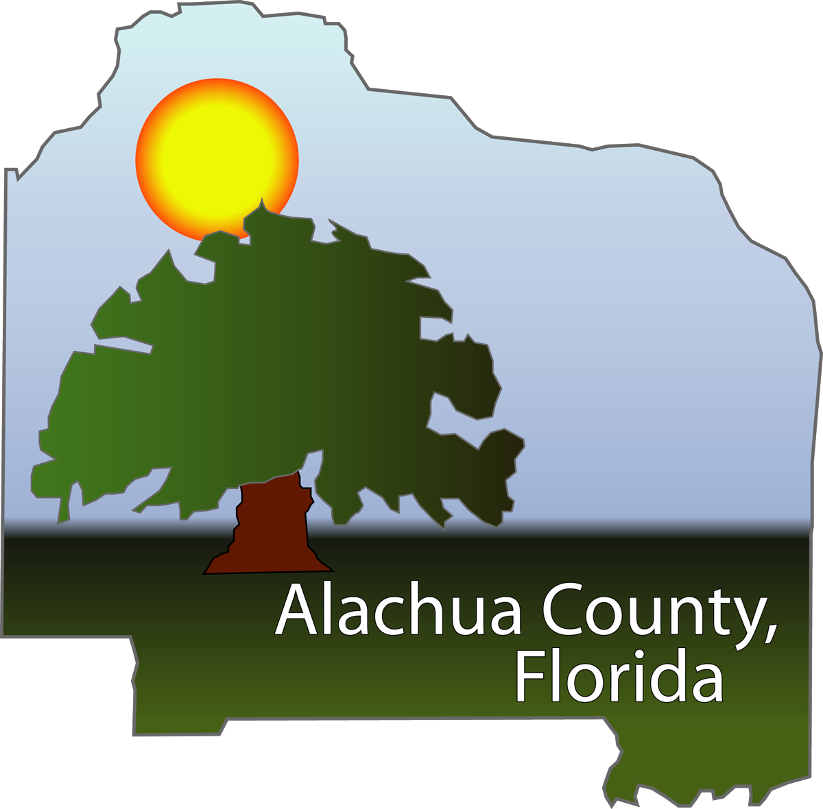

2010 TLG Case Study Application

Title: Community Conversations – A Study in Civic Engagement during the Budgetary Process
Jurisdiction: Alachua County Board of County Commissioners
County Manager: Randall H. Reid

Project Leader: Suzanne Gable, Director, Office of Management and Budget
Phone: 352-337-6205
E-mail : sgable@alachuacounty.us
Mailing Address: 105 SE 1st Ave, Suite 6
Gainesville, FL 32601

Presentation Members: TBD
Synopsis:

Alachua County:
Alachua County was incorporated in 1824 and encompasses 977 square miles with a population of approximately 250,000. The Alachua County Board of County Commissioners has 800+ employees that provide services in such diverse areas as Community Support Services, Fire and Rescue, Public Works, Environmental Protection, Growth Management, and Court Services. Our collegial community, including both the University of Florida and Santa Fe College, blends very nicely with our unique natural surroundings and features, such as, Payne’s Prairie State Park and numerous natural springs, lakes, and preservation areas.

History, Intent, and Anticipated Outcomes of the Program:
Alachua County began to conceptualize the Alternative Futures: Community Conversations program as a means to both include citizen input into the budgetary process, as well as address an unprecedented historic decline in public sector revenues. The whole state of Florida was in economic decline due to:
- The downturn in property values resulting in declining property tax collections,
- Legislative actions such as Save our Homes and Amendment 1 which create revenue limiting caps,
- Reduced travel and increasingly fuel efficient cars resulting in lower gas taxes,
- Increased unemployment and other factors resulting in lower sales taxes.
Furthermore, the state was facing a historic decline in construction and a historic increase in foreclosures. Alachua County, while not hit as hard as some of the coastal counties, was no exception and it too was looking at the probability of having to reduce staff, services, and operations in order to adapt in this new economic climate and produce a balanced budget.

As a result, the Board of County Commissioners (BoCC) encouraged staff to get more citizen involvement in the budget process. A team of employees from the Office of Management and Budget as well as the County Manager’s Office were tasked with developing an informative and interactive program with citizens. After reviewing various resources, attending related webinars, and speaking further with Polk County, FL and the city of Clearwater, FL, the team began to formulate their strategy. Education of the public on the general budget process, current and future estimates of revenues and expenditures, and the complexity of the board activities when evaluating and approving the budget were all part of the framework. When brainstorming ideas to include in this program, the team established that one of the main objectives was to challenge citizens to focus not only on saving their ‘pet program’ but to be cognizant of all services because to save one means to cut another. Another objective was to reduce the ‘NIMBY’ism (Not In My Back Yard) mentality of citizens who believe cuts should be made but not in their backyard; because, a cut in service in any area of the county will likely have a ripple effect throughout the county. Due to the success of the County Manager’s Alternative Futures Program of garnering additional involvement from the citizenry, the Community Conversations aspect of the program would be a creative extension to further involvement by citizens in the budget process.

Alachua County’s Alternative Futures: Community Conversations was developed and implemented with several goals in mind. In addition to those already mentioned, the County was working toward greater civic education and awareness about budget funding sources and services, the impact of voter approved tax revenue caps such as Amendment I and Save Our Homes legislation, and enterprise funding among others. The Community Conversations programs was a way to involve the community in the budgeting process by showing them how it works and providing an outlet for them to voice their opinions on program prioritization, considering tight budgetary times. The program also ensures that the County is providing its citizens an opportunity to get involved in local government in ways other than appearing at a formal board meeting or sending e-mails to the County Manager or Commissioners. The greater the amount of interactive avenues for community discussion will increase operational transparency by allowing the County and citizens to discuss and share ideas concerning the current economic climate and its anticipated impact on the upcoming fiscal years.

The Alternative Futures: Community Conversations budget simulation activity served as a way to involve and educate participants by demonstrating to them what the Commissioners face when making cuts or increasing services in a budget cycle. The County originally intended to run a pilot program involving our advisory board committee members and ACCESS class graduates and improve the program based upon their comments. Two initial pilot Community Conversation sessions were planned and if they were successful, then more would be held and advertised publicly. Additionally a Community Conversations session would be conducted with all the supervisory and managerial staff to make sure they were aware of and understood the program offered to our citizens. Before the County’s annual budget preparation began, the results of the pilot and public meetings would be reported back to the Commission including citizen opinions, prioritization of core services, and recommendations regarding service cuts.

The Program:
Innovative characteristics:
When carrying out Alternative Futures: Community Conversations the County sought to be as innovative as possible, from a citizen input, involvement, and economical standpoint.

During the Alternative Futures: Community Conversations events, citizens had the opportunity to hear highlights from a Commissioner, the County Manager, who incorporated Peter Block techniques into his presentation, and the County Budget Director, who gave a slideshow presentation explaining the county budgeting process, revenue forecasts, and answered any questions or concerns that citizens offered.

Once the brief presentations were completed, the citizens were asked to participate in the budget simulation that was tailored by County staff to be realistic to the process that the Commissioners face annually. The attendees were split up by random selection into groups of five people to be reflective of a diverse group of interests, similar to that of the Commissioners. They were each given mark-up sheets and play money that represented a smaller scale county budget that needed to be cut. By the end of the short time given, each group would have to come to a majority vote approval of their recommended budget. To help facilitate the process, the budget line-items were divided into their respected core services in the County, such as Managed Growth & Development, Economic Development, Health & Human Services, Environmental Stewardship, and Public Safety. To represent the public comments section of each board meeting, volunteer staff members dressed up in character to represent various interest groups petitioning to save certain line items. Characters included a construction worker/architect, homeless person, an animal rights activist, a soccer player, and a pregnant person in need of social services. Citizens were also thrown “zingers” to represent real life possibilities, like an unfunded state mandate being passed down to the County and an additional necessary percentage cut to make at the last minute due to an unanticipated revenue shortfall. At the completion of the budget simulation, each group reflected on and reported the results of their budget decisions.

In increasingly tight budget times, the County had to ensure that this effort was a cost effective method of citizen education. By developing and conducting the program totally by in-house staff, we were able to save development and facilitation costs. Furthermore, partnerships with the school board and health department for meeting room space allowed us to facilitate meetings at various locations throughout the county for no more than the charge of after-hours staff time to clean and lock the building. With the school board and health department buildings on major bus routes, we were able to ensure that those citizens without private transportation would still be able to attend. Media outlets – including the local ABC affiliate station, made event promotion possible at no cost to the County. The County also used free technology, such as ‘Crusher e-invitations’ as a way to spread word about the program and have a good reference point for the number of anticipated attendees for each event.

Costs, if any:
- Office supplies used for budget simulation materials, including paper, dry-erase paper for group modifications to budgeting numbers, pencils, markers, copies for distribution, calculators, and cardstock – approximately $300
- Invitation mailers to advisory board and ACCESS members without email addresses or computer access – approximately $20
- After hours staff at each location (6 meetings x $25 per meeting) - $150
- Snacks at each meeting were through community donations - $0
- Crusher e-invitations - $0
Total cost for all events was estimated at $470.00.

Savings, if any: NA

Obstacles, if any:
Although the programs were carried out successfully, there were some obstacles that had to be taken into consideration. For example, before each event, preparations had to be made to accommodate an unknown number of attendees to a publicly advertised County meeting. Attendance itself was variable depending on the meeting location and the date. At the events groups had to be split up to avoid a disproportionate amount of people with similar interests so a table would not be loaded with participants interested in one core service. Additionally, staffers on hand had to be sensitive to time utilization when groups presented, as the participants were so engaged in the process, in order to make certain that the program stayed within time constraints for both participants and meeting location after hours staff.

Actual outcomes:
- Positive community feedback regarding open communication and citizen outreach
- Positive community feedback regarding a greater understanding of the budget process/transparency
- Greater citizen understanding of difficulties in balancing a county budget
- Valuable information provided to management and board members showing citizen’s core service priorities
- Seven (7) successful programs - 1 pilot w/ TLG Alumni, 2 programs for advisory board members and access graduates, 3 public programs and 1 employee program

Attachments:
- Video clip link
- PowerPoint from one of the public sessions
- PowerPoint created after the sessions to highlight the activities
- Tally sheet used in budget scenario
- Instructions used in budget scenario
- Final tally score sheet from the meetings
- Screen shot of e-invite
- Core Services Chart

Innovation/Creativity:
How did the program/project/service, etc. improve the organization?
As a result of the Alternative Futures: Community Conversations programs, Alachua County was able to reach out to the community and help build support in times of financial stress. The County obtained a firmer grasp on the priorities of the citizens while simultaneously educating the citizenry. Also, the supervisor/manager program resulted in providing better understanding across departmental lines and helping to breakdown departmental silos.

Were new technologies used?
- If yes, what methods and/or applications did you implement?
No, but rather the County was creative with existing technologies – such as use of e-invite for attendance promotion and monitoring; use of video to capture event and turn into a short and positive promotional piece. The program was developed in conjunction with Alternative Futures – which used e-mail and traditional mail based comment submission forum for citizens to recommend changes to government.

Was a private consultant used?
- If yes, describe their involvement; and identify the consultant and/or firm, including contact information.
No, however, ideas were developed from City of Clearwater (which presented in an AFI webinar) and Polk County Florida. Polk County did use a private consultant, however, in times of budget cuts, a consultant was too costly, therefore Alachua County relied upon talented internal staff to be innovative in the design, development, implementation of, and reporting on this program.

Citizen Outcomes:
What customer/community needs and expectations were identified and fulfilled?
- With the ever increasing stress related to the economy, it is important for people to feel that they have input into situations that involve their lives. With the Alternative Futures: Community Conversations program, citizens were able to have a strong input into the program outcome and knew that the results were being brought before the Commissioners. They also got to express their desires and concerns regarding programs and budget directly to the County Manager, Management, and Budget Director. Since attendance was voluntary, those that attended had a specific reason for attending. From the comments that we received after each program and in a letter to our local newspaper, we feel that this program fulfilled the needs and expectations of those in attendance.

Did the initiative improve access to your government? Yes
- If yes, how?
The Alternative Futures: Community Conversations programs allowed the County to reach out to citizens who might not feel comfortable in a commission meeting setting. The site of the meetings was strategic to include places in the county seat as well as outlying locations in SW, SE, and NW areas of Alachua County, with six of the seven meeting buildings on bus lines to allow those without personal transportation to attend. Multiple press releases were sent out. At each event a commissioner and County staff, including the County Manger, the Budget Director, the Strategic performance Manager, the Agenda Coordinator, the Advisory Board Coordinator, Budget staff and other various department volunteers were on hand to answer questions from citizens as well as provide copies of the County Line newsletter and information about advisory board openings.

Has the health of the community improved as a result?
- If yes, how?
The Alternative Futures: Community Conversations program increased citizen engagement, education, and participation. There were also reports of increased discussion among citizens involving budget and meeting all the needs of the public within a balanced budget.

Applicable Results & Real World Advice:
What practical applications could you share if selected?
If selected, we would share meeting materials and slideshow presentations and provide advice from those who participated in the Community Conversations program with participants and demonstrate the activity to the group, as the budgeting activity can be tailored to and repeated in other counties or cities.

How applicable is the project/program/service to other local governments?
The program is very applicable to other local governments, especially considering that many counties/cities are facing difficult financial decisions due to the current economy. This program enables an agency to find out where their citizens’ priorities are and what basic services are supported. The Community Conversations program can be used with community groups and even internally within an organization to detail Board budget process and interdepartmental education. It is also simple enough to use at any level of an organization.

What results/outcomes will you be able to share?
We will be able to share a video that shows citizen expectations and comments about the experience as well as the the compiled data from all sessions held in Alachua County.

Please include any performance measures if applicable.
- Conducted 7 meetings within 3 months
- Attendance ranged from 30 to 70 participants
- Compiled score sheet presented to the Board prior to budget discussions

Case Study Presentation:
Briefly describe what your case study presentation might include.
- Two PowerPoint presentations: (included in summary format during case study presentation)
  - Civic Education Events – Gainesville High (Handout)
  - ICMA package - photos that outlines the event nights
- Video of the Civic Education Events (10 minutes – to be played during case study presentation)
- Handout of the compilation report presented to management and commissioners
- A live audience participation/demonstration of the simulated budget activity – abbreviated (20 minutes)
  - This will also allow the audience to look at all the materials used in the actual budget simulation activity packets
- Sample e-invitation (handout)

