This is to certify that
«First_Name» «Last_Name»
Has satisfactorily completed the ICMA University workshop

We’ve Always Done It That Way Is Over: What’s Next?

October 2, 2021

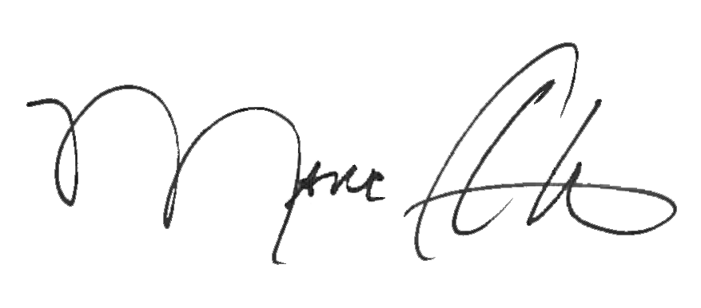

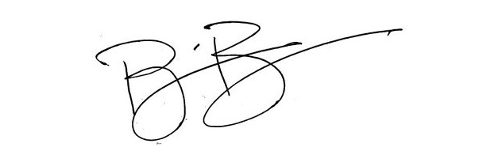
_______________________________ _______________________________
Marc A. Ott Brian Bullock, Director
ICMA Executive Director Worldwide Learning & Professional Development

