This is to certify that
«First_Name» «Last_Name»
Has satisfactorily completed the ICMA University workshop

Winning Federal Grants: Steps to Success

October 2, 2021

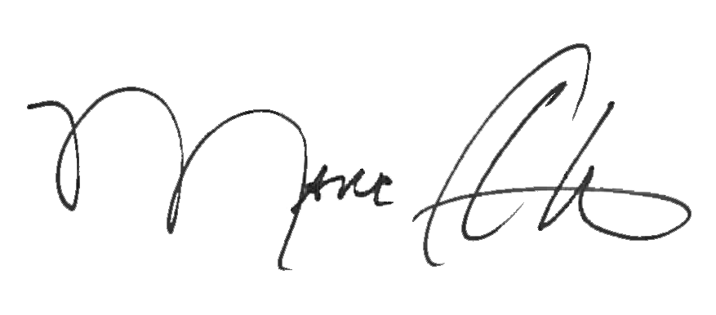

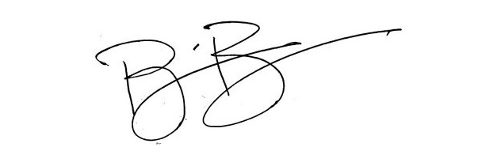
_______________________________ _______________________________
Marc A. Ott Brian Bullock, Director
ICMA Executive Director Worldwide Learning & Professional Development

