This is to certify that
«First_Name» «Last_Name»
Has satisfactorily completed the ICMA University workshop

The Time is Now

October 3, 2021

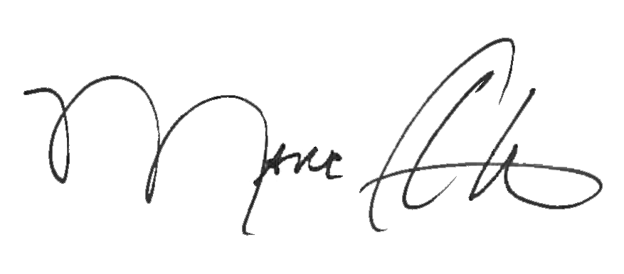

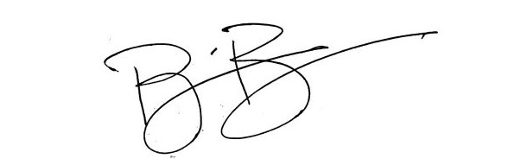
_______________________________ _______________________________
Marc A. Ott Brian Bullock, Director
ICMA Executive Director Worldwide Learning & Professional Development

