This is to certify that
«First_Name» «Last_Name»
Has satisfactorily completed the ICMA University workshop

Social Media And Your Council: How to Stay Ahead of Rogue Councilmembers and Set the Narrative for Your Community

October 3, 2021
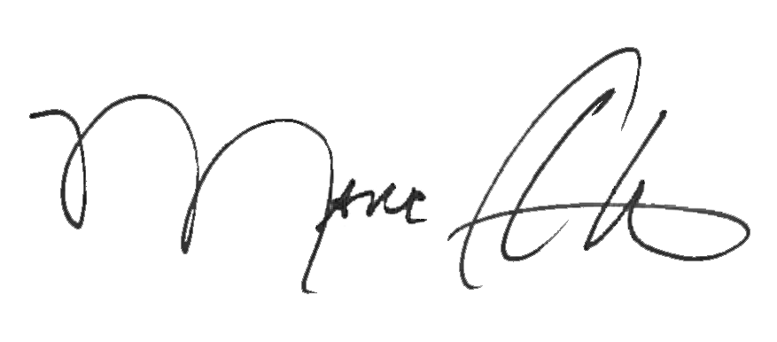

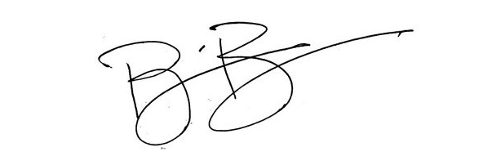
_______________________________ _______________________________
Marc A. Ott Brian Bullock, Director
ICMA Executive Director Worldwide Learning & Professional Development

