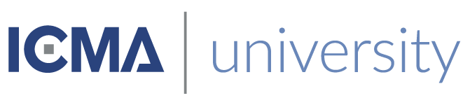

This is to certify that
«First_Name» «Last_Name»
Has satisfactorily completed the ICMA University workshop

Community. Culture. Inclusion. Connection.

October 2021
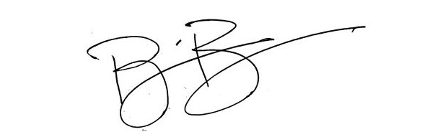
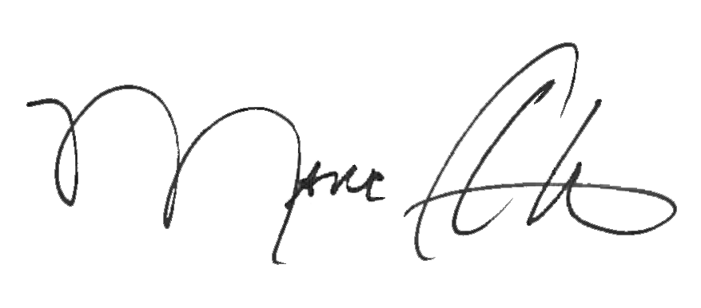

_______________________________ _______________________________
Marc A. Ott Brian Bullock, Director
ICMA Executive Director Worldwide Learning & Professional Development

