This is to certify that
«First_Name» «Last_Name»
Has satisfactorily completed the ICMA University workshop

Art At Work: Finding Joy In Solving Messy Problems

October 2021

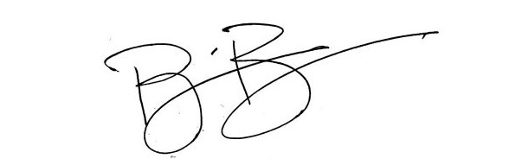
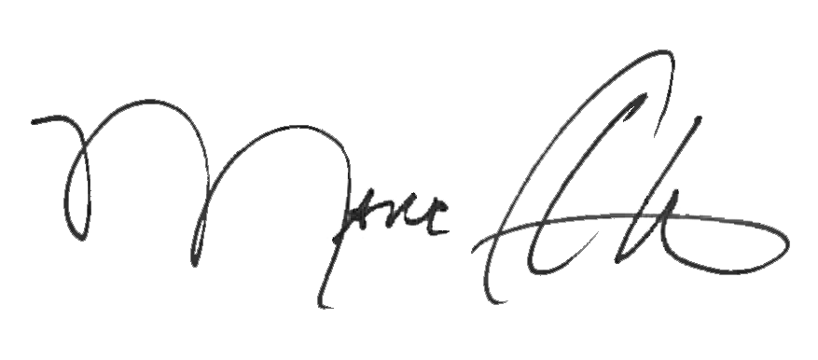

_______________________________ _______________________________
Marc A. Ott Brian Bullock, Director
ICMA Executive Director Worldwide Learning & Professional Development

