CITY OF DELRAY BEACH
INFORMATION TECHNOLOGY DIVISION

ENTERPRISE TECHNOLOGY PLAN

FY 2007-2011

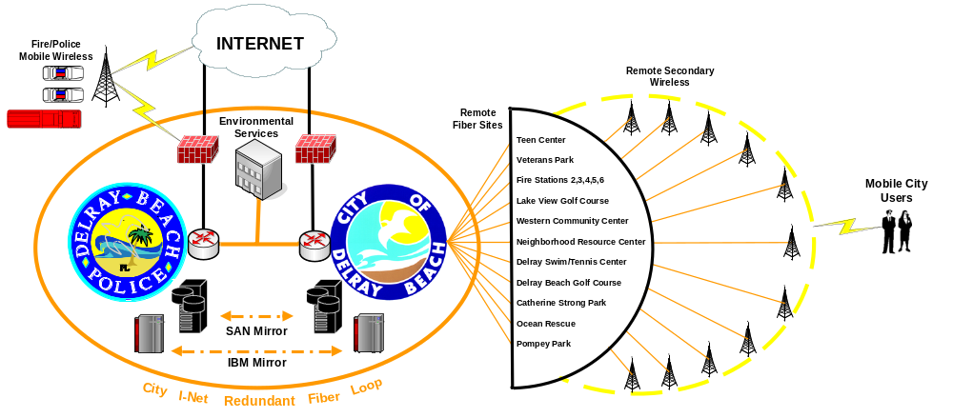

Consisting of:

STRATEGIC PLAN
TACTICAL PLAN
BUSINESS INTERRUPTION/ CONTINUITY PLAN
ANNUAL PROJECT WORK PLAN

PREPARED BY:

Guy Buzzelli, CIO
Ed Del Portillo, Project Manager / LAN

TABLE OF CONTENTS

TRANSMITTAL LETTER i

STRATEGIC PLAN 1

Vision Statement 2

Mission Statement 2

Personnel Core Values 2
Goals and Objectives 3
TACTICAL PLAN 6

Organization 7
Current Organization Chart FY 2005-06 11
Proposed Organization Chart FY 2006-07 12
Facilities and Work Environment 13
Hardware Infrastructure 16
Diagram of City of Delray Beach- Current Logical Network 17
Diagram of City Hall - Current Logical Network 18
Diagram of Police - Current Logical Network 19
Diagram of City of Delray Beach - Future Logical Network 24
Diagram of City Hall - Future Logical Network 25
Diagram of Police - Future Logical Network 26
Communication System 27
Diagram of Internal/External Voice and Data Transmission Mediums 29
Diagram of City of Delray Beach Phone Infrastructure/Current 30
Diagram of City of Delray Beach Phone Infrastructure/Future 31
Software 32
Operating Systems and User Applications Software 32
Website Infrastructure (E-Government Initiatives) 33
GIS Initiatives 35

BUSINESS INTERRUPTION/CONTINUITY PLAN 38

Business Interruption Plan (Short-Term) 39

Business Continuity Plan (Long Term) 41

ANNUAL PROJECT WORK PLAN 42
Annual Project Work Plan 43





November 1, 2006

To the Honorable Mayor and City Commission
City Manager
City Staff and Employees
Citizens and Friends of Delray Beach

Ladies and Gentlemen:

The Information Technology (IT) Division of the Finance Department is proud to present our Enterprise Technology Plan for FY 2007-2011. This plan consists of four individual plans that focus on and compliment our City goals and objectives as set forth by the City Commission and Staff at their annual leadership and goal-setting sessions. These plans are as follows:

Strategic Plan
The plan is a written statement to guide and direct our decision-making process as we continue to balance the demands of our mission, employees, and customers. It is written to help forecast and anticipate the future growth and direction of technology. The plan states how we intend to achieve our stated mission and ultimately our vision.

Tactical Plan
This Plan carries out the tasks defined in the goals and objectives as outlined in the Strategic Plan. The tasks require IT, on an annual basis, to examine the current organization, facilities, hardware infrastructure, communications systems infrastructure, software, website development and business interruption/continuity plans. The tasks further require the preparation of observations and recommendations for the succeeding five-year period. This process is an annual requirement that should be accomplished prior to the end of the calendar year so that the recommendations may be incorporated into the normal operating and capital improvement budget processes.

Business Interruption/Business Continuity Plan
We realize the City provides many services that are vital to the health, safety and welfare of our citizens; therefore, it is essential that our IT systems be built to be fault tolerant with redundancy networks that are capable of continuing to support these services even under the most adverse conditions. Some conditions such as power outages and equipment failures are short-term in duration and will be addressed in the Business Interruption (Short-Term) Plan. Other conditions, including severe storms that could result in destruction of equipment and facilities, could be longer in duration and will be addressed in the Business Continuity (Long-Term) Plan.

Annual Project Work Plan
The IT Division prepares an annual time-phased schedule of all projects each fiscal year broken down into detailed tasks. This schedule allows management to communicate a reasonable schedule of work to the operating departments so that they can anticipate when their individual projects will be finalized. Monthly updates to this plan keep management advised as to the status of the projects.

Executive Summary

Fiscal Year 2005-2006 Accomplishments
- Enterprise Technology Plan was recognized by the International City/County Management Association (ICMA) as a blueprint for other municipalities and was posted on their internal technology website. (International Recognition)
- The 2005 Digital Cities First Place Award was received from the Center for Digital Government and the National League of Cities (NLC) for cities with a population from 30,000 to 75,000. (National Recognition)
- The 2006 Technology Achievement Award for Leadership in the Management of Information Technology received from the Florida Local Government Information Systems Association (FLGISA). (State Recognition)
- Completed the conversion of all large report printouts from expensive continuous-form greenbar paper to laser-printed reports, thus generating savings to the City in both paper and space costs.
- Upgraded the entire Sunguard HTE application software to Version 3 with no customer downtime registered by departments.
- Replaced the older PC server backup system with a newer, faster and more efficient system, which resulted in saving the City over $60,000 in server licenses.
- Replaced the older Type I and II (CAT 3) cabling with newer CAT 6 cabling in City Hall, Fire Station No. 1 EOC and some remote locations, thus improving transmission speeds from 20 megabits (20 million bytes per second) to 1 gigabit (1 billion bytes per second).
- Replaced 72 PC’s and 7 servers and added an additional 3 servers to our network this fiscal year.
- Fully deployed Parks & Recreation RecTrac software now that the City has fiber optic lines connecting our remote sites to City Hall (Adelphia Franchise I-Net Agreement).
- The IBM iSeries computer and the PC network infrastructure remained in constant operation with no downtime even though the City was hit with multiple hurricanes this year.
- Installed and implemented Interactive Voice Response (IVR) hardware and software upgrade for the Community Improvement Department, allowing customers to schedule or cancel inspections and receive inspection results and the history of their permits by telephone.
- Installed and implemented a website interface in conjunction with the Interactive Voice Response (IVR) hardware and software for the Community Improvement Department allowing customers to view on-line plans, permit activity, inspection scheduling and inspection history.
- Installed and implemented Interactive Voice Response (IVR) hardware and software upgrade for the Utilities Customer Service Division, allowing account inquiry (ability to listen to audible playback of current balance and next billing date, last billing amount and date, and last payment amount and date), credit card payments and Spanish language support.
- Installed and implemented a website interface in conjunction with the Interactive Voice Response (IVR) software for the Utilities Customer Service Division, allowing account inquiry (on-line viewing of account status, billing history, and payment history) and on-line payments by credit card.
- Installed software for Utilities Customer Service Division that allow utility delinquency notices to be sent to customers by phone messages as opposed to mail or notices placed on customer doors.
- The City installed a 5-ton air conditioning system to supplement the existing air conditioning system in the computer room due to repeated episodes of extreme temperature conditions causing server disruptions. This room temperature is consistently at 75 degrees or less on a daily basis.

Major Projects in Process (FY 2005-2006)
- The City has approved a new IT building and this facility is presently in the design stage. The architect, David Miller and Associates, has solicited the services of Jim Sinopoli, an industry expert in IT technology and IT buildings, to assist in the engineering of the facility.
- The IT Division is working with the Finance Department in evaluating and installing new timekeeping and payroll reporting software and hardware.
- Microsoft Office 2003 is being rolled out to each PC client.
- We are in the process of implementing a new and more efficient Help Desk reporting and tracking software system.
- The IT Division is working with the Finance Department to implement a new pension administration software package.
- We are installing additional fiber optic cabling from Fire Station No. 1 to the City Attorney’s office to complete an underground public safety loop for redundancy. This public safety loop will allow us to keep the main facilities running by automatically rerouting communications if either of the fiber optic lines is severed.
- At the request of the City Commission, we have issued an Invitation to Negotiate (ITN) for firms to present their recommendations regarding wi-fi services in the downtown area (I-95 to the beach). The Wi-Fi Committee has reviewed these proposals, ranked their choices and are currently checking their references. This project has been in an on-going review for the past several years. The problem has been that no firm has been able to provide reputable references, firms that appear to be capable have gone out of business, firms have recommended hardware that has inadequate transmission speeds and very few cities have completed projects that have been successful.

Major Improvement Recommendations (FY 2007-2011)
Operating Efficiency Projects:
Continue to improve internal communications with departments in the development of the Annual Work Plan to reduce the number of “unscheduled projects”.

Recommend the establishment of a Technology Committee to educate and coordinate all interdepartmental Technological IT involvement projects such as GIS, IP phones and wireless data communications.

In concert with Community Improvement Department and GIS, continue to develop an accurate address dictionary and database to ensure our revenues are being distributed correctly (communications services taxes, premium taxes, utility taxes, franchise fees, utility surcharges).

In concert with City Clerk, continue to work on implementation of the EZ Agenda preparation software with laptop applications to the City Commission.

Network Transmission Projects:
Continue to upgrade the network backbone infrastructure to 10 gigabits to include switches and cabling requirements and the network client infrastructure to 1 gigabit that involves finishing our cable upgrades to CAT 6. These improvements prepare our systems for the future transmission of large GIS files and continuing e-government activity.

Cost Efficiency Projects:
The IT Division will conduct a review of historical repairs and maintenance versus the cost of the maintenance agreements and possibly reduce future costs by establishing a spare parts inventory and not renewing some maintenance contracts.

The Finance Department installation of pension administration software should allow the City to deposit the annual pension contributions earlier thereby saving interest costs and reducing the City contribution requirements.

Recommend an evaluation of the costs of the IBM hot-site backup as a cost-effective and efficient backup equipment solution to the City disaster plan.

Disaster Recovery/System Redundancy Projects:
Develop redundant data storage in City Hall and the Police Headquarters with mirrored SANS (Storage Area Network) units by taking data storage off individual servers and placing the data on redundant SANS units. These systems will also allow complete, on-line “snapshot” backups to improve our daily system backup routine.

Complete the underground, non-public safety fiber optic loop from the new ESD administrative building to City Hall. This non-public safety loop will allow us to keep the main ESD facilities running by automatically rerouting communications if either one of the fiber optic lines in the loop is severed.

Coordinate the outsourcing of printing the monthly utility bills and newsletters since this method would provide redundant backup in multiple locations in case of equipment failure or power failure.

E-Government Initiatives:
Work with the Chamber of Commerce, CRA and Downtown Development Authority in designing a consolidated website front page with a combined activity calendar that can be easily accessed by customers and then they may choose to access any other information they desire.

Upon the completion of the eleven fifty-foot transmission towers currently in construction at various sites throughout the City, we will conduct a pilot wireless project involving field personnel and the connectivity of systems and the ability to receive and transmit reports directly from the field.

Assist the Finance Department in the installation of pension administration software that will allow employees to develop retirement calculations on the website and provide the ability of Finance to automate the data transmission to the Plan actuary for preparation of actuarial calculations and the annual actuarial reports.

Acknowledgements
The IT Division would like to take this opportunity to express our appreciation to the Finance Director, City Manager and the City Commission for their continued input and support of the IT Division staff and the technological improvements contained in this report. This has resulted in significant improvements in the overall state of our computer and network systems.

This report could not have been produced without the valuable input from the entire IT staff, Telecommunications Manager, Police Department personnel, Engineering Department personnel and the City Attorney’s Office. Their input was extremely useful in identifying current problem areas that allowed us to make final recommendations to resolve these problem areas.

Respectfully Submitted,


STRATEGIC PLAN

STRATEGIC PLAN

In order for the Information Technology (IT) Division to keep up with forthcoming challenges, we need to anticipate the future growth and direction of technology. The Strategic Plan is a written statement to guide or direct our decision-making process as we continue to balance the demands of our mission, employees and customers.

The Strategic Plan will help forecast and anticipate the future growth and direction of technology. This plan helps direct our decision-making process as we continue to balance the demands of our mission, our employees and our customers.

VISION STATEMENT
The Vision Statement defines the image of what we want the IT Division to be in the future. Our Vision Statement is:

To become a model information technology center that will provide reliable, cost-effective and efficient support services that consistently meet or exceed the expectations of the user departments in maintaining their internal operations and their delivery of information and services to their customers.

MISSION STATEMENT
The Mission Statement is a statement of purpose. It identifies what we do, how we desire to do it, and for whom, in order to attain our ultimate vision. Our Mission Statement is:

The IT Division will consistently strive to provide up-to-date, reliable, efficient and professional information technology equipment and services to enable departments to operate at their optimum efficiency and to promote both internal and external customer satisfaction.

PERSONNEL CORE VALUES
The Personnel Core Values are the desired personnel values of individual team members that directly impact our overall program activities and objectives and are a critical part of achieving our mission and vision. These personnel core values are as follows:

Quality Service: Personnel will always provide high quality, customer-focused service that is timely, responsive and in line with professional standards.
Performance Excellence: Individuals and assigned teams are proficient in their priorities and timelines for their project assignments from management.
Technical Proficiency: Personnel are highly dedicated, productive and committed to individual technical proficiency through education, experience and training.
Communication: Personnel and teams will communicate their project performance, identification of problems and challenges, and prepare verbal and written reports on a timely basis to management (internal) and customers (external).
Cooperation: Personnel will work cooperatively with other employees in a team environment.

Strong Individual Character: Personnel shall have personal integrity, reliability, dependability and commitment to follow established policies, procedures, rules and regulations.
Progressive Attitude: Personnel should adapt quickly to change, keep abreast of new technologies and seek out innovative approaches and techniques to improve individual performance, systems and customer efficiencies and resolve problems.
Independence: Personnel will be objective in their relationship with customers and show no prejudice or preference to any individual in their project selection process or in the assignment of service priorities.
Customer Satisfaction: Personnel will attempt to exceed customer expectations in their project assignments.

GOALS AND OBJECTIVES
The IT Division has established several goals and objectives. A goal is results-oriented and represents a desired outcome. The objectives represent the tasks that are necessary to achieve these goals. These goals and objectives are as follows:

Goal: To maintain an organization with a salary and benefit structure that promotes the highest level of competent technical expertise, provides at least one level of backup to every critical task and provides adequate resources to effectively complete service requests and other project assignments within acceptable time limits for our customers.
Objectives
- Prepare a current organization chart of the IT Division.
- Review individual positions, years of service to retirement, salaries and benefits, technical training needs, individual employee performance, personnel inequities, restrictions, bottlenecks and other support needs or issues.
- Prepare recommendations based on observations.
- Prepare a proposed organization chart of the IT Division.

Goal: To maintain adequate facilities and work environment to preserve, protect and accommodate IT equipment, provide appropriate personnel work space to facilitate the efficient production of customer service, offer a high level of employee job satisfaction and promote employee pride in their work environment to minimize costly employee turnover and maintain high morale within the division.
Objectives
- Review present facilities, support systems, workspace environment, work requirements, employee technical equipment and turnover statistics.
- Prepare proposed improvements and/or recommendations from observations.

Goal: To maintain a cost-effective hardware infrastructure with a reliable midrange computer and PC network providing the highest level of technical performance, security, effectiveness of operations, redundancy and sufficient capacity to provide for a realistic increase in growth and utilization over an extended period.
Objectives
- Prepare charts of the current infrastructure system design.
- Evaluate the entire hardware infrastructure and identify problems or inefficiencies within the current system. These could include areas such as system security, redundancy, transmission bottlenecks, outdated technology and other shortcomings, as well as the ability to handle future projected needs.
- Prepare recommendations from observations.
- Prepare charts of proposed future infrastructure system design.

Goal: To maintain an effective and secure communication system infrastructure that is efficient, includes reliable voice, video and data transmission, and ensures adequate redundancy for emergency services.
Objectives
- The IT management team, in conjunction with the Telecommunications Manager, will prepare a chart of the current telecommunications infrastructure that diagrams all internal and external voice, video and data transmission devices and mediums.
- The IT management team, in conjunction with the Telecommunications Manager, will evaluate the communication system infrastructure and identify problems or inefficiencies within the current system.
- Prepare recommendations from observations.
- Prepare chart of proposed infrastructure system design.

Goal: To maintain the operating system software and user applications software at the latest version and release level to provide the most reliable overall user technical performance, consistency, operational efficiency and customer satisfaction and to ensure that all user licenses are up to date. To evaluate all proposed changes to upgrade our software inventory for the upcoming year.
Objectives
- IT staff will update the inventory list of all operating systems and user applications software, noting the current version and release level available, and verify appropriate licensing compliance requirements.
- The IT management team will evaluate the final inventory listing of all operating and user systems software.
- Prepare recommendations from observations.

Goal: To assist in the development of a GIS (Geographic Information System) Plan to bring together data and geographic components that serve both internal and external customer needs for location-based data and the delivery of an added benefit to current applications.
Objectives
- The IT management team, in conjunction with the Engineering Department, will evaluate and identify restrictions, bottlenecks and inefficiencies of the GIS system.
- Prepare recommendations based on observations.

Goal: To maintain an up-to-date Business Interruption Plan (short-term disruption and recovery) and a Business Continuity Plan (long-term disruption and recovery) to ensure that the IT facilities, hardware, infrastructure, software systems and data files are physically protected, insured and can be recovered or restored in a timely manner to the satisfaction of all customers and users of the system.
Objectives
- The IT management team will evaluate possible short-term disruptions and develop a plan for prevention and IT responses to ensure recovery within acceptable timeframes.
- The IT management team will evaluate possible severe long-term disruptions and develop a plan for prevention and IT priority responses to ensure recovery within acceptable timeframes.
- Prepare recommendations from observations.

Goal: To develop and maintain an Annual IT Project Work Plan to efficiently schedule existing resources to projects. This schedule will keep management informed of IT projects, new hardware and software installation and workstation as well as system replacements.
Objectives
- The IT management team will prepare an IT Project Work Plan at the beginning of each fiscal year.
- IT will communicate this schedule to City departments.
- IT will maintain current updates to the plan on a monthly basis.

TACTICAL PLAN
TACTICAL PLAN

The Tactical Plan carries out the tasks defined in the goals and objectives as outlined in the Strategic Plan. The tasks require IT, on an annual basis, to examine the current organization, facilities, hardware infrastructure, communications systems infrastructure, software, website development and business interruption/continuity plans. The tasks further require the preparation of observations and recommendations for the succeeding five-year period. This process is an annual requirement that should be accomplished prior to the end of the calendar year so that the recommendations may be incorporated into the normal operating and capital improvement budget processes.
Organization
Goal: To maintain an organization salary and benefit structure that promotes the highest level of competent technical expertise, provides at least one level of backup to every critical task and provides adequate resources to effectively complete service requests and other project assignments within acceptable time limits for our customers.
Objectives
- Prepare a current organization chart of the IT Division (Schedule I).
- Review individual employee positions, salaries and benefits, individual employee, performance technical training needs, personnel inequities, restrictions, bottlenecks, and other support needs or issues.
- Prepare observations and recommendations.
- Prepare a proposed organization chart of the IT Division (Schedule II).

Observations and Recommendations
This past fiscal year, the MIS Division (Management Information Systems Division) name changed to the IT Division (Information Technology Division) and the MIS Manager Position title changed to the CIO (Chief Information Officer) to reflect current technology terminology.

- Chief Information Officer (CIO)
The Chief Information Officer (CIO) position is a responsible management position accountable for directing the information and data integrity of the enterprise and for all information services functions. This position provides overall management and definition of all information processing, communication systems and data processing operations. This position is responsible for the entire division including preparation and maintenance of the Division operating budget, the five-year Enterprise Technology Plan and the Annual Work Plan.

The CIO has developed a good relationship with Boca Raton and Boynton Beach counterparts as well as other regional, state and federal managers who attend the CIO (Chief Information Officer) conferences. This is essential for the discussion of common problems. The information they disseminate, especially in the areas of emerging technologies, homeland security initiatives, as well as the grant funds administered at the State and Federal levels, are vital to the current and the future development of the IT organization. CIO meets with the cities of Boca Raton and Boynton Beach to discuss emergency operations centers and the sharing of information from the County by utilizing our fiber optic connection to the County.

- Project Manager/LAN (Local Area Network)
The position of Project Manager/LAN requires both managerial and high technical skills. This position has supervisory responsibility over those employees that oversee the network infrastructure to include the PC network servers, customer PC’s and laptops, switches, cabling, routers, wireless towers and peripherals. This position oversees all network project assignments. The Project Manager/LAN also works closely with the CIO in current project issues, employee training and development, budgeting, purchasing and the development of short-term and long-range plans for the division. This position backs up the CIO position in his absence.

- Network Engineers (3)
The Network Engineers are in charge of network infrastructure and system security. Network infrastructure includes servers, switches, routers and cabling, wireless towers and connectivity issues between major platforms (LAN and iSeries) and with peripheral equipment.

In previous years, two Network Engineers backed up each other and the third Network Engineer backed up the Senior Office Automation Analyst and the function of PC/Server tape backups. Now with the new position of the Office Automation Analyst, the third Network Engineer will backup our Application Support Specialist. This Network Engineer will need additional training with the Application Support Specialist to fully understand and undertake the total responsibility to assist and backup this position.

One of the Network Engineers is also responsible for the duties of a security officer as well as doing the day-to-day network functions. This duty entails the constant monitoring of the firewalls for City Hall and Police in order to protect them from external intrusions and this position updates all the security patches on our hardware and software. The daily security responsibilities are becoming more intensive and difficult because specific skill sets are necessary to keep up with the demand of constant security threats and intrusions. This responsibility may soon demand the attention of a full-time Security Officer due to the daily load requirements but this is not recommended at this time.

- Application Support Specialist
This position is a high-level support position that is responsible for support of client/server and standalone line of business software applications. This position also assists with the administration of the City’s website by maintaining the server components, supporting the website content providers in maintaining website content and monitoring the performance and quality of the website.

- Senior Office Automation Analyst
This is an intermediate level technician position responsible for all aspects of support for office automation. The position is responsible for desktop management, advanced technical tasks to include the implementation and interconnection of microcomputers, the local area network and hardware and software that allows various levels of customer access to applications, files and decision support systems.

This employee is primarily responsible for field installations. This employee is a backup to the iSeries operations and for the utility bill processing operation (printing, folding, inserting and preparation for mailing). This position also backs up the Help Desk Administrator who has been covering the Operations Support Specialist position. The hiring of the new Office Automation Analyst this year alleviated these issues.

- Senior Programmer/Analyst (2)
One Senior Programmer/Analyst is a specialist in programming the iSeries utilizing Sunguard HTE application software.

The second Senior Programmer/Analyst also is a specialist in programming Sunguard HTE application software on the IBM iSeries and programs and maintains the City website. This employee will have 30 years of service and therefore be eligible for retirement within the next seven years. Management analysis of the backup to the website programming shows that we have a definite weakness in this area. At this time, if something happens to this employee, we would probably need to outsource the website programming until we could train or hire a suitable person for this position. Management realizes that it would be more desirable to train the other Senior Programmer/Analyst, but with the current workload shared between these two positions, it would be difficult to find the extra time to do so. This Senior Programmer/Analyst already works over forty hours a week to keep up with his workload.

In addition, over the last several years, the actual programming hours have exceeded what was scheduled on the IT Annual Project Work Plan. This is due in part to unscheduled projects (urgent spur of the moment projects), operating system administrative and maintenance tasks. Due to these additional tasks and our scheduled programming workload, we have no choice but to move some scheduled projects into the next fiscal year. As these conditions continue, we will need to provide additional staffing in this area.

- Operations Support Specialist
The employee in this position was terminated for disciplinary reasons. The primary responsibility of this position was the printing, folding and inserting of the utility bills and any related correspondence, backing up the Help Desk Administrator, running daily computer backups and other operations of the IBM iSeries system.

Following the employee termination, management reviewed the responsibilities of this position and the Help Desk Administrator position and decided to consolidate these positions. By combining these two job duties, we have produced a more efficient utilization of the Help Desk Administrator’s hours. This change has allowed management to delete the Operations Support Specialist position and provide for an Office Automation Analyst (O/A) position.

- Help Desk Administrator
This position has been combined with the job duties of the Operations Support Specialist. The primary duties for this position are the printing and folding of the utility bills and the daily tape backup of the IBM iSeries. Other responsibilities include the assigning of Help Desk requests to the appropriate IT personnel for resolution.

The Administrative Assistant, Office Automation Analyst and Senior Office Automation Analyst, all backup this position.

The Customer Service Division is outsourcing the utility billing process this fiscal year. The job duties that will be left are the tape backups of the IBM iSeries data and assigning Help Desk tickets to the technical staff. This in itself is not enough work to keep this position busy 40 hours per week. The Help Desk ticket assignments can be taken over by the Administrative Assistant with the Office Automation Analyst and the Senior Office Automation Analyst as backups. The level one technical staff would do the daily tape backup process. In addition, the City Manager’s Office is considering a centralized customer service area allowing this employee to become part of the staff in this new area. In addition, the Finance Director will utilize this employee to fill in a finance position while one of his staff is out due to needed surgery.

- Administrative Assistant
The IT Division recommended that the part-time position (32 hours per week) of Administrative Assistant be full time in the 2006-2007 Budget. The City Manager and commission approved this recommendation. This position is required for the preparation of the Division Budget, Five-Year Enterprise Technology Plan, Annual Work Plan, documents, maintaining office records, purchase requisitions, scheduling of meetings and training conferences, training and travel arrangements, preparation of agenda backup materials, monitoring maintenance agreements and contracts and other clerical duties pertaining to IT and its operations.
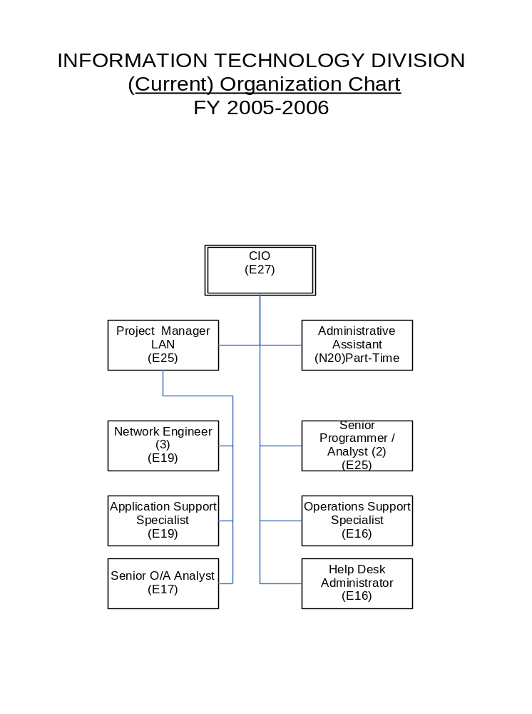

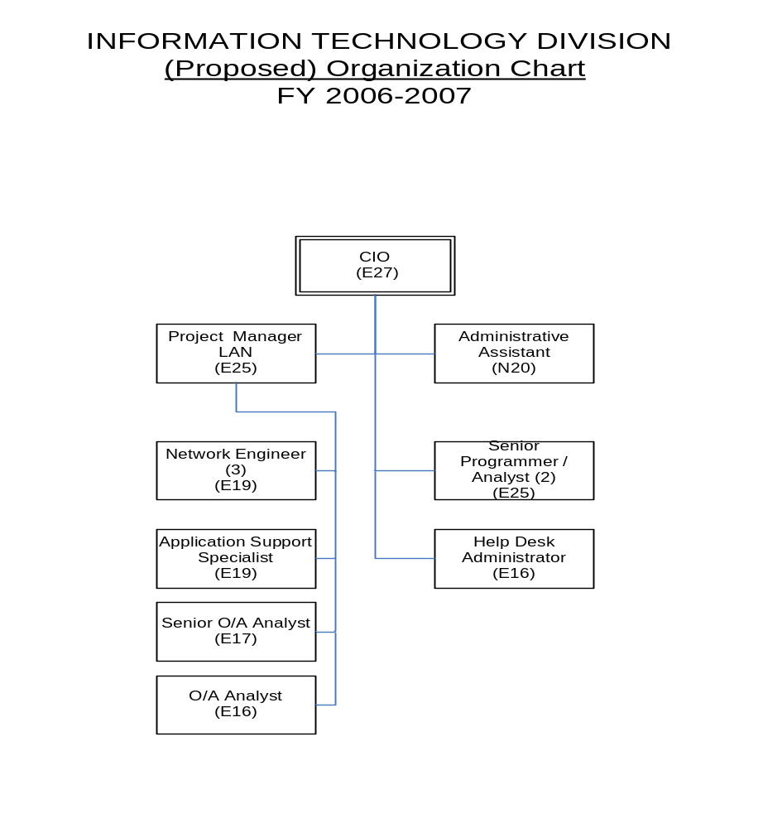
FACILITIES AND WORK ENVIRONMENT

Goal: To maintain adequate facilities and work environment to preserve, protect and accommodate IT equipment, provide appropriate personnel work space to facilitate the efficient production of customer service, offer a high level of employee job satisfaction and promote employee pride in their work environment to minimize costly employee turnover and maintain high morale within the division.
Objectives
- The IT management team will evaluate present facilities, employee space requirements, work environment and technical equipment needs.
- Prepare recommendations from observations.

Observations
- The main City Hall computer room temperature has recently experienced temperatures of 80 degrees to over 90 degrees in the early morning hours. The room had both a chiller air conditioning unit and an assigned separate air conditioning unit. The chiller unit is turned off after normal working hours. This room needs to be kept under 72 degrees. The temperature change during the normal off hours is harmful to the computer servers and switches causing hardware failures.
- The UPS (Uninterrupted Power Supply) has exceeded the capacity to handle the load that is in the City Hall computer room. It is working above what it was originally designed for, it overheats and warning alarms sound off frequently. It has failed in the past in handling very short durations of electrical outage.
- The two large exterior windows in the City Hall computer room are covered with hurricane screening and the interior of these windows are covered with drywall. This does not provide suitable protection from severe storm damage. This room has over $1,000,000 worth of computer equipment that includes the IBM iSeries midrange server and network system servers and serves as the primary backup to emergency Police computer systems. Ideally, this room should be in a separate building with more substantial protection from the elements.
- The main City Hall computer room, according to industry standards, should have an 18-24 inch raised floor for cabling and air conditioning ductwork. The present floor is only six inches high and has no room for air conditioning ducts.
- The main City Hall computer room has a zoned water sprinkler system, which is not the appropriate fire suppression method for electrical equipment. This area is a critical facility and requires a clean agent extinguishing system that would not damage sensitive equipment, tapes and is electrical equipment. The computer room has two small manual CO₂ extinguishers for small electrical fires, but this is primarily for working hours when employees are present. After hours, fires would activate the zoned fire sprinkler system. The current facility cannot support a clean agent system change over without major work involved. The main City Hall computer room walls do not extend to the second floor. The room actually has a dropped ceiling with wall openings to the adjacent offices. A pressurized, fire suppression system cannot be installed in this situation since you need a sealed room.
- The Police dispatch center, computer room and evidence room, all have halon fire suppression systems. Industry standards require training for the employees in these areas in the use and effects of a halon system, which voids a room of all oxygen in order to suppress a fire.
- The City Hall telecommunications closet, located outside of IT, also has a water sprinkler system. The telecommunications closets should be relocated to the new facility that would house the clean agent fire suppression system, if possible.
- The current City fire codes stipulate that halon can no longer be used unless a clean agent system is installed, if one part of a building is sprinkled, then the entire building must be sprinkled.
- If halon or a clean agent system is activated and the fire is not completely extinguished, there is no further fire suppression system to address the continuing fire.
- The City presently insures all facilities and equipment at replacement value with a $75,000 deductible SIR (Self-Insured Retention). Present policies do not address fire prevention and suppression methods required.
- The IT Division has no workroom for unpacking PCs, servers or other equipment. There are times when 10-15 PCs come in at a time. Wires have to run down hallways and across rooms to connect into the main computer room for testing equipment. This creates a work hazard.
- Current carpet in the IT Division is old and may have mold. The current carpet is not appropriate in this area due to static electricity.
- The IT Division has no room for staff meetings, conferences or training. They must use rooms outside of the IT area and these rooms are not always available.
- Confidential employee meetings cannot be held in the CIO’s office since it is not sound proofed (drywall only). Employees have to leave this area and utilize other City conference areas for these type meetings.
- The IT Division has no room for growth for additional employees who may be required in the future.

Recommendations
The City installed an additional five-ton air conditioning unit in July 2006 to resolve the temperature issue in the computer room. This unit was designed to be utilized in the proposed new facility.

The City Commission has approved, as part of the City Hall Space Study, for the IT Division to relocate into a new facility. The following actions have been addressed in the design of this facility to this point:
- David Miller & Associates has been retained as the project architect.
- Jim Sinopoli, industry engineering expert on technology structures, has been retained by the project architect to assist in engineering the new facility.
- Preliminary design shows the computer room to be a sealed room with proper fire suppression systems, overhead wiring to negate the need for a raised floor, air conditioning systems built into server racks in addition to the central air conditioning system, upgraded universal power supply, an emergency backup generator for this facility, appropriate room for conference room and workspace for multiple PC installations, additional room for growth potential and a modern security system.
- The new facility will need new furnishings, as the old partitioned furnishing will not fit properly in the new building design.
- In the new data center, we recommend advanced cooling, power distributing, cable management and security featured racks to properly house and protect the servers. These server racks have self-contained cooling systems that eliminate the dangerously hot spots by boosting the airflow within the enclosures.
HARDWARE INFRASTRUCTURE

Goal: To maintain a cost-effective hardware infrastructure with a reliable midrange computer and PC network that provides the highest level of technical performance, security, effectiveness of operations, redundancy and sufficient capacity to provide for a realistic increase in growth and utilization over an extended period.
Objectives
- Prepare charts of the current infrastructure system design for the citywide system, City Hall and the redundant system at the Police Department.
- Evaluate and identify inefficiencies within the current system design by determining weaknesses, security problems, redundancy capabilities and shortcomings, as well as the ability to handle future projected needs.
- Prepare recommendations from observations.
- Prepare charts of proposed future infrastructure system design for the citywide system, City Hall and the redundant system at the Police Department.

Charts
- Diagram of City of Delray Beach - Current Logical Network - (Pg. 17)
- Diagram of City Hall - Current Logical Network - (Pg. 18)
- Diagram of Police Department - Current Logical Network - (Pg. 19)
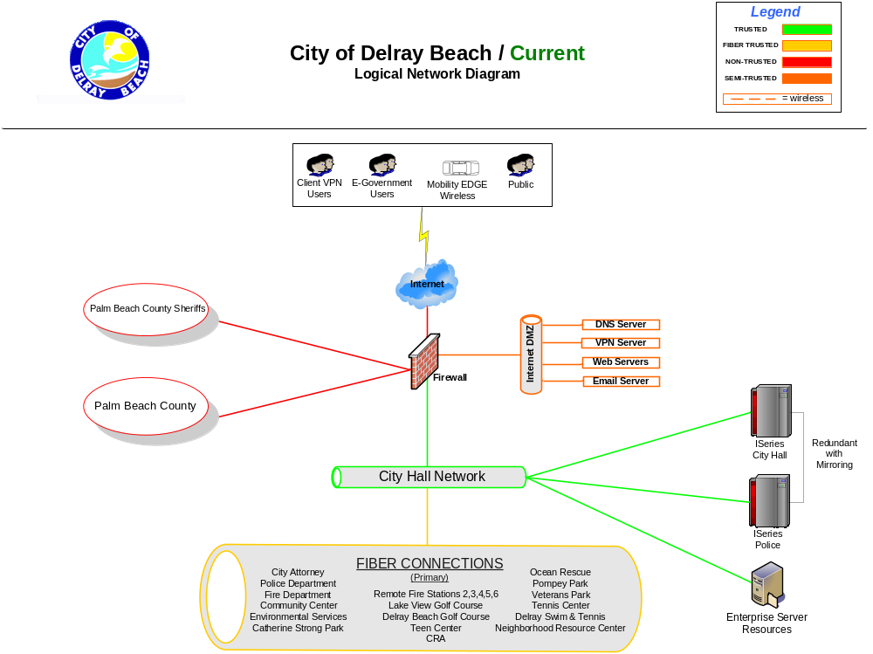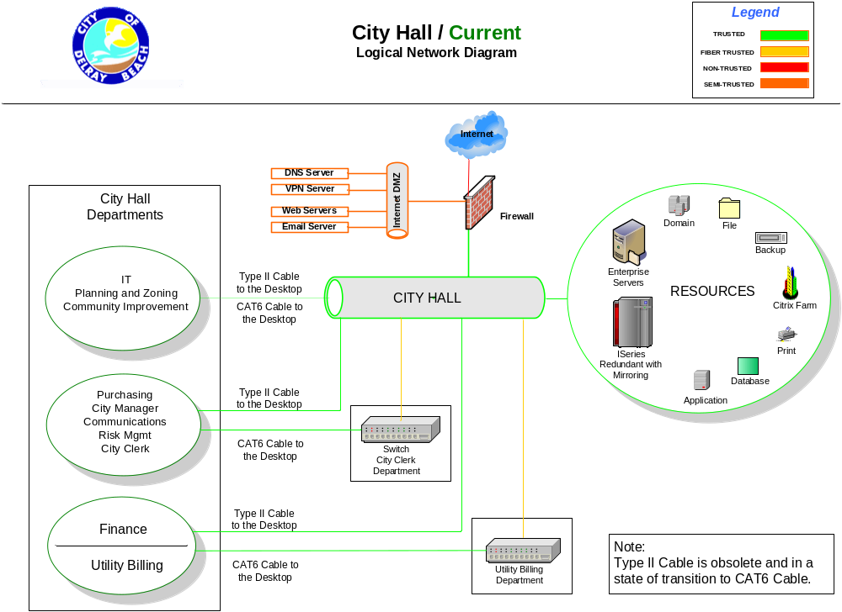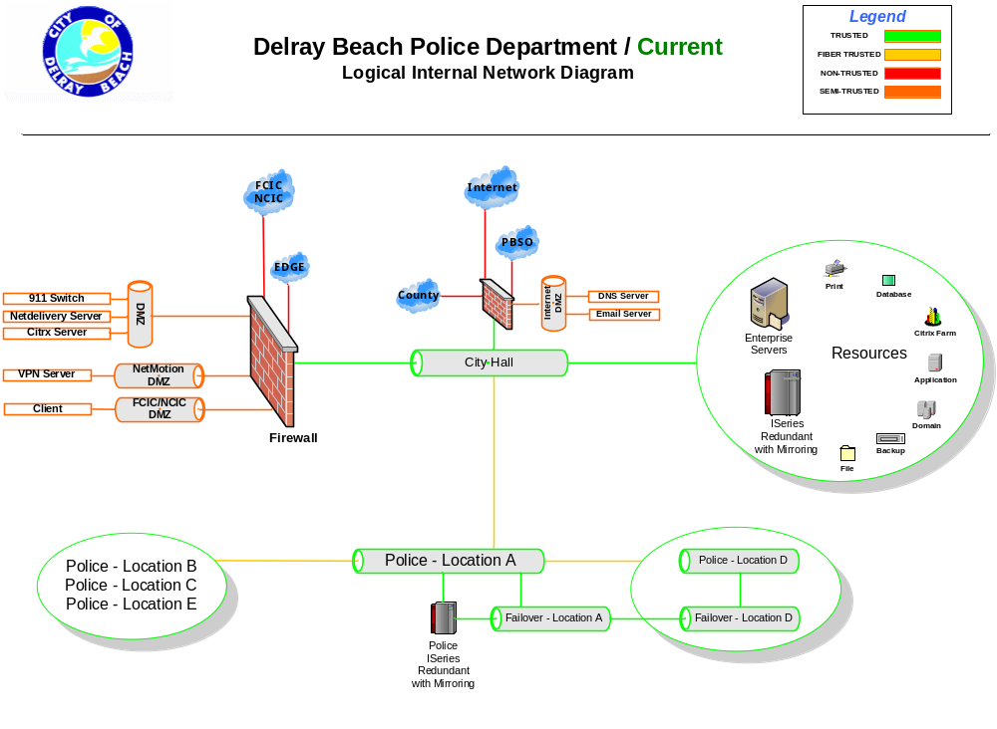
Observations
Infrastructure Connectivity and Transmission Speeds (Fiber Optic Lines)
The City currently has underground fiber optic lines between major buildings that presently include:
- City Hall
- City Attorney
- Community Redevelopment Agency (CRA)
- Environmental Services Complex
- Fire Headquarters
- Parks and Recreation Maintenance Compound
- Police Headquarters
- Parks and Recreation Community Center
- Tennis Center
- Water Plant
- The Police Department has a fiber connection to the Palm Beach County Sheriff’s Department for use of the FCIC (Florida Crime Information Center) and the NCIC (National Crime Information Center).
- City Hall has a fiber connection to the Palm Beach County Appraiser’s Office.

The City currently has overhead fiber optic lines to our remote sites that presently include:
- Fire Stations 2,3,4,5,6
- Delray Beach Golf Course
- Lakeview Golf Course
- Teen Center
- Ocean Rescue Headquarters
- Pompey Park
- Veterans Park
- Delray Swim & Tennis Center

Last fiscal year, to improve the overall system capability, reliability, system security, and provide for redundancy to our remote sites, a dedicated franchise and I-Net Agreement was negotiated with Adelphia Cable.

We are expecting to add three additional fiber optic connections to our remote sites in the near future:
  - Catherine Strong Center
  - Neighborhood Service Center
  - Western Community Center

This year we are installing additional underground fiber optic cabling from the main Fire Department Headquarter (Station No.1), as part of the 5th Avenue improvement project, to the City Attorney’s office to complete an underground public safety loop for redundancy.

The fiber optic line from City Hall to Police is a multi-mode line and should be replaced with a single-mode fiber optic line to accommodate the storage area network (SAN) units that are proposed to be installed next year.

In addition, part of the redundant underground fiber optic line conduit to Environmental Services has been installed from City Hall to S.W. 2nd Street as part of the Swinton Avenue project. For FY 2006-2007, we propose to complete this underground loop conduit from the new ESD Administration building to S.W. 2nd Street and install the fiber optic lines.

These two redundant loops will allow us to maintain connectivity to our public safety and Environmental Services Department by automatically rerouting the data communications if either one of the fiber optic lines is severed within either loop.

The infrastructure backbone connectivity and transmission speeds to our main facilities and our remote sites are now at 1 gigabit (1 billion bites per second). Our remote sites are limited to 1 gigabit within our agreement with Adelphia but the backbone infrastructure to our main buildings (City Hall, Police, Fire Headquarters and ESD) is proposed to be increased to 10 gigabits. In order to increase to 10 gigabits, we would need to upgrade our switches at either end of the fiber optic lines.

Fiber optic transmission speeds are only limited by the speed of the equipment installed on each end of the fiber. These fiber optic connections are considered “trusted” because they are hard-wired within the City’s infrastructure systems. Connected to each end of the fiber optic line within our buildings is a switch. The current switches contain fiber ports that are rated at 1 gigabit (1 billion bits per second), server ports that are also rated at 1 gigabit, and PC ports rated at 10/100 megabits (10 million, 100 million bits per second). We have some switches that have ports that are rated at 10/100/1000 (10 million, 100 million, 1 gigabit).

These PC ports are presently connected internally to individual desktops (PCs or printers) using Type I and Type II cabling (Cat 3). The Cat 3 cables were originally designed for older token ring networks and are only rated at 20 megabits (20 million bits per second). We have converted some of the older Cat 3 cables to the newer Cat 6 cables rated at 1 gigabit. All remote sites have been converted to Cat 6 cabling along with most of City Hall. We need to upgrade our remaining switches to 10/100/1000 and finish cabling City Hall, Police, Fire Headquarters and ESD, with Cat 6 cabling in order to bring our entire network up to 1 gigabit.

Within each of these desktop hardware devices are network interface cards (NIC cards) which are presently configured to run either at 10/100/1000 megabits. The desktop cards therefore allow up to 1 gigabit.

In conjunction with our remote fiber connectivity, we are in the process of completing 12 fifty-foot wireless transmission towers that will be connected to the remote fiber optic lines at various sites throughout the City. When completed we will conduct a pilot wireless project involving field personnel and the connectivity of systems and the ability to receive and transmit reports directly from the field.

Recommendations
Infrastructure Connectivity and Transmission Speeds (Fiber Optic Lines)
We recommend that we continue overhauling the network infrastructure capacity for the City to be designed for a minimum transmission speed of one gigabit (one billion bits per second) to the desktop PC and 10 gigabits (ten billion bits per second) to the primary backbone (one gigabit to remote sites and 10 gigabits to primary sites). This transmission speed is sufficient to accommodate the future handling of large files such as GIS, video streaming, video conferencing, kiosks and other interactive e-government applications.

In order to achieve this capability and provide for improved redundancy, we would recommend the following:
- Continue to replace our internal Type I and Type II (Cat 3) cabling over the next two-year period with Cat 6 cabling or with fiber optic cabling, both of which are rated for one gigabit or more.
- Continue to replace our primary switches to switches that have Ethernet ports rated at 10/100/1000 (10 million, 100 million, 1 gigabit) and fiber backbone ports rated at 10 gigabits (10 billion bits per second).
- Replace older printers with new units that have 10/100/1000 NIC cards as the need arises.

Network Server Systems
Observations
The current network is designed in a single server environment that supports both our network applications and data storage operations. This type of design is considered a single point of failure configuration. If a single server fails or needs to be taken down for maintenance or upgrades, the application and the data on that server will not be available for a period time.

With the amount of data we currently store and backup, we must take most of the night to backup files with the exception of our Exchange server (mailbox data). The Exchange server is so large that it can only be backed up on weekends. This is considered a weakness in our system backup routine and is not the optimal solution for a fault tolerant and redundant network.

Recommendations
Our recommendation would have servers designed to operate in a cluster environment with larger “virtual” enterprise servers for applications only and have our data stored on SAN (Storage Area Network) units.

Virtual enterprise servers are large servers that can contain a capacity from 10-30 individual servers (dependent upon application functions) in which, if any individual virtual server goes down for any reason, the server cluster software automatically will switch those functions to another virtual server. By locating duplicate virtual server clusters at City Hall and the Police Department, we would have full server redundancy with mirrored units.

Data would be taken off the servers and placed on a SAN unit. A SAN unit system stores data in one large area available to any server connected to the network. By locating one SAN unit at City hall and the other at the Police Department, we would have full redundancy of data with mirrored units. With this configuration, it would allow us to do “snapshot” backups anytime during the day. This solution would give us a 100% assurance of daily backups of our entire data files, which would include our Exchange mailboxes that are currently now only backed up on weekends due to their size.
IBM Mid-Range Servers
The City currently has two IBM iSeries mid-range servers. One is at City Hall and the other is at Police Headquarters. These servers are entirely compatible in that they are at the same revision level and have the same hardware such as memory, disk space, card configurations and application software. The primary server is located at Police Headquarters with the failover server residing at City Hall. The IBM mid-range server software (programs, data files, user profiles and system configuration objects) is mirrored from one server to the other continually throughout the day.

These systems are redundant to each other. If there is an interruption of service to our primary IBM iSeries server during the workday, users are able to sign onto the secondary failover IBM iSeries server and continue to work. This is part of our Business Interruption/Continuity Plan for short-term interruptions. In addition, since the two IBM iSeries servers are mirrored, the tape backups are done from the secondary failover server without any interruptions to the 911 operations. However, we currently only have one fiber optic line from City Hall to the Police Headquarters. If this fiber optic line were disrupted, it would cause the failover process to fail. The public safety fiber optic loop to be installed this year will resolve this situation.

Charts
- Diagram of City of Delray Beach - Future Logical Network – (Pg. 24)
- Diagram of City Hall - Future Logical Network – (Pg. 25)
- Diagram of Police - Future Logical Network – (Pg. 26)

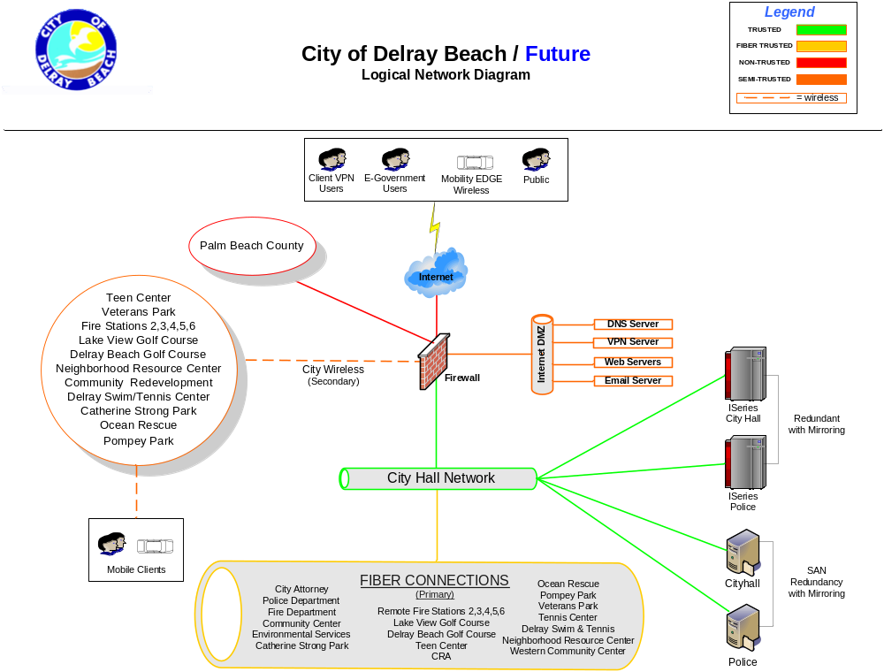
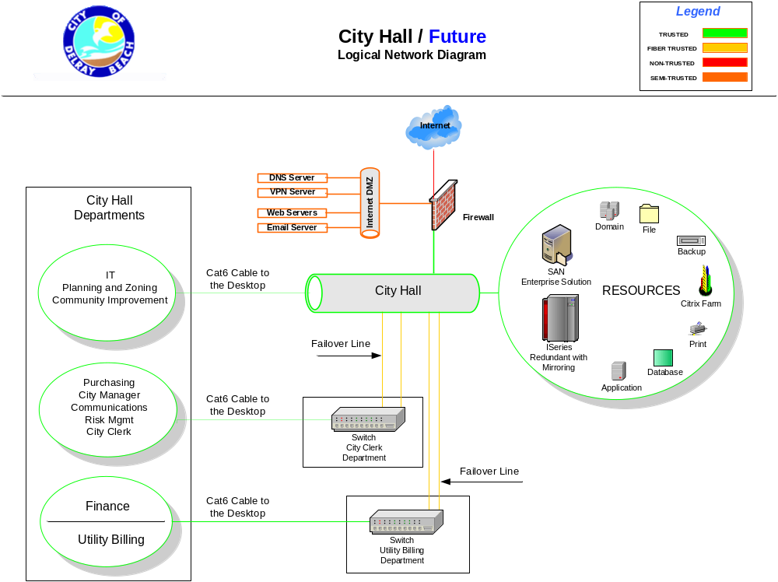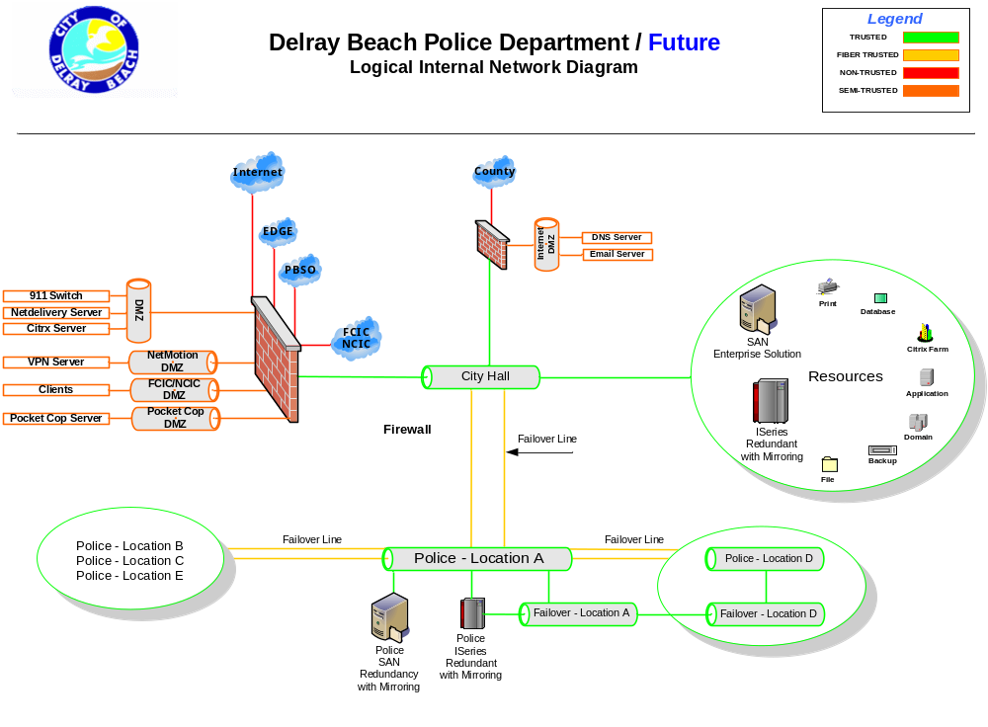

COMMUNICATION SYSTEM

Goal: To maintain an effective and secure communication system that is efficient, includes voice, video and data, and insures adequate redundancy for emergency services.
Objectives
- The IT management team, in conjunction with the Telecommunications Manager, will prepare a chart that diagrams all internal and external voice and data transmission devices and mediums.
- The IT management team, in conjunction with the Telecommunications Manager, will evaluate and identify inefficiencies within each individual communication device and then prepare recommendations from observations.

Observations
Telephone Systems (Voice Communications)
The City presently has five T-1 private access telephone lines for the following:
- 911 Emergency Line
- Internet (Bell South) to City Hall
- Palm Beach County Sheriff’s Office
- EDGE (Enhanced Data rates for GSM Evolution) Line
- National Crime Information Center (NCIC) and Florida Crime Information Center (FCIC) also referred to as CJNET (Criminal Justice Network).

Bell South supports the primary Police/Fire 911 emergency dispatch telephone system. The agreement with Bell South stipulates that, in case of telephone outages, the 911 system is the first system to be restored. The primary backup system to our 911 emergency dispatch telephone system is the Palm Beach County Sheriff’s Department 911 system. This system is a T-1 frame relay system with Bell South that would reroute any 911 calls from Delray Beach to the Palm Beach County Sheriff’s Department, who in turn, would dispatch the Delray Beach Police/Fire emergency units.

The City Hall telephone system upgrade was completed in FY 2003 along with the fiber optic line from the IT center to the telecommunications closet. It also connects the City Attorney’s office to the City Hall telephone system.

The City Manager’s Office budgeted, in FY 2004-2005, to replace the Police Department telephone system that is in excess of 17 years old and very costly to maintain. It was determined that the cost to replace and upgrade this system to state-of-the-art technology was $185,000. This new phone system will be connected to the City Hall phone system to create a fully redundant telephone system.

Radio Systems (Mobile or Portable Voice Communications)

The primary Public Safety radio (voice) communications is conducted from the Police Dispatch Center radio console, through the radio tower located at the Police Department, and is then transmitted to mobile radio units and portable radio units (Police or Fire) according to talk groups. The primary backup to the this communications system console is within the system itself and a secondary backup is the City of Boca Raton or Boynton Beach, if the entire console is down. The primary backup to the tower is the Forest Hill tower (consists of four T-1 direct lines). The secondary backup is the tower located at Congress Avenue (consists of one T-1 line).

Rebanding Project
First responders, nation-wide, are in the process of changing the 800 Mhz band due to interference from commercial wireless carriers. Public safety communications systems are located next to commercial systems (cell phones) in the 800 Mhz wireless spectrum. These technologies are incompatible and cause interference in the public safety services in several areas. The commercial carriers will pay for the cost of this project.

800 Mhz Replacement Project
Motorola has notified the Police Department that they will no longer support our current radio configuration as of FY 2009. This technology will be replaced with radio systems that include both voice and data transmission. This project is in the current CIP for $7 million.

Cellular (Mobile Data Communications)
The primary Police method of data transmission to vehicles is through an EDGE (Enhanced Data rates for GSM Evolution) card that is inserted into a laptop MDT (Mobile Digital Terminal) or a trunk-mounted device. The trunk-mounted device plugs into the MDT and is more durable that the cards. We currently have 150 EDGE cards. This could expand to as many as 200 cards when we transmit data to Code Enforcement, Environmental Services and other departments.

Data is presently transmitted into and from our internal network through a T-1 line to AT&T, who transmits the data through cellular towers to our Police vehicles. This data is transmitted at 384k (384,000 bits per second) speeds. This is slower than our internal fiber optic network that can transmit at speeds exceeding one gigabit (one billion bits per second).

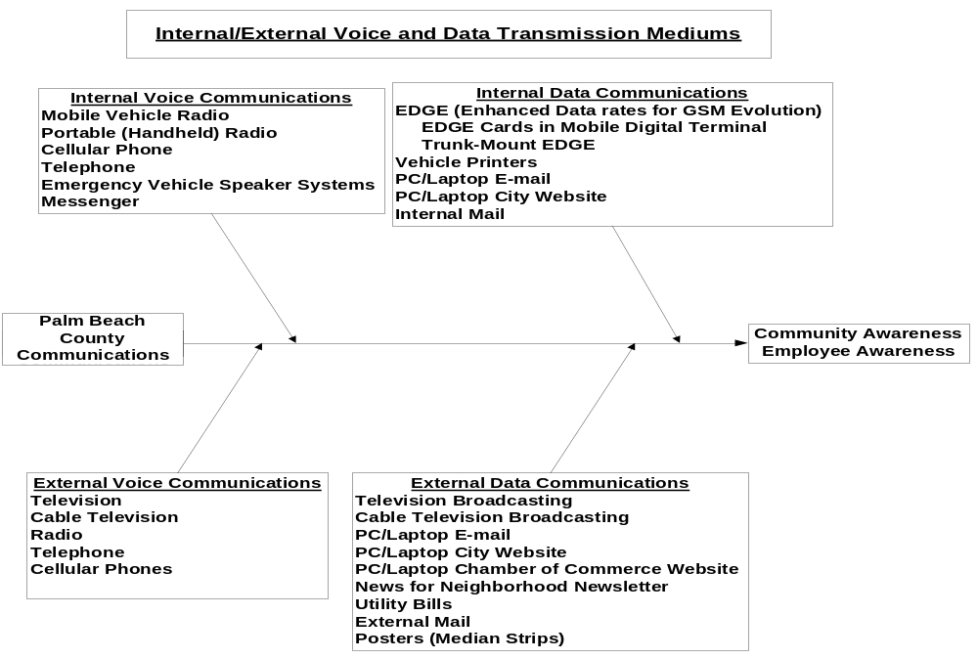
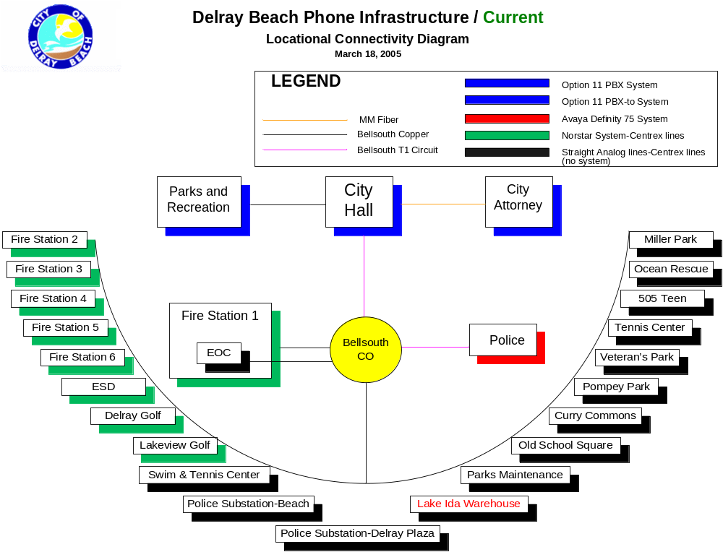
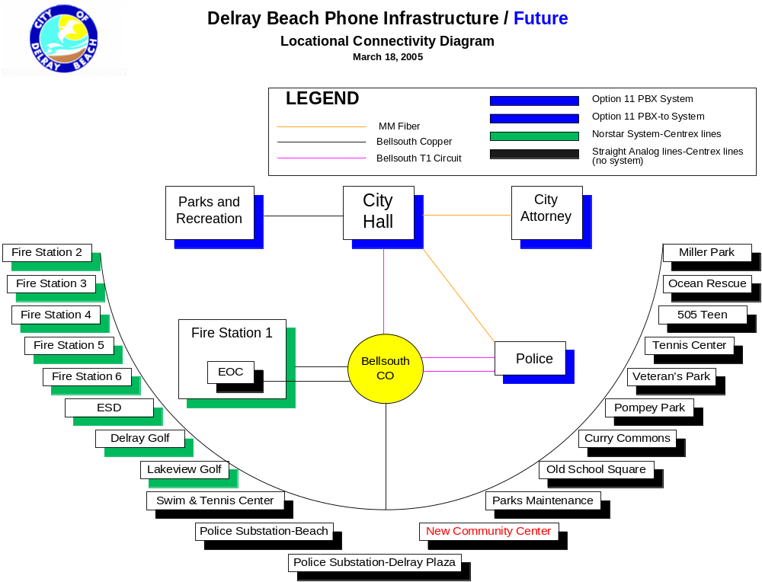

SOFTWARE
Operating System and User Application Software

GOAL: To maintain the operating system software and user applications software at the latest version and release level to provide for the most reliable overall user technical performance, consistency, operational efficiency and customer satisfaction.
Objectives
- Update the inventory list of all user applications software noting the current version and release level available and verifying appropriate licensing compliance requirements.
- Evaluate version and release of current application software inventory listing.
- Prepare recommendations from observations.

Observations
The City’s primary mission-critical user applications software is from Sunguard HTE and runs on the IBM iSeries servers. Overall, the HTE applications software has been extremely reliable and stable and has worked well for the City.

PC client software and PC servers are based on Microsoft applications and overall is extremely reliable and stable.

Recommendations
At this time, we do not recommend changing any of our major operating software. However, we recommend looking at updating the Sunguard HTE application software to the next level called Sunguard HTE Naviline. This software has a browser like look but still has the same solid database running in the background.

WEBSITE INFRASTRUCTURE

GOALS: To maintain a professional website infrastructure for e-government initiatives to provide a means of disseminating information to internal and external users, customer inquiries and comments, for authorizing and facilitating the submission of on-line forms, on-line payments and other customer service applications.
Objectives
- The IT management team will evaluate the present website contents, utilization, future applications and resources assigned to website programming and development.
- Prepare recommendations based on observations.

Observations
The IT Division, in concert with the Community Improvement Department and the Utilities Customer Service Division of the Finance Department, implemented new e-government initiatives to improve our Interactive Voice Response (IVR) software and Website interfaces on the following:

Community Development
- Interactive Voice Response (IVR)
  - Inspection Scheduling: schedule or cancel inspections on-line.
  - Inspection Results and History: request for delivery by e-mail.
- Web Interface
  - Plan Review Status: viewable on-line.
  - Permit Status: viewable on-line.
  - Inspection Scheduling: schedule or cancel inspections on-line.
  - Inspection Results and History: viewable on-line.

Utilities Customer Service
- Interactive Voice Response (IVR)
  - Account Inquiry: ability to listen to audible playback of current balance and next billing date, last billing amount and date and last payment amount and date.
  - Payments: make payments by credit card.
  - Spanish language support.
- Web Interface
  - Account Inquiry: on-line viewing of account status, billing history and payment history.
  - Payments: make payment by credit card on-line.
- Customer Service Staff
  - Delinquency Notices: ability to deliver notice of delinquency by phone messages.

Mailing List System
The e-government initiative allows a user to subscribe to a variety of mailing lists, allowing the subscriber to be sent information published for that particular list. For example, newsletters, announcements, public notices (Commission meetings, committee meetings, election information, minutes, agendas, ordinances, resolutions and other information) and public advisories (boil water notices, road closures, hazardous materials spills, serious weather conditions, security alerts and beach conditions).

At the request of the commission, IT is redesigning the City’s website. With this redevelopment, we are working with the Chamber of Commerce, Community Redevelopment Agency (CRA) and the Downtown Marketing Cooperative (DMC) to develop a main webpage that incorporates the same look and feel for all entities. This will give Internet visitors one place to go for information concerning our community.

Recommendations
- IT recommends that we continue with the next e-government software utilizing Selectron Technologies, Inc. At this time, the parking tickets would be next.
- We recommend taking an inventory of all forms used in the City and determine which forms could be available online then IT would research the best method to deliver the forms electronically.

GIS INITIATIVES

GOALS: To develop a GIS (Geographic Information System) plan to bring together data and geographic components which serve the entire City’s needs for location-based data and deliver an added benefit to current applications.
Objectives
- The IT management team, in conjunction with the Engineering Department, will evaluate and identify restrictions, bottlenecks and inefficiencies of the GIS system.
- Prepare recommendations based on observations.

Observations
The City has completed the following GIS projects this year:
- The GIS coordinator has developed a street segment file for Delray Beach. Plans are being discussed to maintain and keep it current.
- A Geo-rectified City Boundary Map has been created. The efforts of the GIS Coordinator along with the help of the Senior Planner produced an accurate boundary of the city based on the city charter and any amendments or annexations.
- A Geo-rectified Utility Service Boundary Map has been created. The efforts of our GIS Coordinator along with the help of Senior Planner produced an accurate boundary of the city based on a resolution with Palm Beach County, the city charter and any amendments.

The following projects are in Progress:
- Utilizing our GIS Consultant, Spatial Focus an Address/Geo-Audit project is currently underway. A benefit of this project for GIS will be the creation of a geo-coded address database whose contents have been checked and verified. It is the most vital part of the system. Part of creating such a data source is checking the existing data for entry anomalies and inconsistencies with filed records. The GIS Address/Geo-audit project overall is approximately 60 percent complete.
- Document Imaging - E-Government Initiative: This project is approximately 32 percent complete. It covers the scanning, coding, data entry and means of Intranet access for large size Engineering As-built Record drawings. The laser fiche program used by other departments within the city was chosen as the application to record and distribute this data. Its data is also compatible with, and can be incorporated into our GIS plans for future applications.
- Develop Interactive Web Applications: The GIS Coordinator is currently working with our consultant to evaluate and select a GIS web-authoring tool. The consultant will also help establish one priority application. This project is approximately 25 percent complete.
- Asset Inventory – GPS Data Collection: Storm Water is 80 percent of inlets, manholes, headwalls, pump stations and clean outs are GPS located with identifying attributes added to a feature database. When this data set is completed it will be subject to quality control checking prior to use.

The following observations need to be addressed to further the development of the GIS system:
- The GIS initiative over the last couple of years has been mainly data preparation.
- The GIS Coordinator is responsible for other CAD (Computer Aided Design) job duties within the Engineering Department that require his expertise, thus taking away time from the GIS duties.
- One very critical area is the Address Repository.
  - The City does not have a dependable backup to the employee responsible for establishing new addresses.
  - This foundation layer ties together the parcel data within the HTE Land Parcel system to the GIS layers.
  - This is the main layer that the GIS system is built upon.
  - The Address Repository must be updated on a current basis and properly supported to have an accurate GIS system.
      - Ultimately, GIS will be available to employees using the internal Intranet and the public will have limited use through the Internet.
      - The outside GIS consultant, Spatial Focus Inc., has helped prepare a GIS Strategic Plan and has been very useful in developing major tasks and the address plan. They will continue to support our efforts as we move forward in completing our GIS system.

Recommendations
- Departments should continue to work closely with the Engineering Department in contributing time and resources to data collection and quality control of existing data.
- The Address Repository methodology needs to be documented, in detail, so that this function can be carried on if the current employee is not available.
- Plans for the future of GIS initiatives include the following:
Fully develop the Address Repository.
Complete data collection for different layers of the GIS system.
  - Water (valves)
  - Sewer (manholes, valves)
  - Drainage (inlets, pump stations, headwalls)
  - Public Works (light poles, trees, trash cans, signs, sidewalks, bus shelters, etcetera)
Develop GIS layers for departmental use from data collected.
- Link GIS layers to external databases (HTE, Hansen and others).
- Utilize GIS digital infrastructure as part of e-government initiative.
- Convert non-GIS utility maps to accurate GIS data maps.

Other possible usages.
- Public Safety issues such as crime zone areas or Fire maps, etc.
- Flood Zones (Is a property in a flood zone.)
- E-Map (Location of restaurants, entertainment, parks, etc.)
- Address Information (Property owner information, assessed value of a property.)
- Liens on property.

BUSINESS INTERRUPTION/CONTINUITY PLAN

BUSINESS INTERRUPTION/CONTINUITY PLAN

Goal: To develop a written Business Interruption Plan (short-term disruption and recovery) and a Business Continuity Plan (long-term disruption and recovery) to ensure that the IT hardware, infrastructure, software systems and data files are physically protected, insured and can be recovered or restored in a timely manner to the satisfaction of all customers and users of the system.
Objectives
- The IT management team has evaluated possible short-term disruptions and continues to update this plan to ensure recovery within acceptable timeframes to customers and users.
- The IT management team will evaluate possible severe long-term disruptions and develop a plan for prevention and IT priority responses. This will ensure recovery within acceptable timeframes to customers and users.

Business Interruption Plan: Short-Term
Observations
We are updating our system designs to minimize any possibility of a short-term business interruption to the primary infrastructure. Short-term interruptions are for the most part caused by a power or equipment failure. Some actions have been taken and additional actions have been proposed to address these problems in order to provide a fault tolerant, redundant system.

The IT management has already replaced the AS/400 systems, located at City Hall and the Police Station, with new IBM iSeries servers. These systems are identical in hardware and operational software configurations with application programs and data files mirrored in real time. In the event that the primary system goes down, the secondary system will continue operations. However, these redundant systems are connected by one Cisco 6509 switch, that is why this switch is considered a “single point of failure” in our Business Interruption/Continuity Plan. In conjunction with this scenario, the present fiber optic line from City Hall to the Police Department is a multi-mode 12-strand fiber optic line. A multi-mode line was originally designed for short distances and not for distances from City Hall to the Police Department. In addition, we only have one strand of fiber remaining and need additional connectivity for the new switch and SAN storage units approved in the next fiscal year.

In analyzing the present conduit (City Hall to the Police Department) to determine if we have the capacity to install a single mode 24-strand optic line, we found that the conduit is crushed underneath the Tennis Center parking lot and needs to be replaced.

Emergency telephone numbers of all IT employees are updated yearly.

The IT and Police computer rooms have UPS (Universal Power Supply) battery backup systems that will allow priority units to continue operations in the event of a power outage until emergency generators are activated.

Full tape backups are done daily at City Hall for the IBM iSeries servers and the PC network servers. These full system backups are confirmed every morning and the once a week backups are stored in a vault at an off-site location.

In order to provide fault tolerant, redundant communications of major systems, we have recommended additional fiber optic loop lines to be installed. The first fiber-optic loop is for public safety (Police, Fire and City Hall) and the second fiber optic loop is for non-public safety (ESD area and City Hall). These two loops will give us the opportunity to continue communications even if one fiber line is severed. These fiber optic loops are scheduled for late 2006 and the third quarter of 2007 respectfully.

Recommendations
- We are recommending redundant PC network servers clustered together with SAN’s data depository in order to provide a fault tolerant, redundant PC network system.
- We are recommending approval of another 6509 Cisco switch located at the Police Station to be mirrored to the first switch. This will provide additional redundant capabilities to our network design.
- We are recommending approval for the replacement of the multi-mode 12-strand fiber optic line with a new single-mode 24-strand optic line.
- Maintain an up-to-date inventory of all hardware, software and cabling for insurance and recovery purposes. Have hard copies and CD’s for use on PC’s.
- Inventory listings and insurance policies to be stored in a fireproof vault.
- Find and test alternative location for operations in case access to City Hall or Police Department is not accessible (contamination, fire, explosive threat, etc.).
- Work with the EOC (Emergency Operation Center) to provide IT services as needed.

Business Continuity Plan: Long-Term
IT management is committed to protecting the city’s technological assets and being prepared to quickly recover and resume operations in the event of a significant business interruption. We have always regarded this as an obligation to our customers. We are committed to allocating more resources into the Long-Term Business Continuity plan to ensure our ability to meet this commitment.

A disaster that destroys our computer operations center in City Hall or the Police Department would represent a long-term business interruption. Worst-case scenario would be that both facilities are destroyed. The overview of the Long-Term Business Continuity Plan addresses how the City would re-establish operations following this type of disaster.

Long-Term Business Continuity Plan Overview
- Consider the impact of various types of potential long-term interruptions and prepare an appropriate strategy for each.
- Provide for the complete recovery of our technology infrastructure and data.
- Enable the city to continue to perform our critical business functions and minimize the impact to our customers.

Recommendations
The goal of our long-tem business continuity plan is to be able to recover and resume business operations within the shortest possible time after the onset of a situation that warrants a disaster declaration. To accomplish this we will:

- Write detailed recovery plans that identify specific actions to be taken, personnel requirements to meet those actions and other resources necessary to restore critical processes and resume business operations.
- Contract with vendors in providing or making available PC networks, communication infrastructure and workspace for personnel in the event that our facilities are unusable because of an incident.
- Annually test the effectiveness of our long-term business continuity plan to ensure that we have the ability to continue to operate in the event of an incident.

ANNUAL PROJECT WORK PLAN

