Email to Cell Phone User with Links to Wireless System

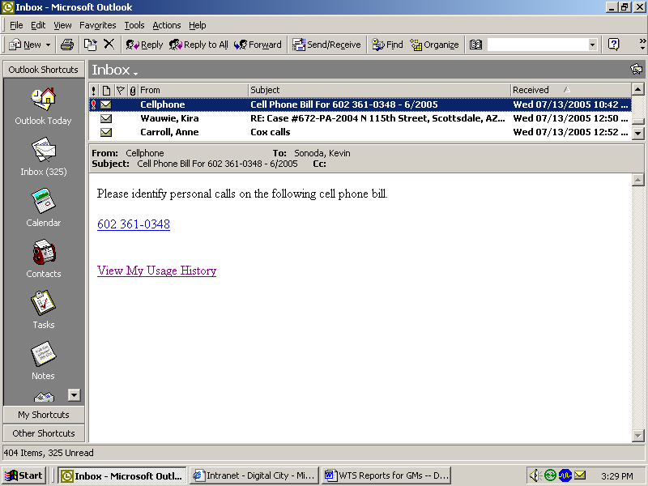

Example Monthly Statement

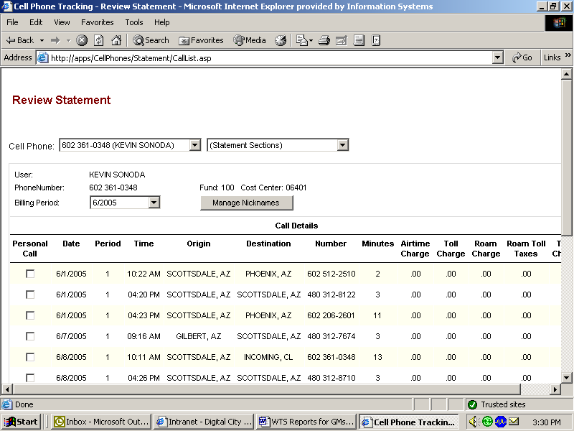
602 867-5309 (BAXTER BOBCAT)
BAXTER BOBCAT
602 867-5309
602 867-5309

Example of View Usage History Summary

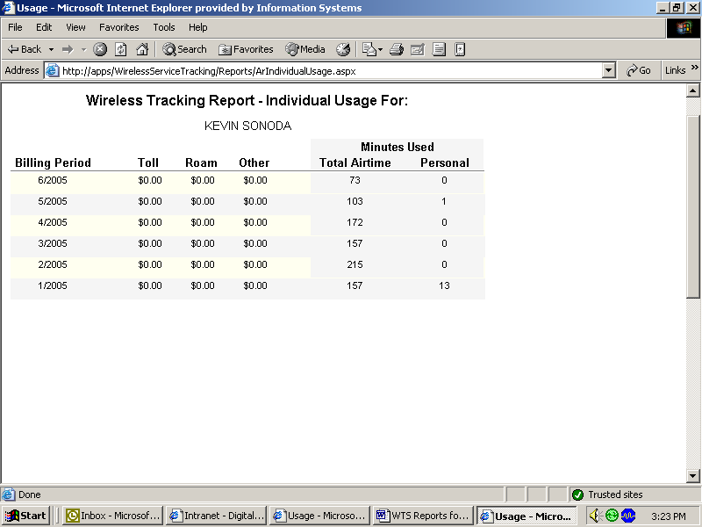
BAXTER BOBCAT

Example of Statement with Personal Calls – Checked on Left Column

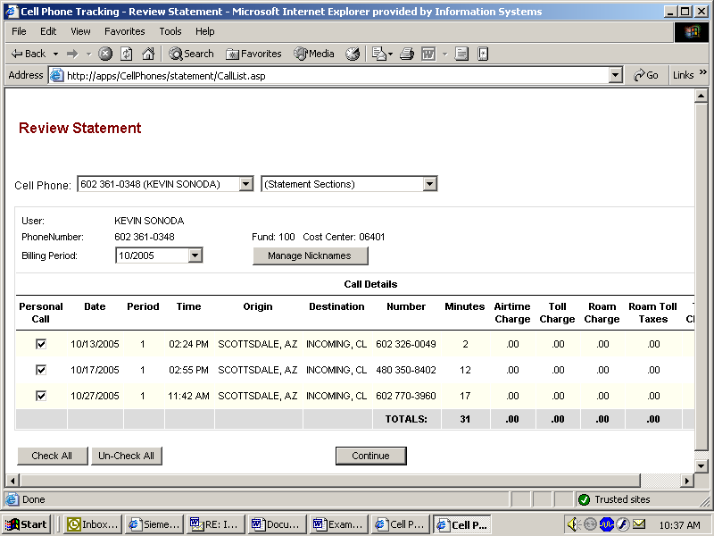

After “Continue” Button – Next Page – Summary of Personal Calls

(NOTE: City policy allows up to 15 minutes of personal use per month. Personal call minutes in excess of 15 minutes are charged 12 cents per minute plus applicable roaming and LD charges)

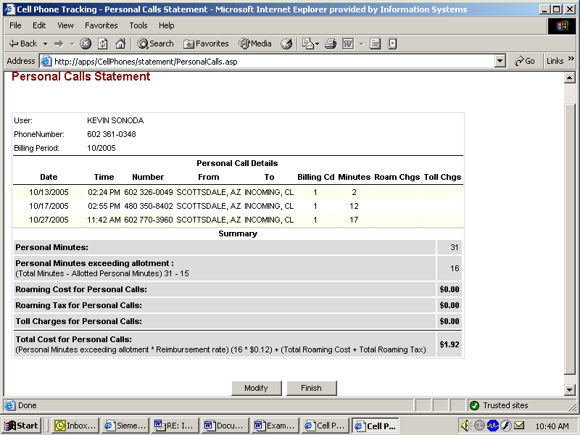

Final Screen – After “Finish” Button – Showing Invoice to Print & Remit with Payment

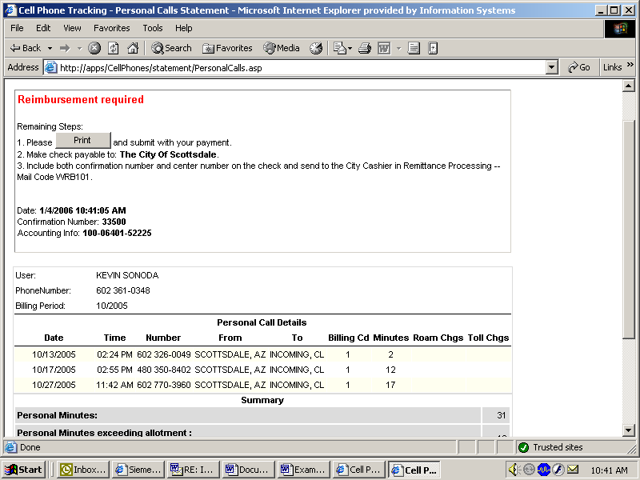

Bottom of Screen on Previous Page

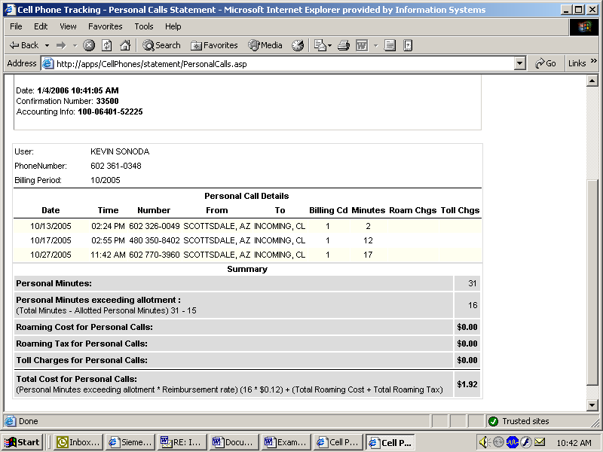

Final Screen Shot When No Personal Calls Selected

